Physics of Flight Pt 6
Understanding how to distribute lift-producing surfaces
to achieve stable flight.
The following demonstrations take the form of building model aircraft the test the theory of stable flight. The information required to build the models is presented in a continuous presentation but of course the tasks could be split into aircraft types and the flying of them carried out separately.
By making three types of small paper aircraft from paper and drinking straws, we can show how different kinds of aircraft layouts achieve stability in flight.
These models are not too difficult to make but it may be the chance for students with more nimble fingers to show off their skill. We suggest that the building of the models could be speeded up by two or three students working on a single model.
These models are by their very nature rather fragile and should be flown in an indoor open space free of obstructions such as a wide corridor or drill hall. Tips on trimming and flying the models are added at the end of the building instructions.
The materials needed are:-
Some sheets of A4 printer paper
A few paper drinking straws approx. 21cm long
Clear adhesive tape
A tube of clear adhesive [Evostick, Bostick or similar]
Some modelling clay or BluTack
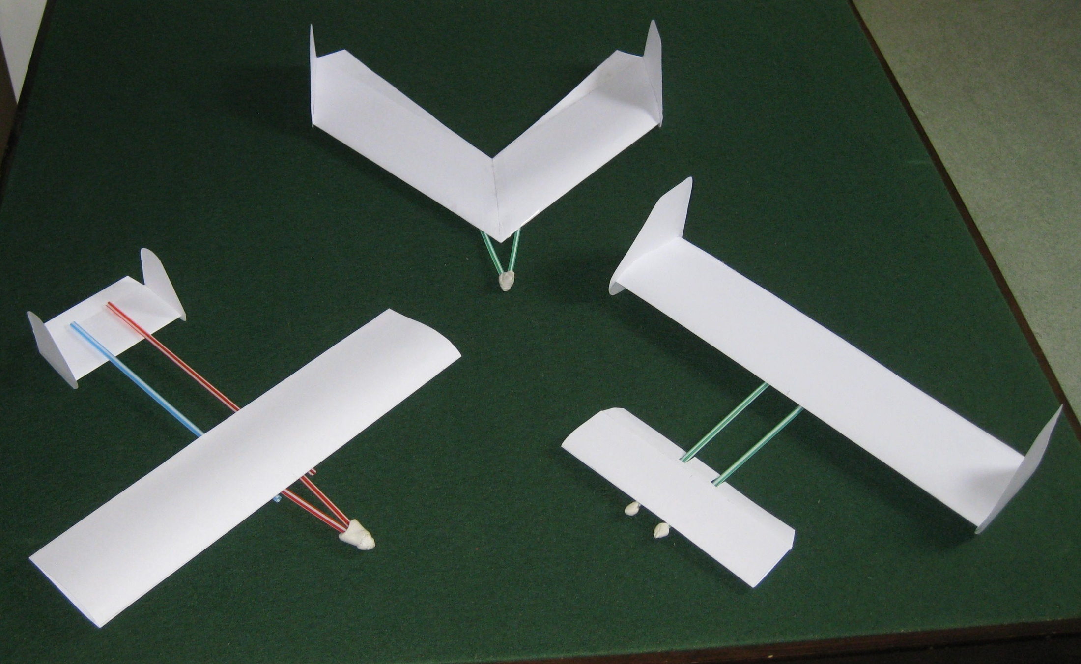
These are the three types of aircraft that we will make.

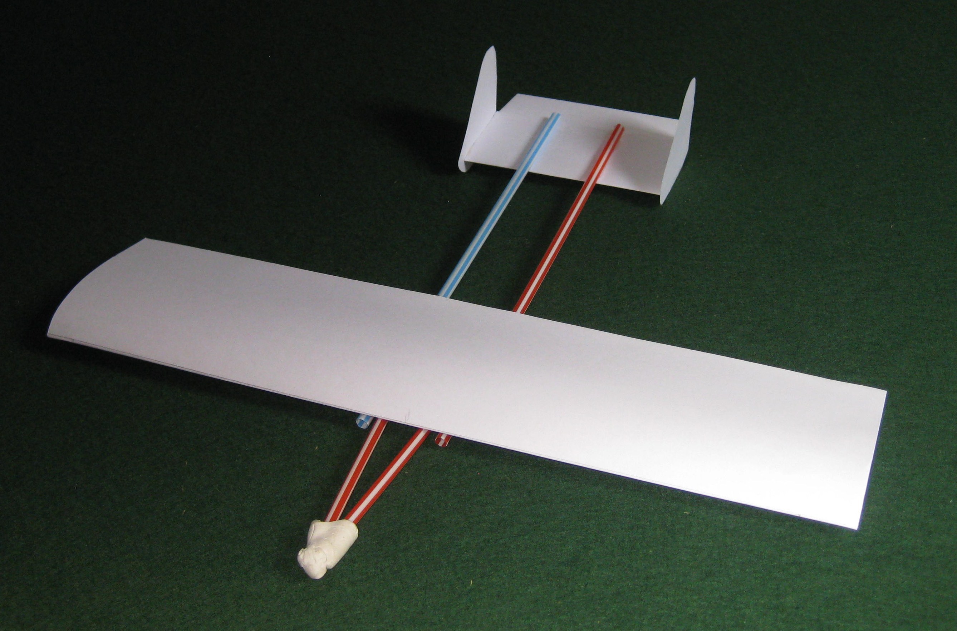
This is the first type. It has what we would call the “standard” layout
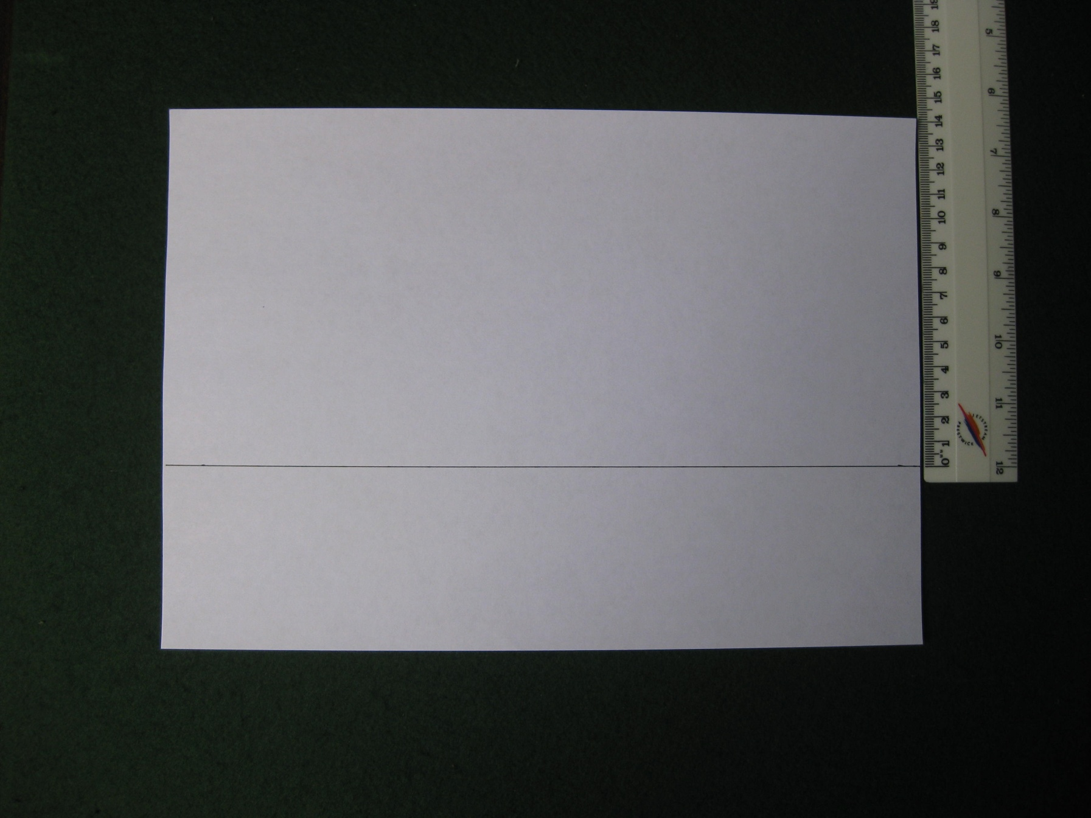
To make a wing section, take a sheet of A4 paper and
draw a line across it 14cm down from the long edge.
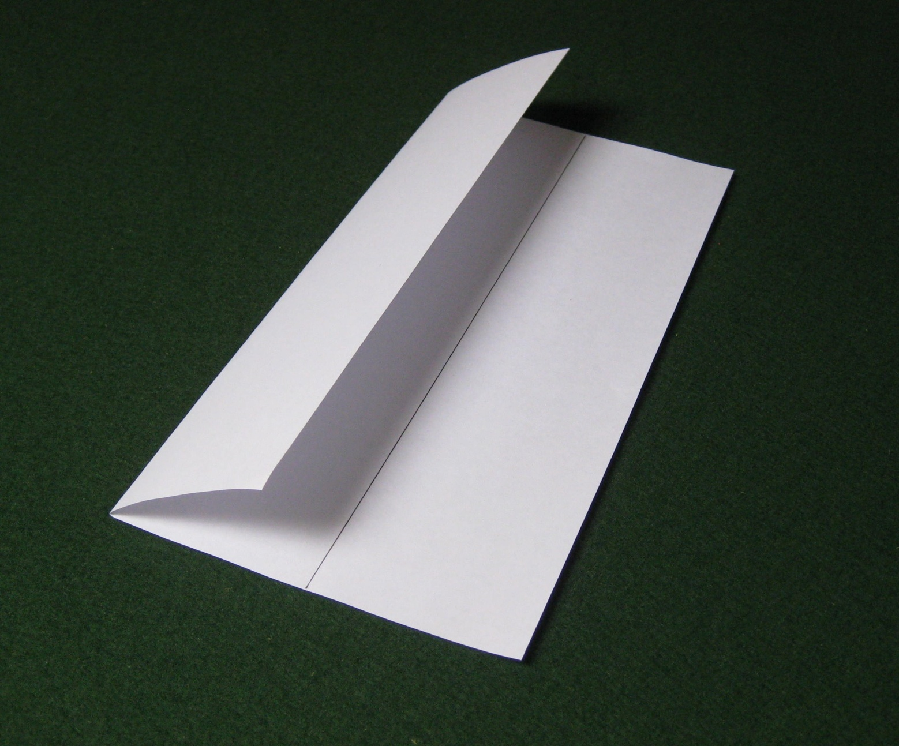
Fold the edge of the paper down to the line. Do not press the crease down hard since we want a nice rounded nose on the wing section.

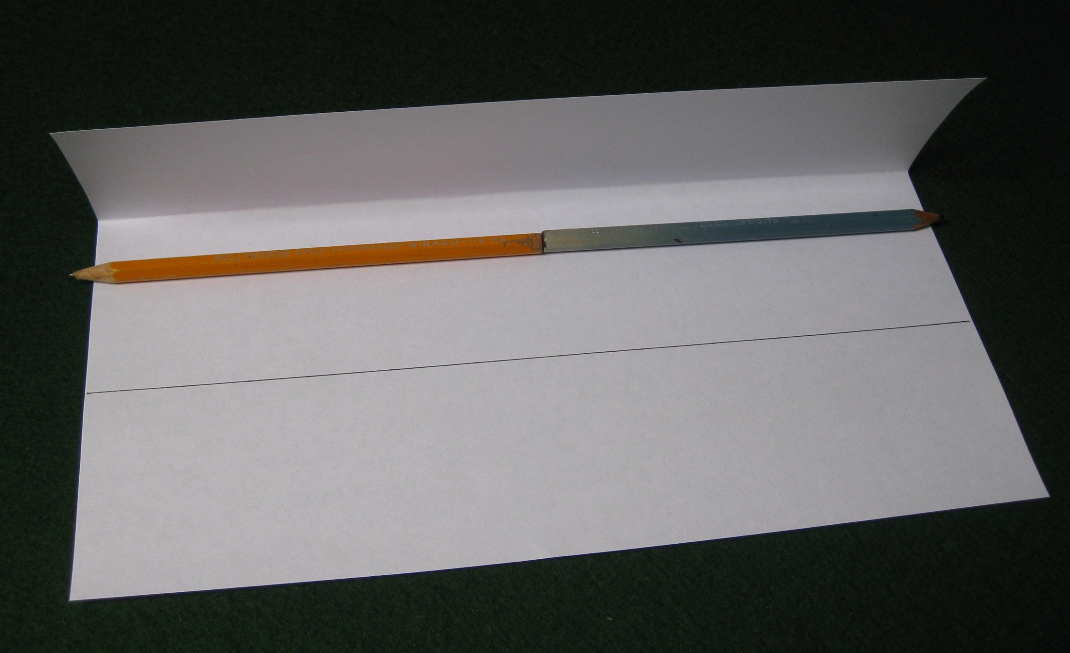
This is the tricky bit. Put a thin layer of glue on the underside of the edge of the folded flap. Lay two pencils where shown in the photo. Gently hold the fold line down onto the work surface and at the same time fold the free edge down onto the top of the pencils and then down at the edge towards the pencil line. Because of the curve, the edge will now be short of the pencil line.
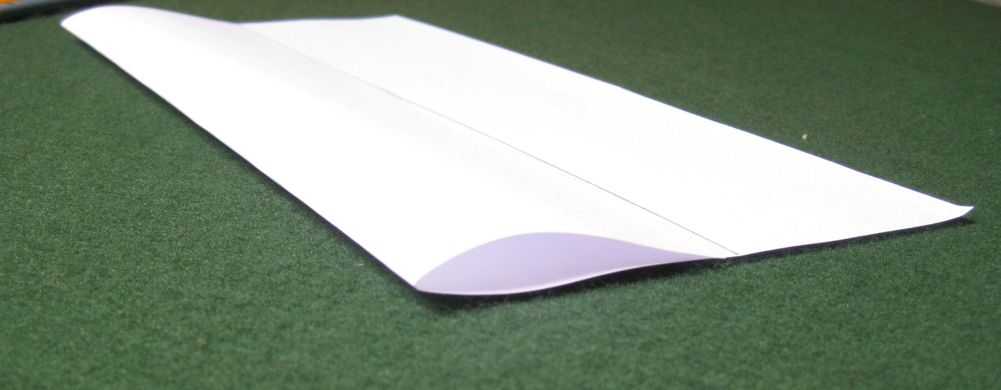
Remove the pencils and, if you have folded the section correctly, you should end up with a nice section like this.
Cut off the spare paper along the trailing edge of the wing section.
This will produce the wing that you need for the standard and canard models.

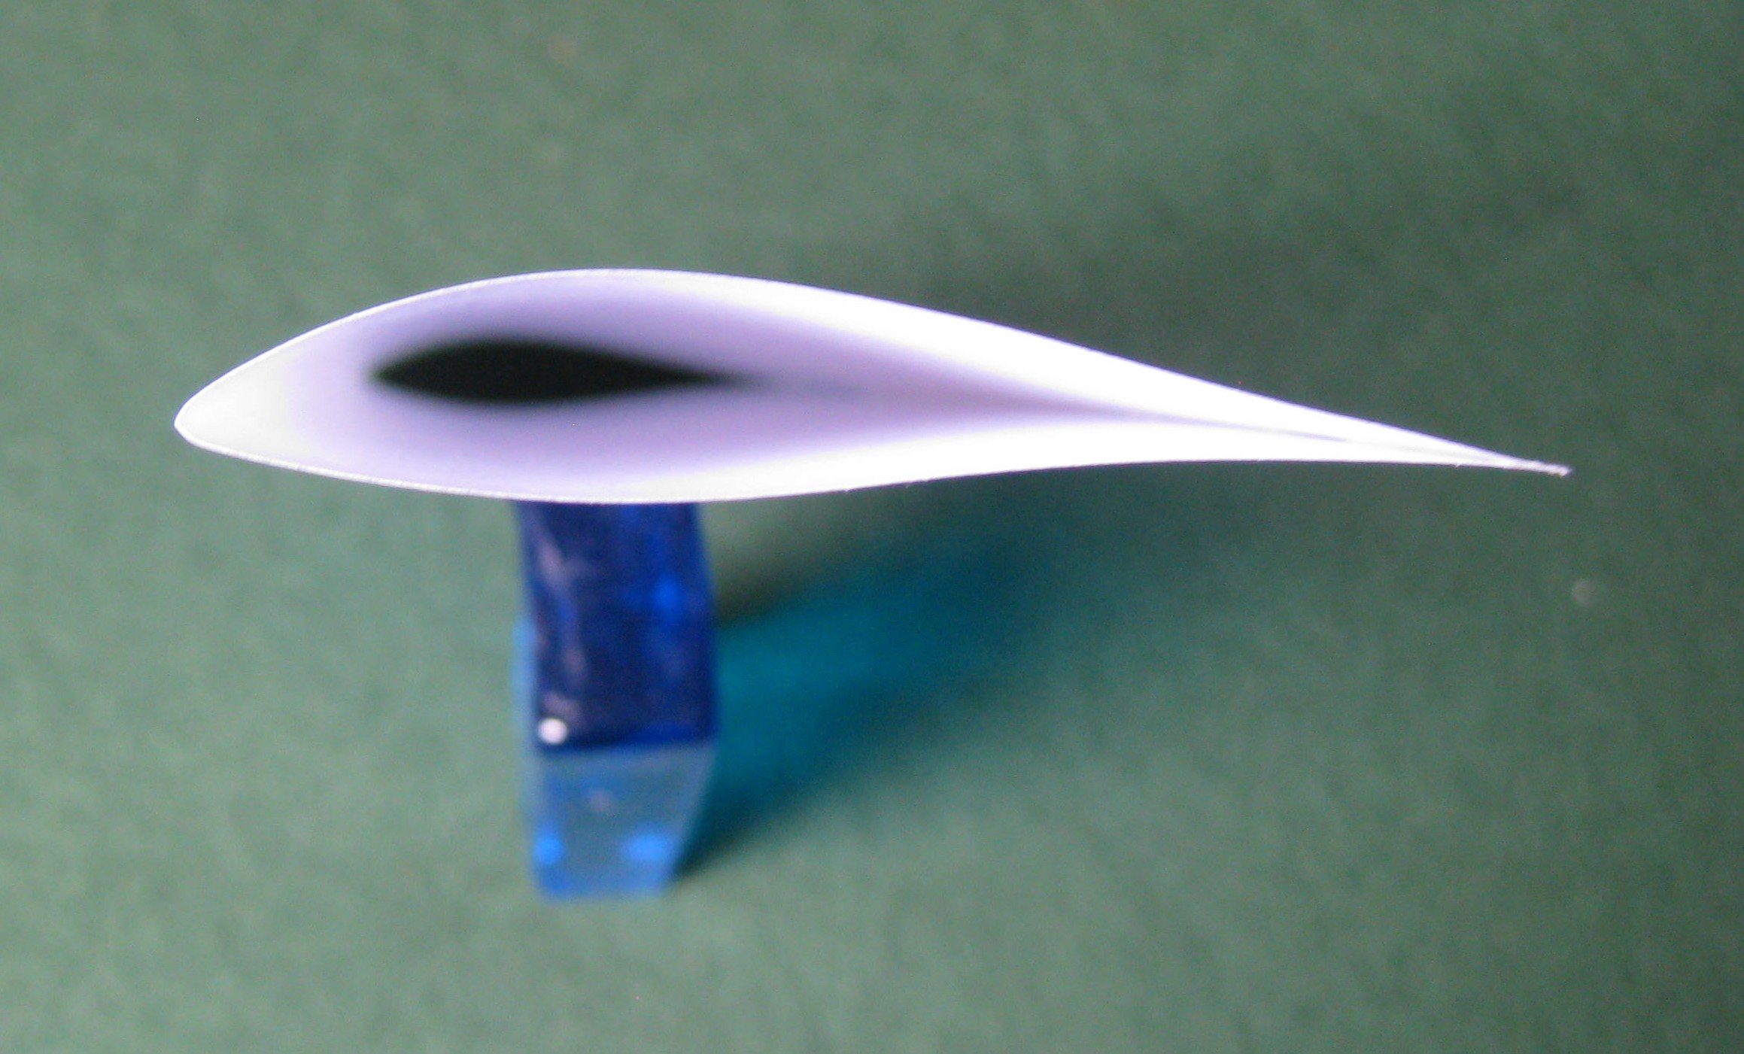
If you look directly on the tip of the wing you will see that the paper has formed a very nice wing section with an upward- cambered centreline.
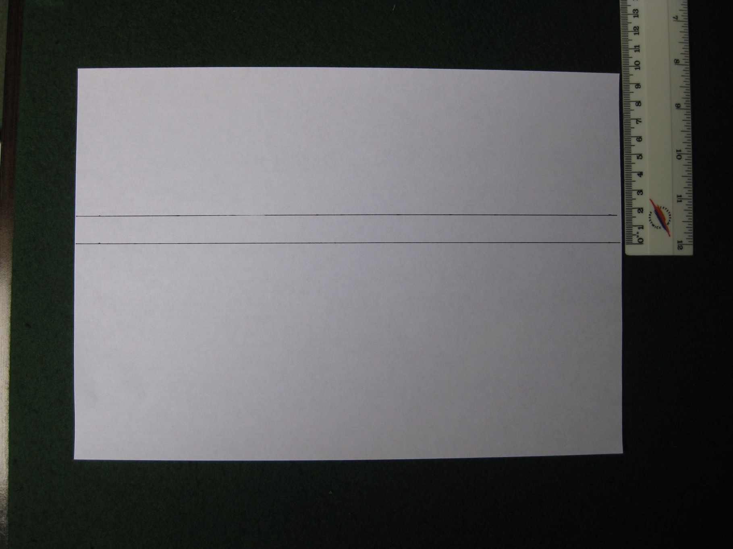
The stabiliser section is made just like the wing section, but smaller. Take a sheet of A4 paper and draw two lines across it 8cm down from the long edge
and then another line 15mm down from the first one.

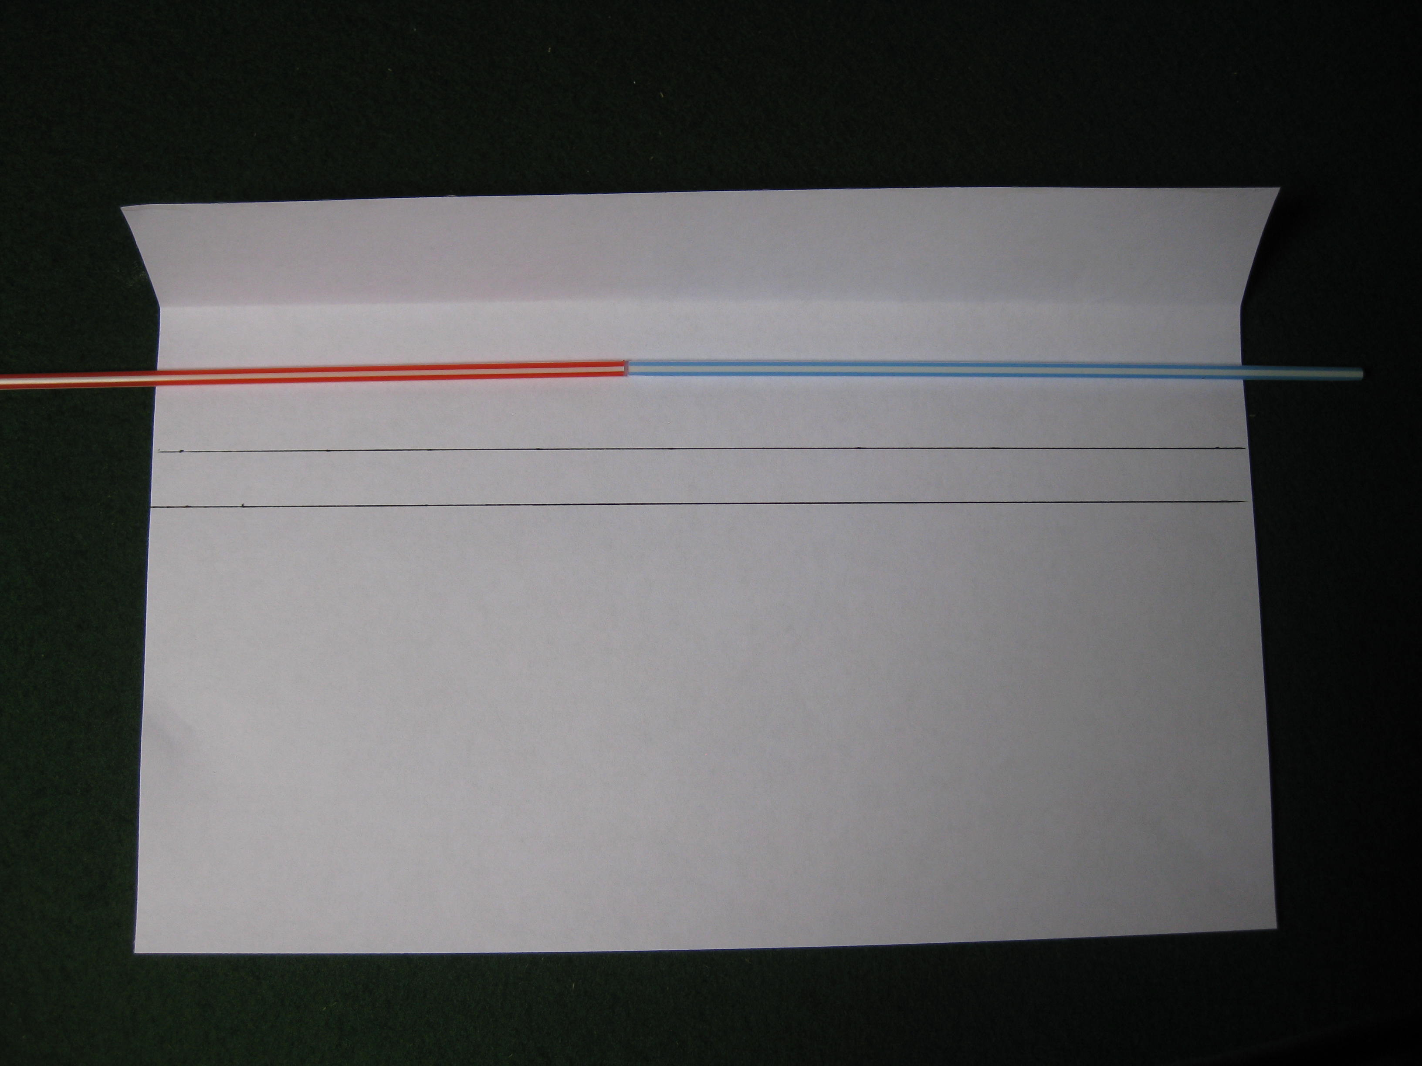
Fold over and glue the stabiliser section in the same way as the wing section but this time place two drinking straws inside the section to control its thickness. You should get another nice aerofoil section.
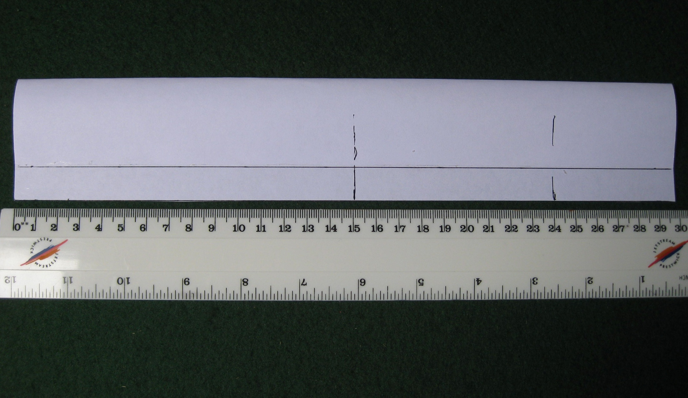
Cut off the spare paper along the second line to leave a free flap that we will use later to trim the model for flight. Mark off two lengths of the section, one at 15 cm and the second at 9cm. Simply make straight cuts through the section with scissors.

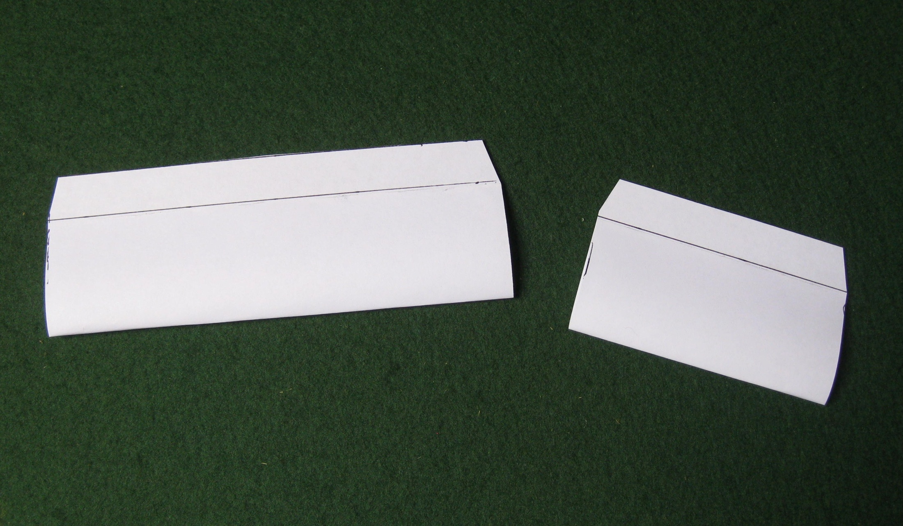

You now have two stabiliser sections. Trim off the ends of the free flaps at an angle to give them a nicer appearance. The short one is the one we need now.
Put the longer one aside, it will be used later to make the canard aircraft.
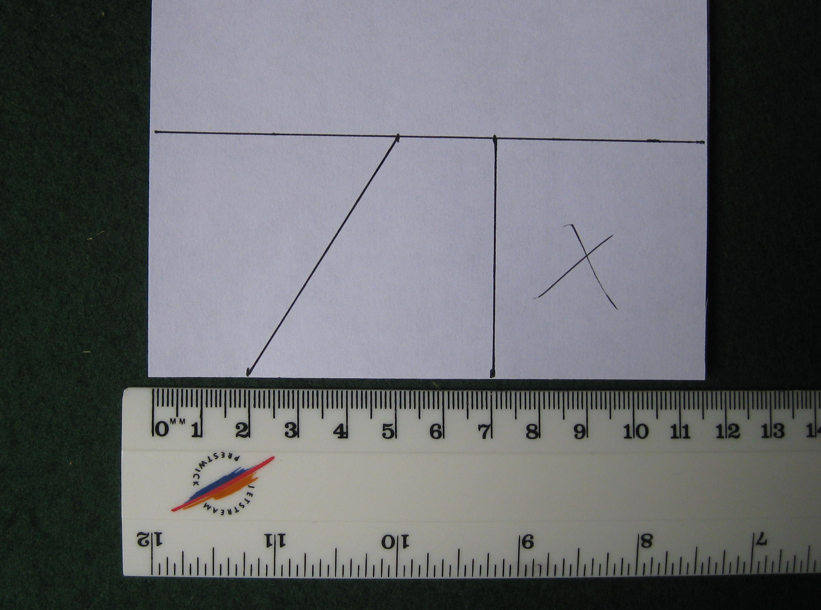
To make two vertical stabilisers, mark out the shapes on a scrap piece of paper. They are 5cm tall and 5cm long at the bottom and 2cm long at the top.

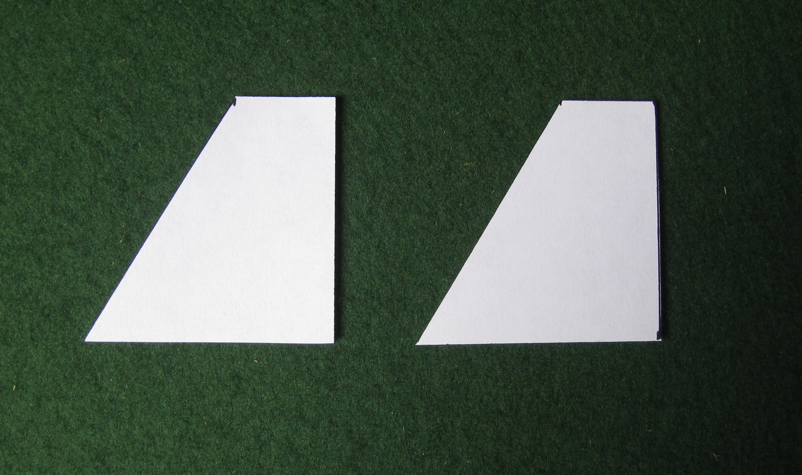
Cut out the shapes and then round off the corners to improve the appearance.
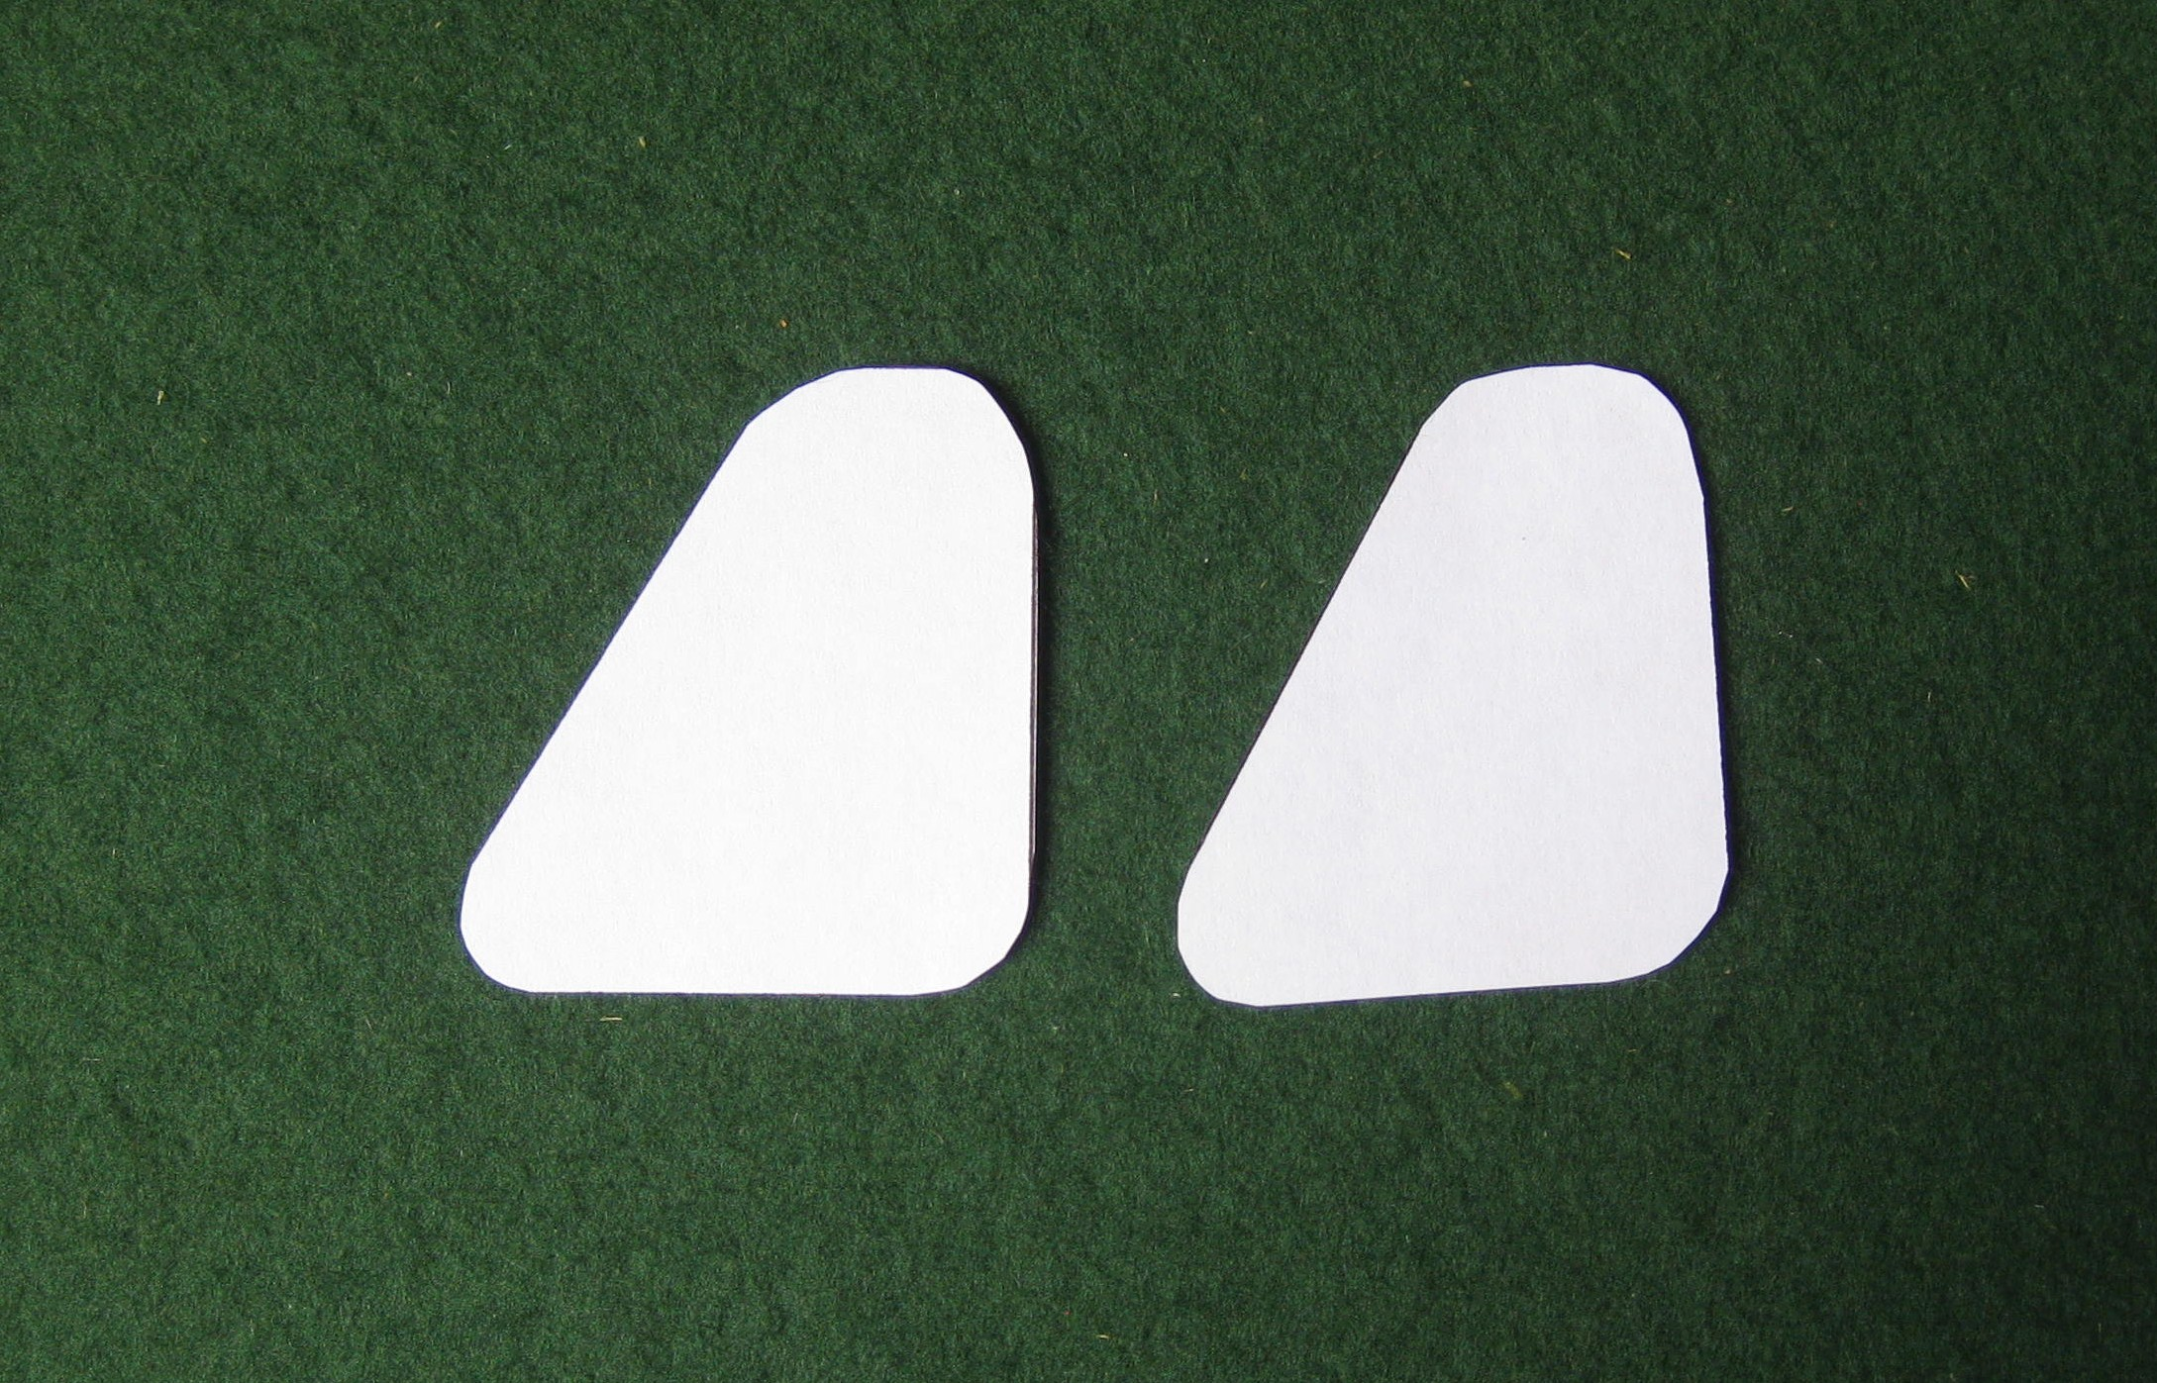
The vertical stabilisers should now look like this.

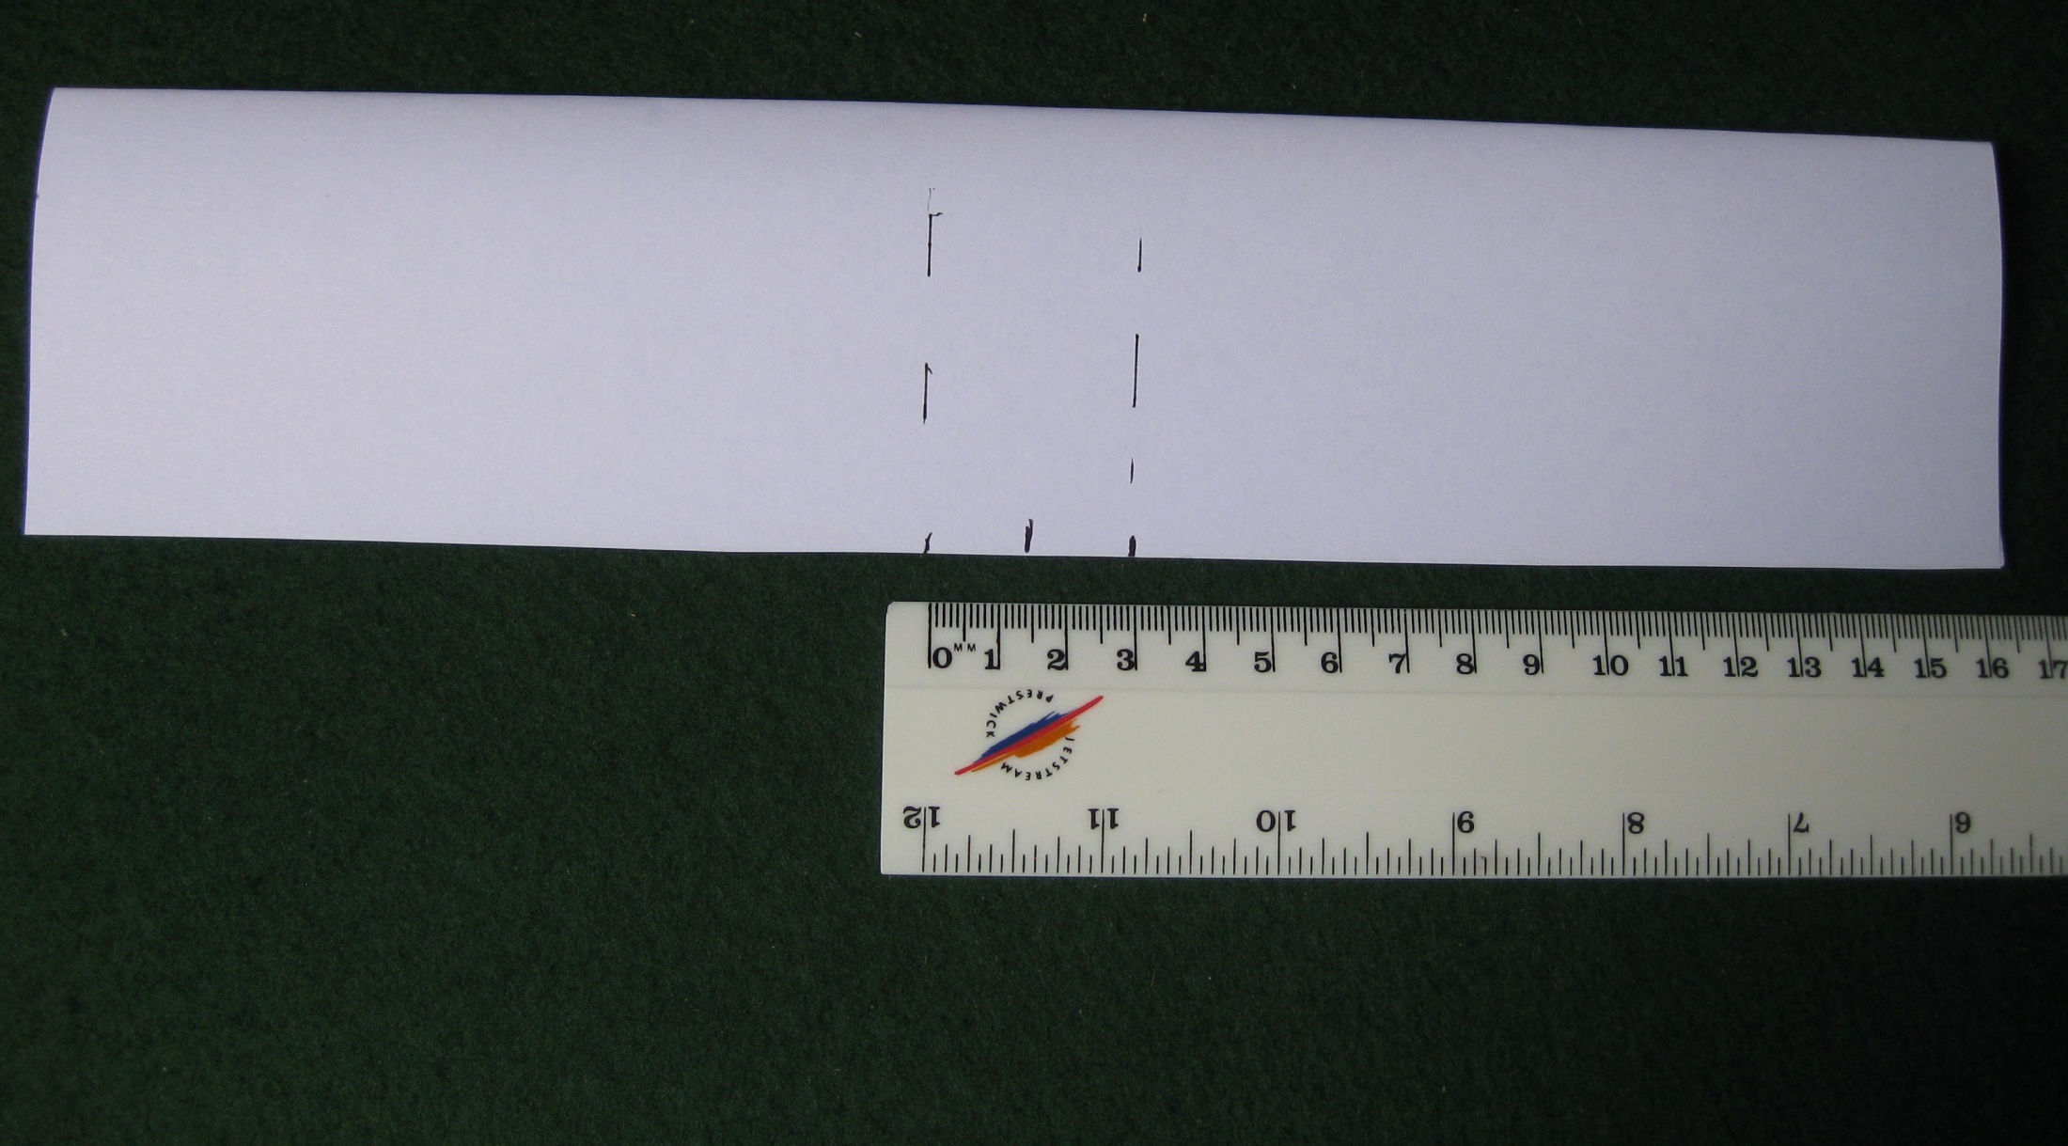
To assemble the aircraft first turn the wing upside down. Mark the centre of the wing and then two other marks 15mm either side of the centreline.
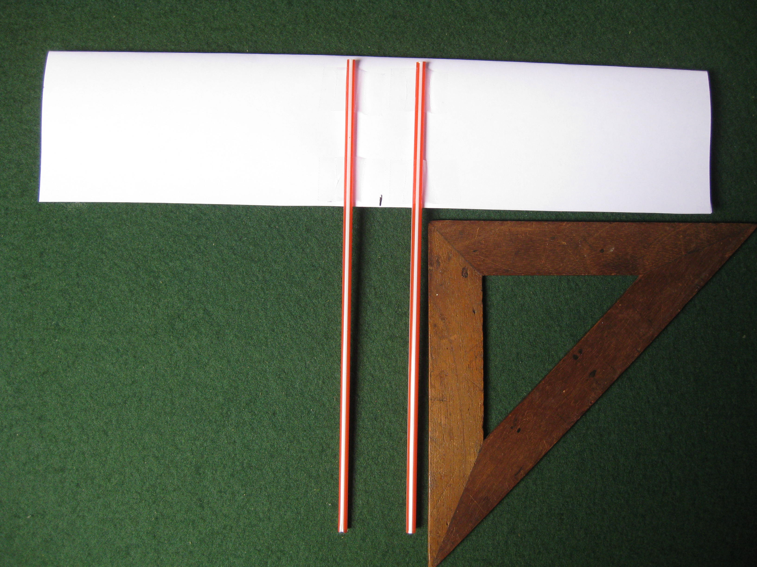
Using small pieces of adhesive tape, attach two straws to the underside of the wing 3cm apart. Use a set square to make sure that the straws are fitted at right angles to the wing.

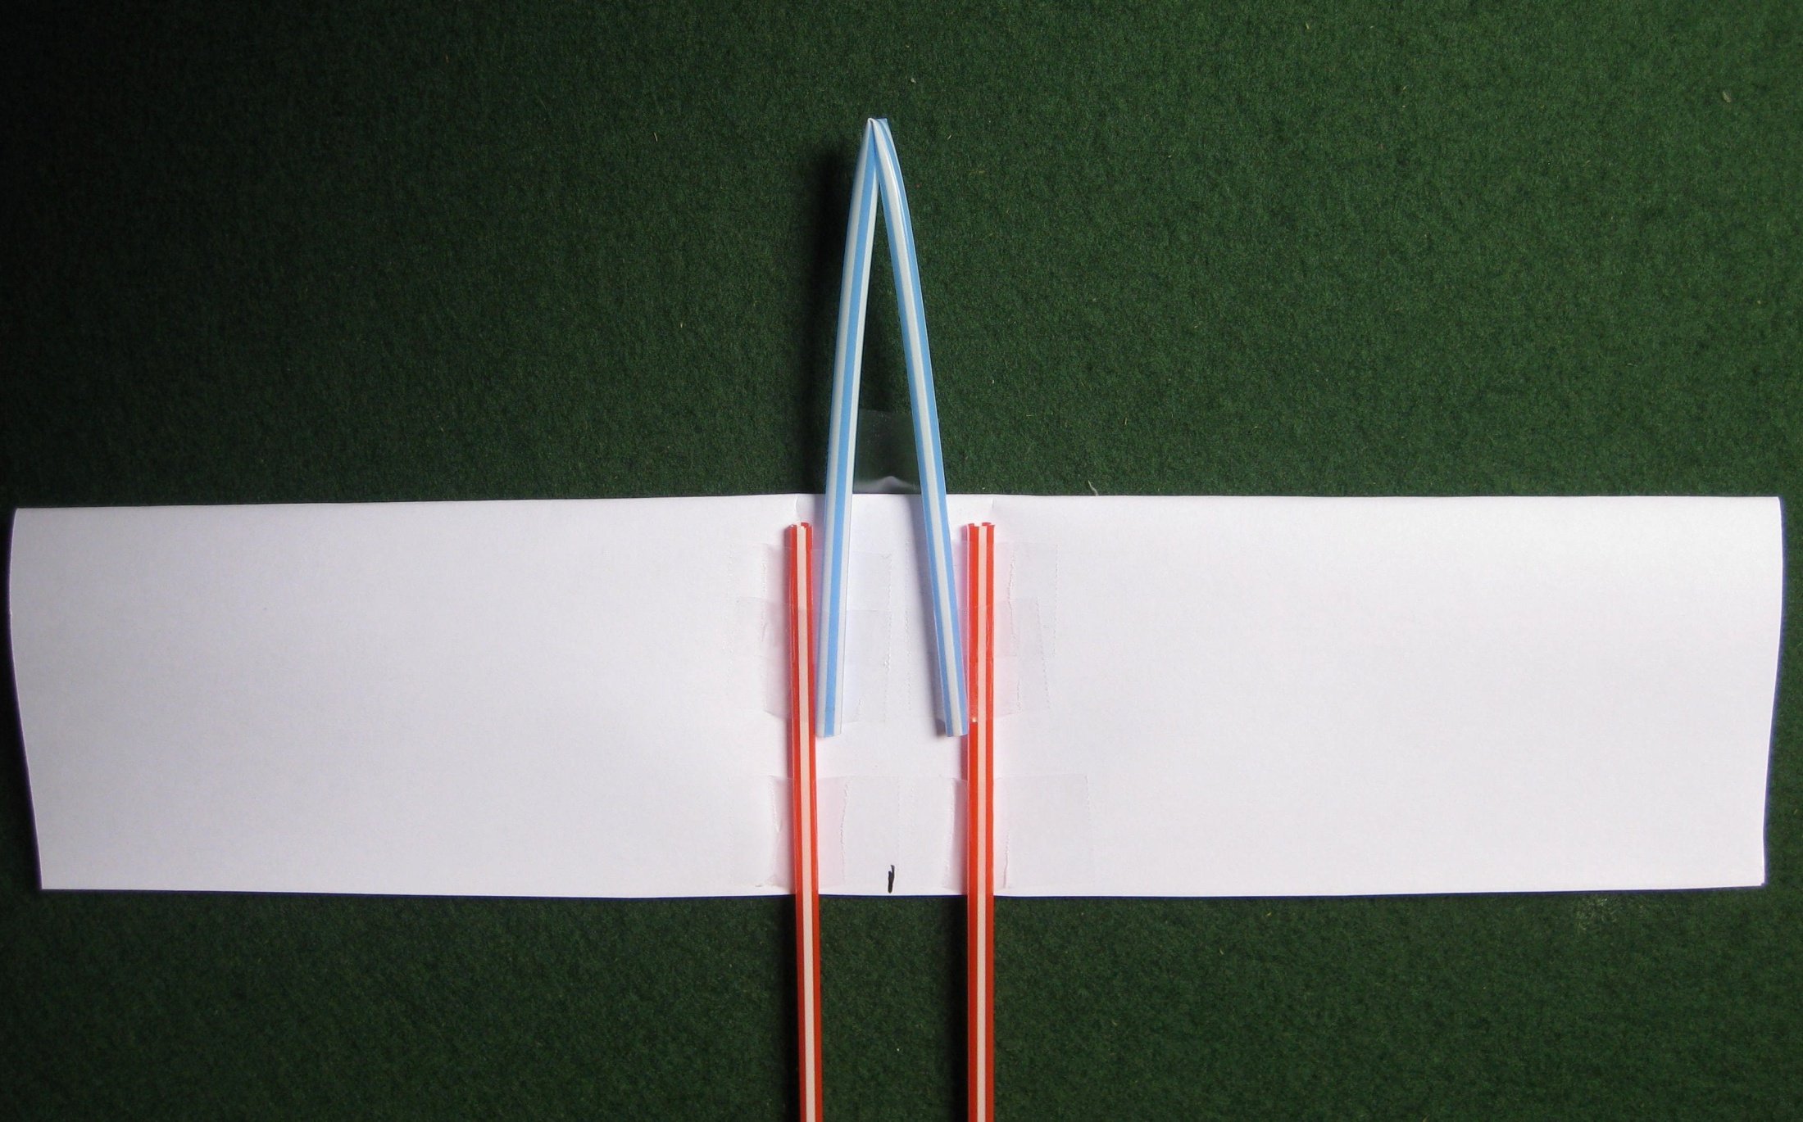
Bend another straw exactly in half and tape it to the first two straws in the position shown. Try to not crush the wing section when doing this, it will help if you slide a pencil back inside the wing while you tape the straws to the wing.
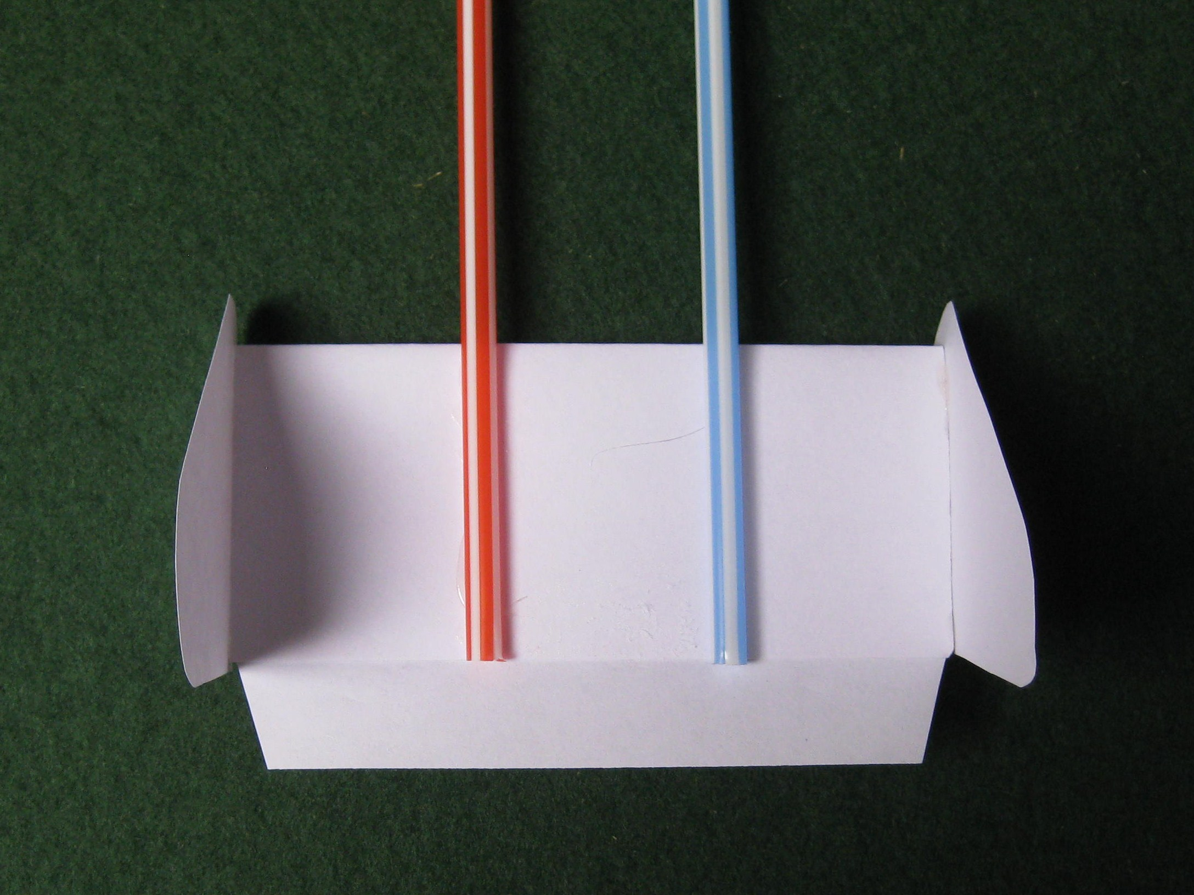
Turn the wing back up the right way and then using small pieces of adhesive tape, attach the tail unit to the straws. Note that the wing is attached to the top of the straws but the tail unit is attached to the underside of the straws.

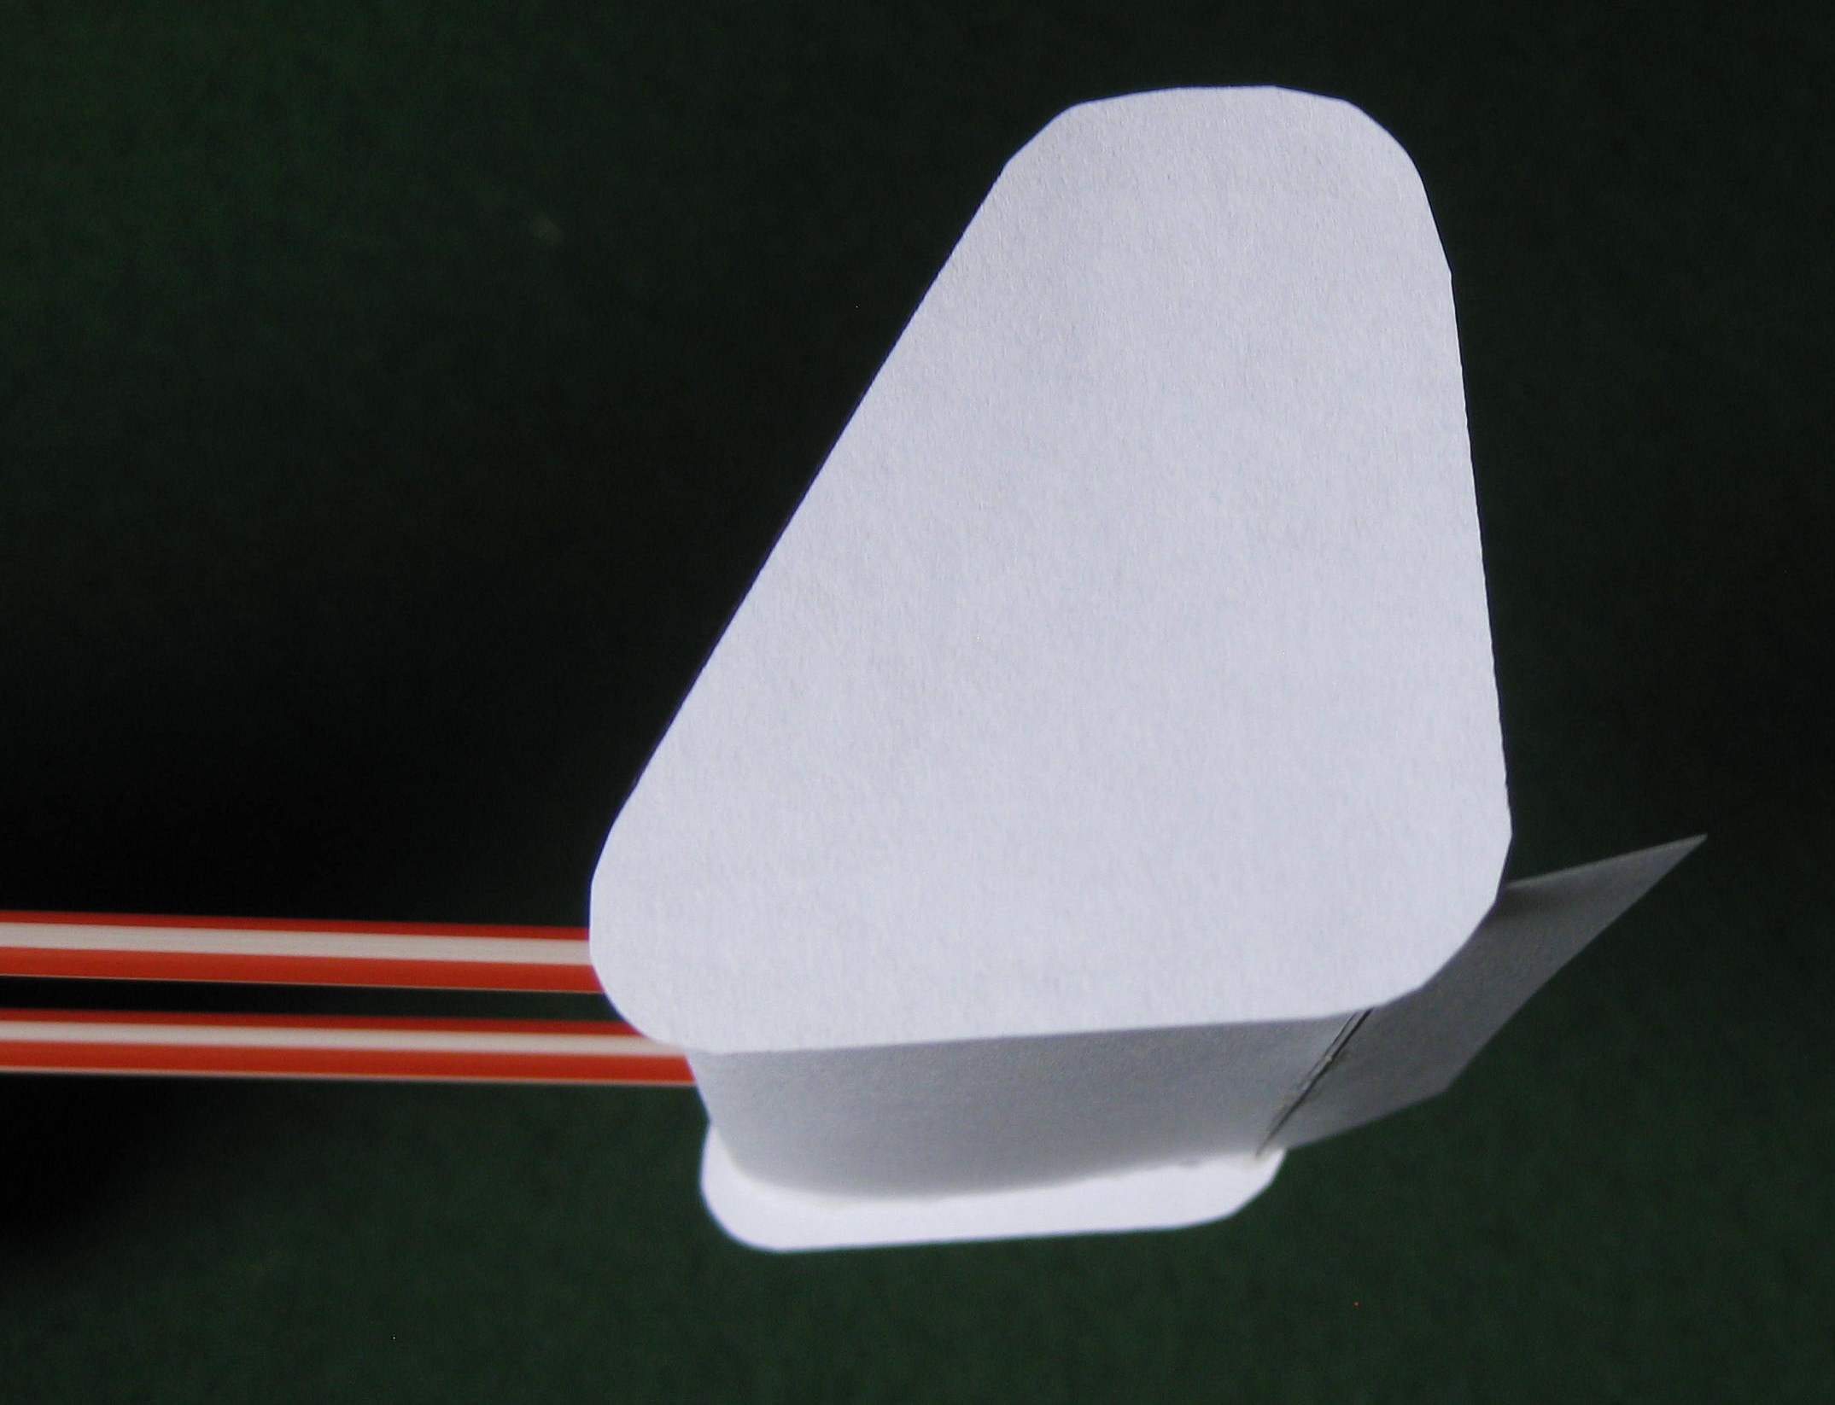
To fix the vertical stabilisers [fins] in position, smear some glue on the ends of the horizontal stabiliser and hold the fins in position until the glue sets. It is important to make sure that the horizontal stabiliser is upside down when you fit the fins. Note that some of the fin shape sticks down below the under-surface of the horizontal stabiliser. The accurate positioning of the fins is not important.
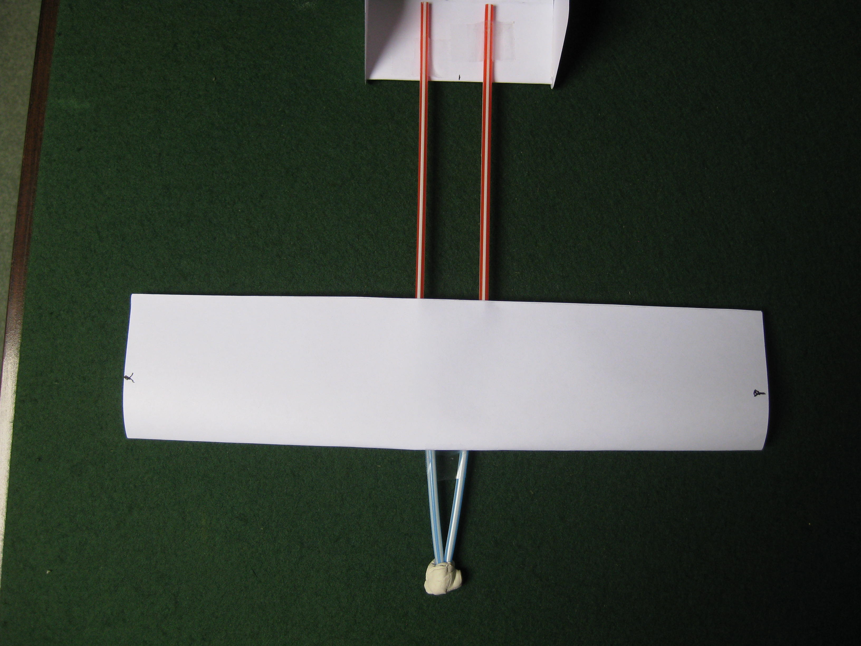
Make two small marks on the wing tips 3cm back from the leading edge. Add small pieces of modelling clay or BluTack to the nose of the front straw until the aircraft balances when lifted at the marks.

You should end up with an aircraft that looks like this.

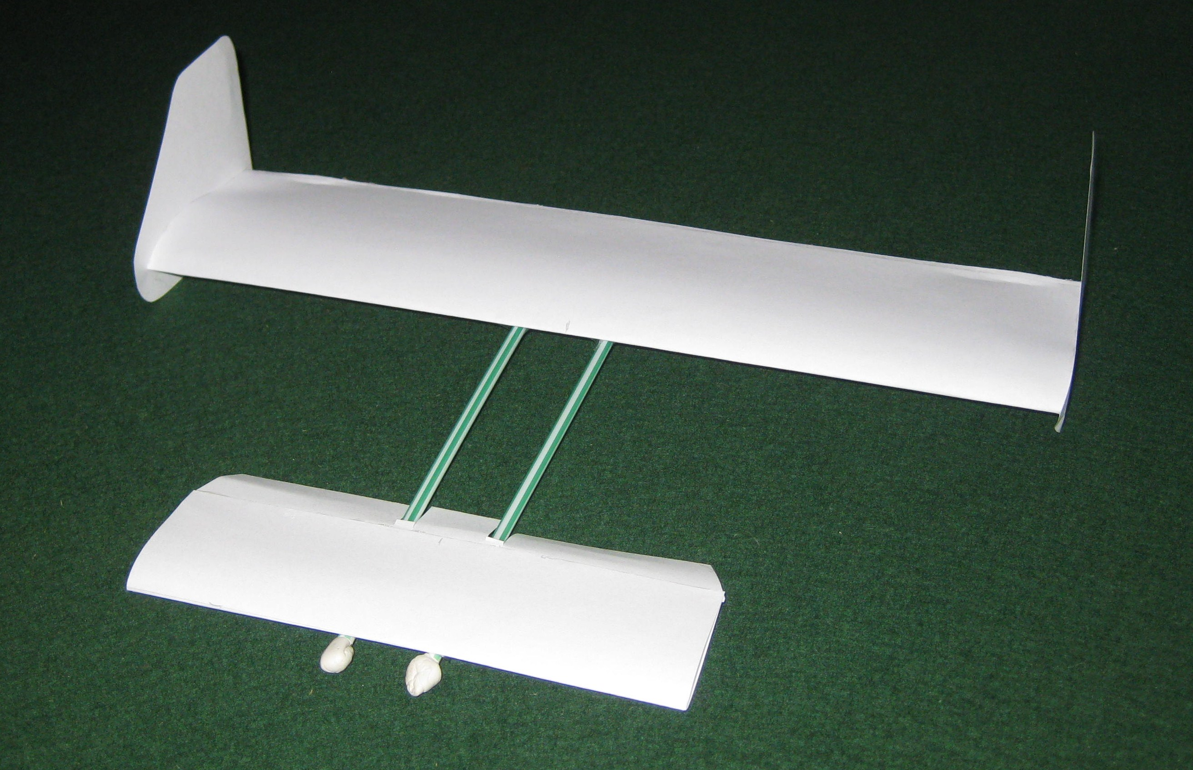

This is the second aircraft type that we will make. This one has the horizontal stabiliser at the front and it is usually called a “canard” layout.
Make another wing section exactly the same as the one for the standard aircraft.
The stabiliser is the 15cm long section that we have already made.
The assembly of the aircraft is similar to the “standard” aircraft but we will need bigger vertical stabilisers [fins].

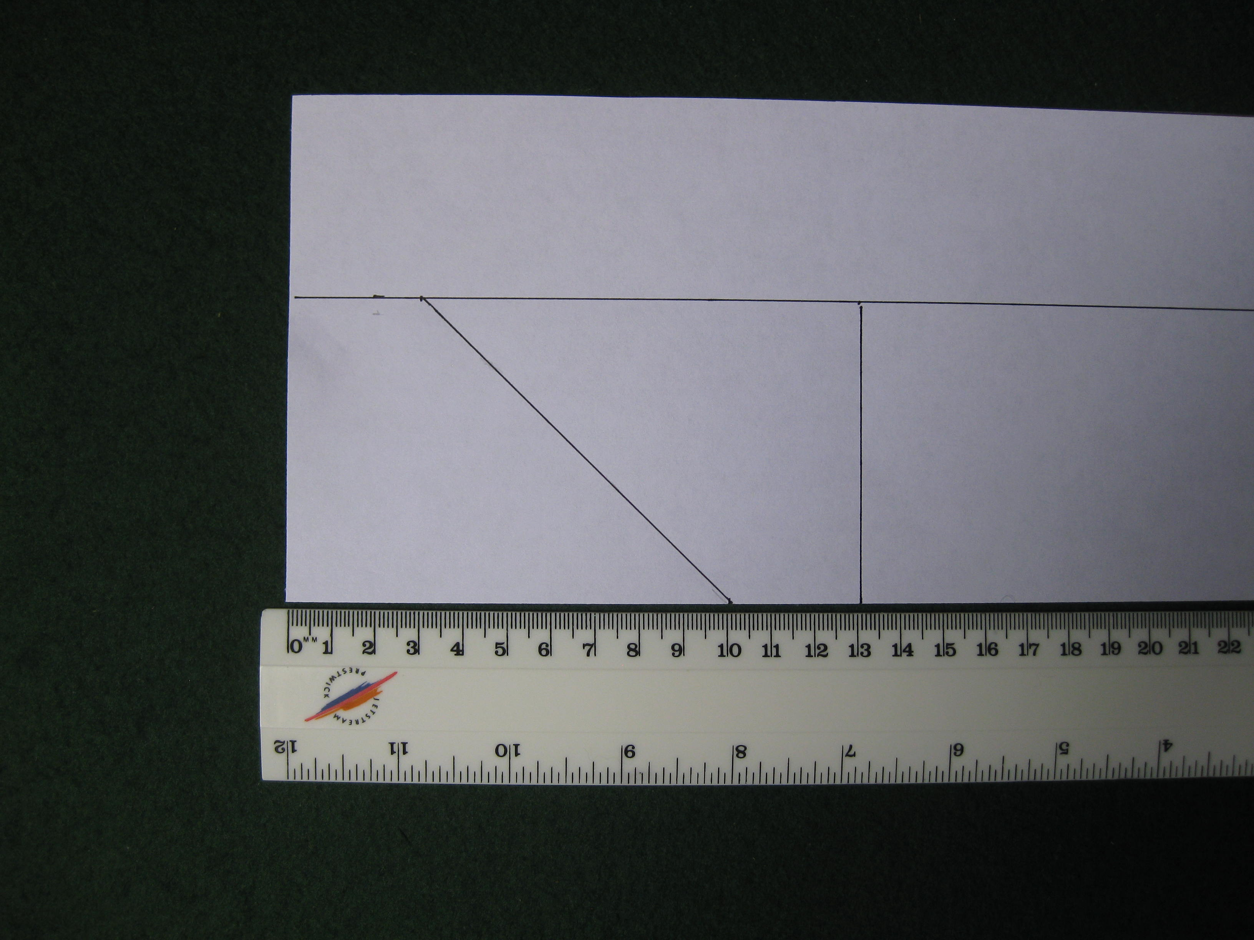
To make two vertical stabilisers, mark out the shapes on a scrap piece of paper. They are 7cm tall and 10cm long at the bottom and 3cm long at the top.

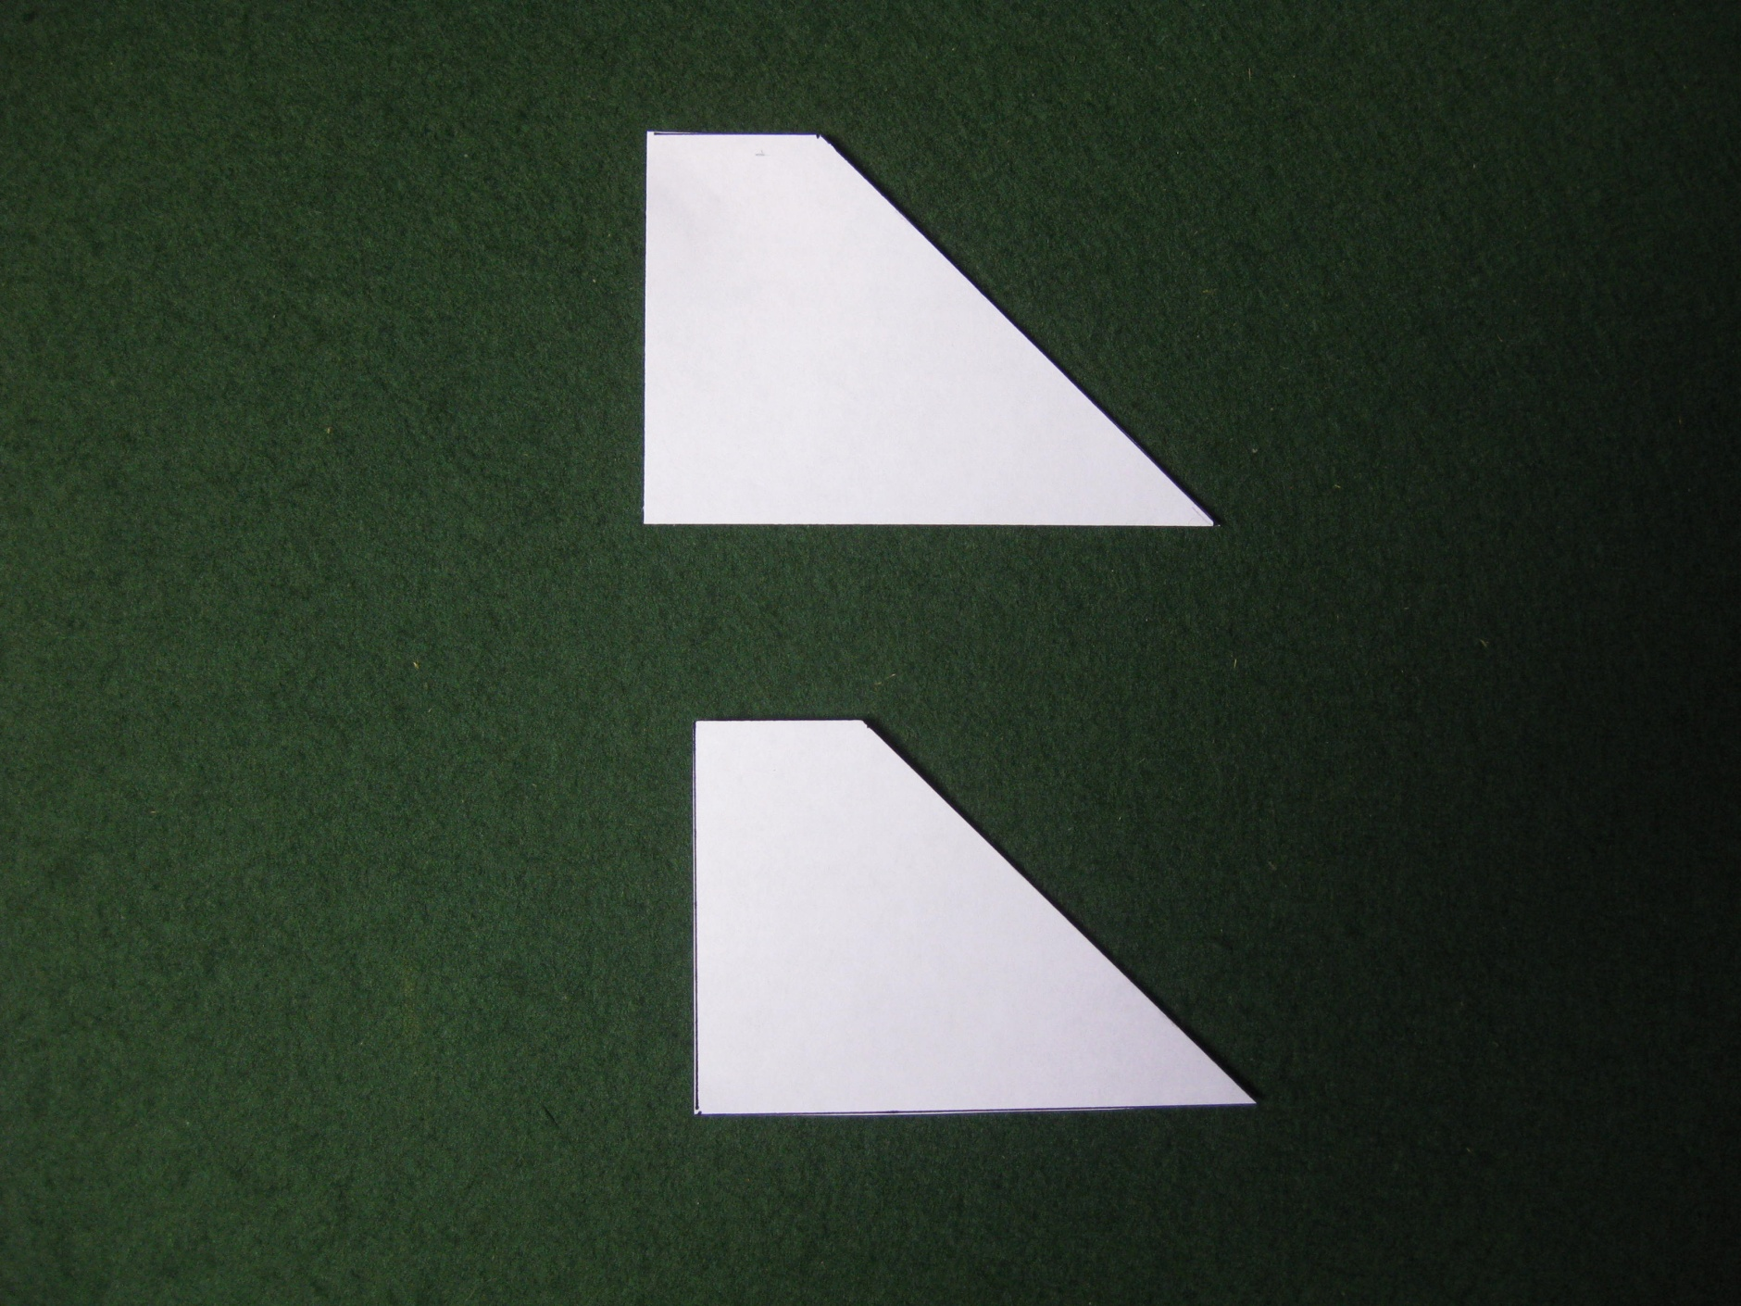
Cut out the shapes and they should look like this.

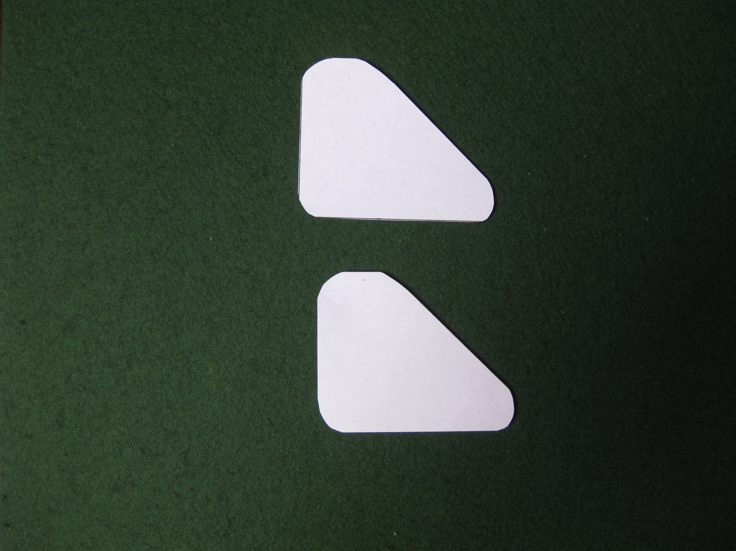
Round off all the sharp corners until they look like this.
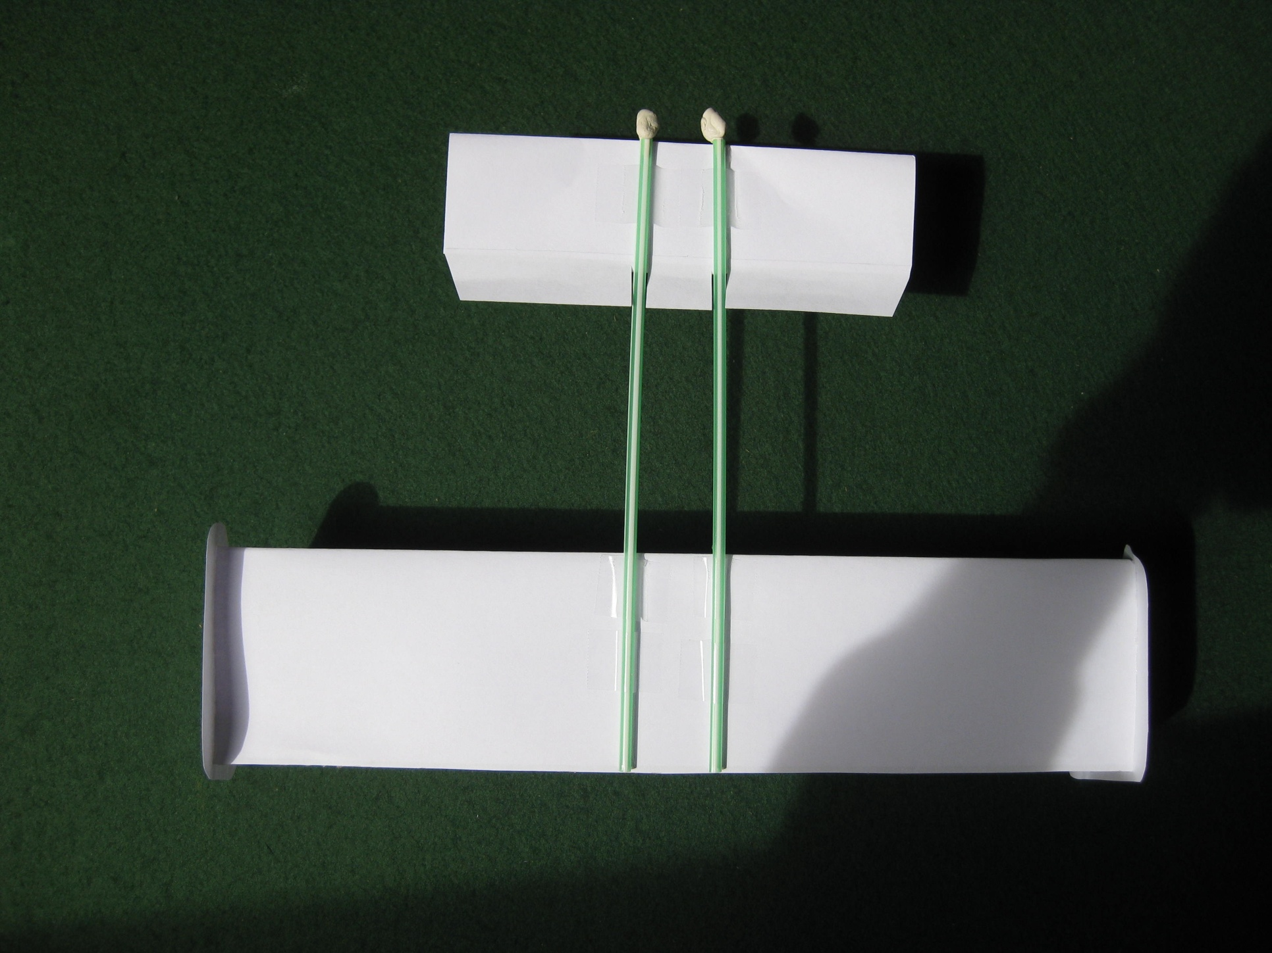
Attach two straws to the underside of the wing and horizontal stabiliser. Remember that they both point forward towards the top of the photo. The straws are 3cm apart, the same as on the “standard” aircraft.
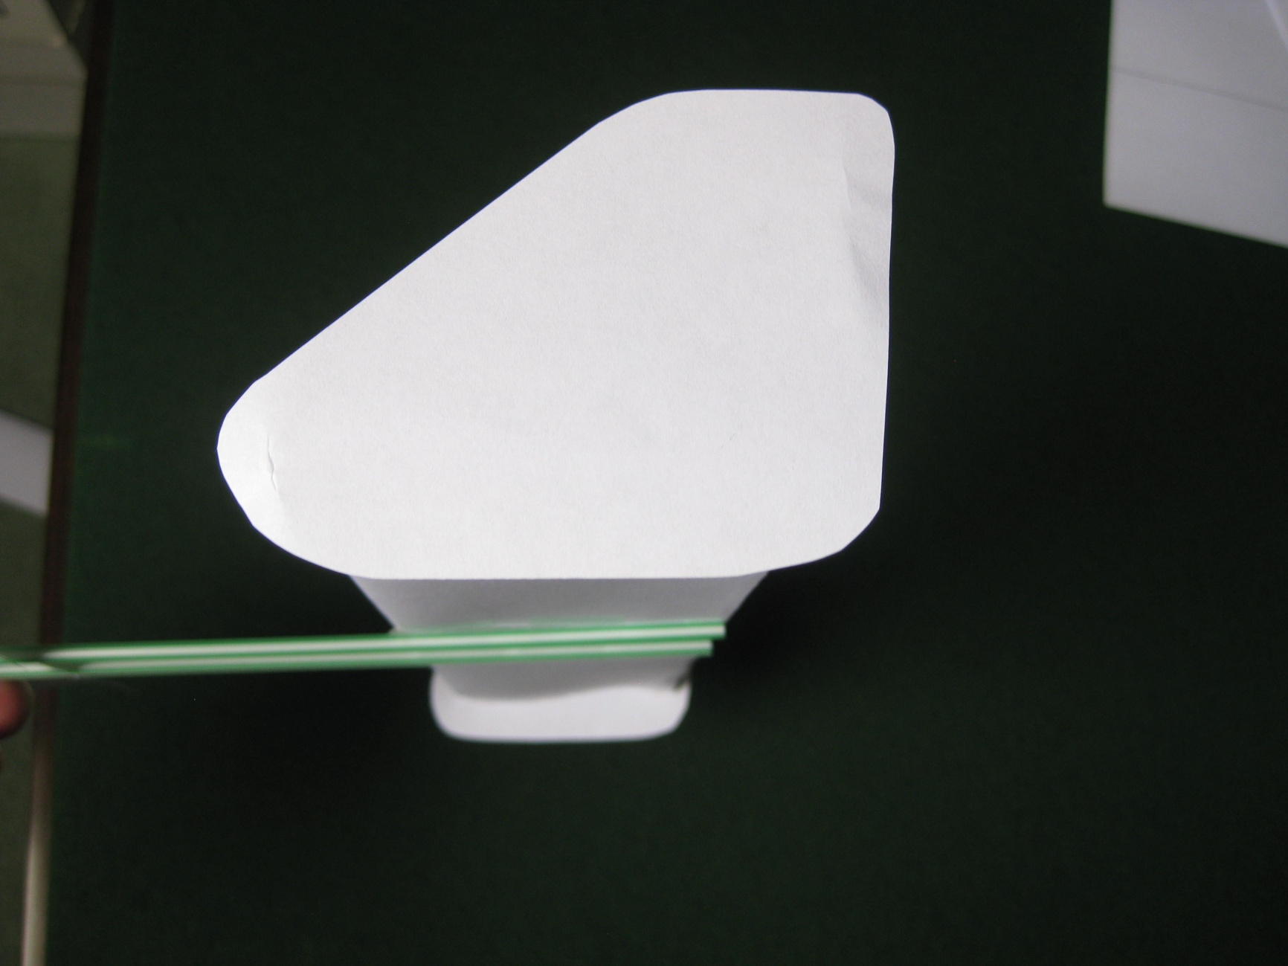
Turn the aircraft the right way up and fit the two vertical stabilisers to the tips of the wing much the same way as the fins on the stabiliser of the “standard” aircraft.
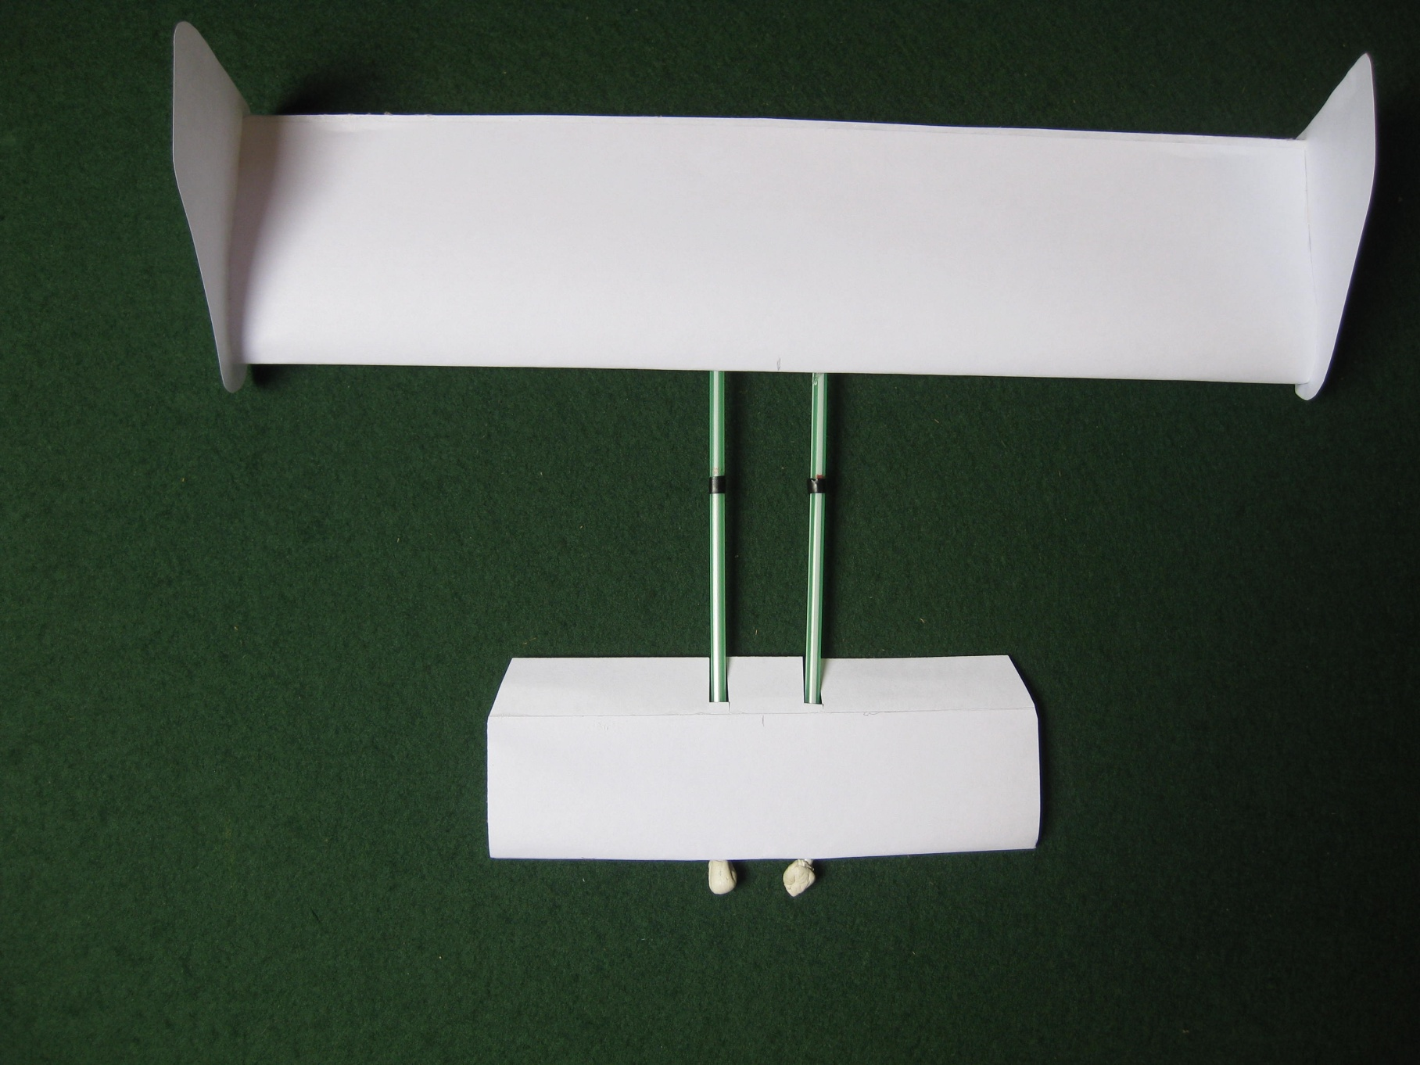
To balance the aircraft, add two black marks on the straws 3cm ahead of the wing. Add small pieces of modelling clay or BluTack to the front of the straws until the aircraft balances at these black marks.

Snip away small sections of the forward flap either side of the straws so that the flap can bend down. The finished aircraft should now look like this.

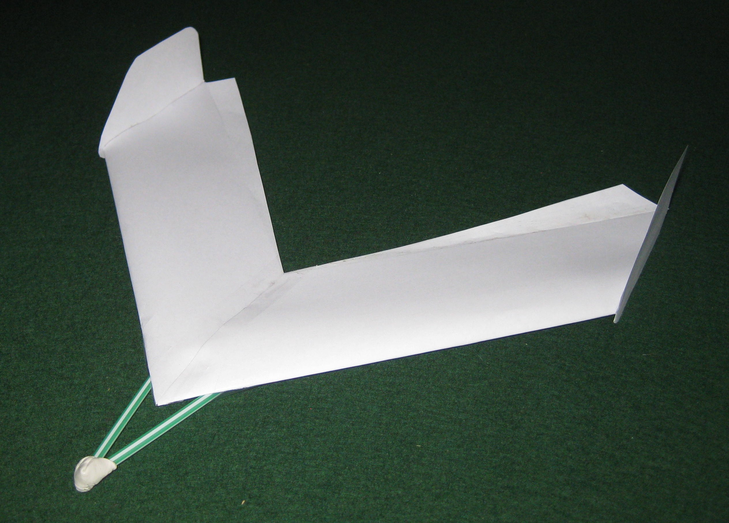

Now we can build the “tailless” aircraft. As we have seen this type of aircraft were called tailless because they did not have a separate horizontal stabilising surface. But of course, as we now know, it does have a stabilising surface built into its wing.

We need to make two more wing sections but this time do not cut off the spare paper at the rear of the wing section.

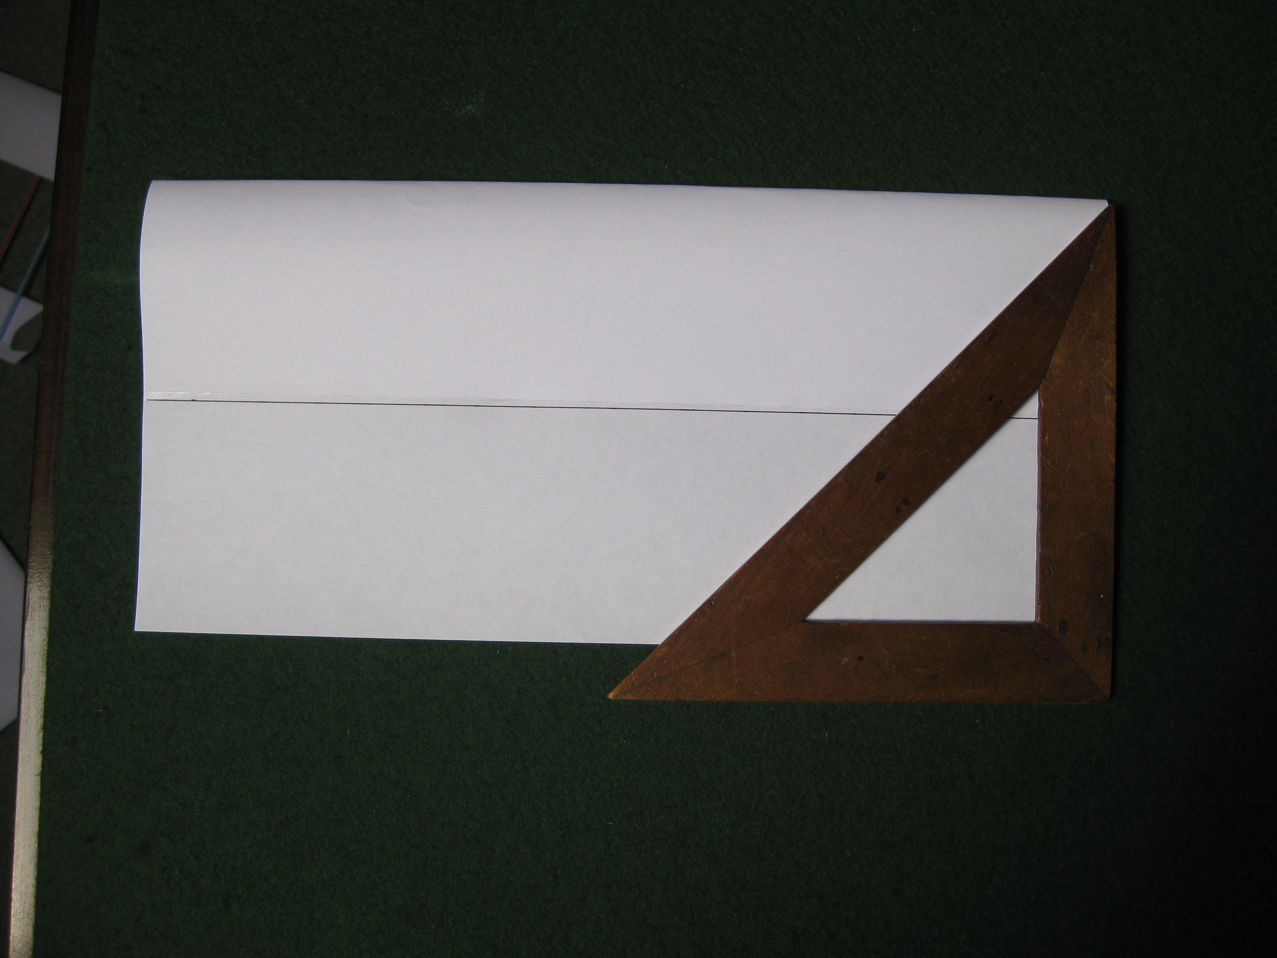

Lay a 45º set square gently onto one of the wing sections as shown and draw a line across the section from the top corner to the trailing edge.

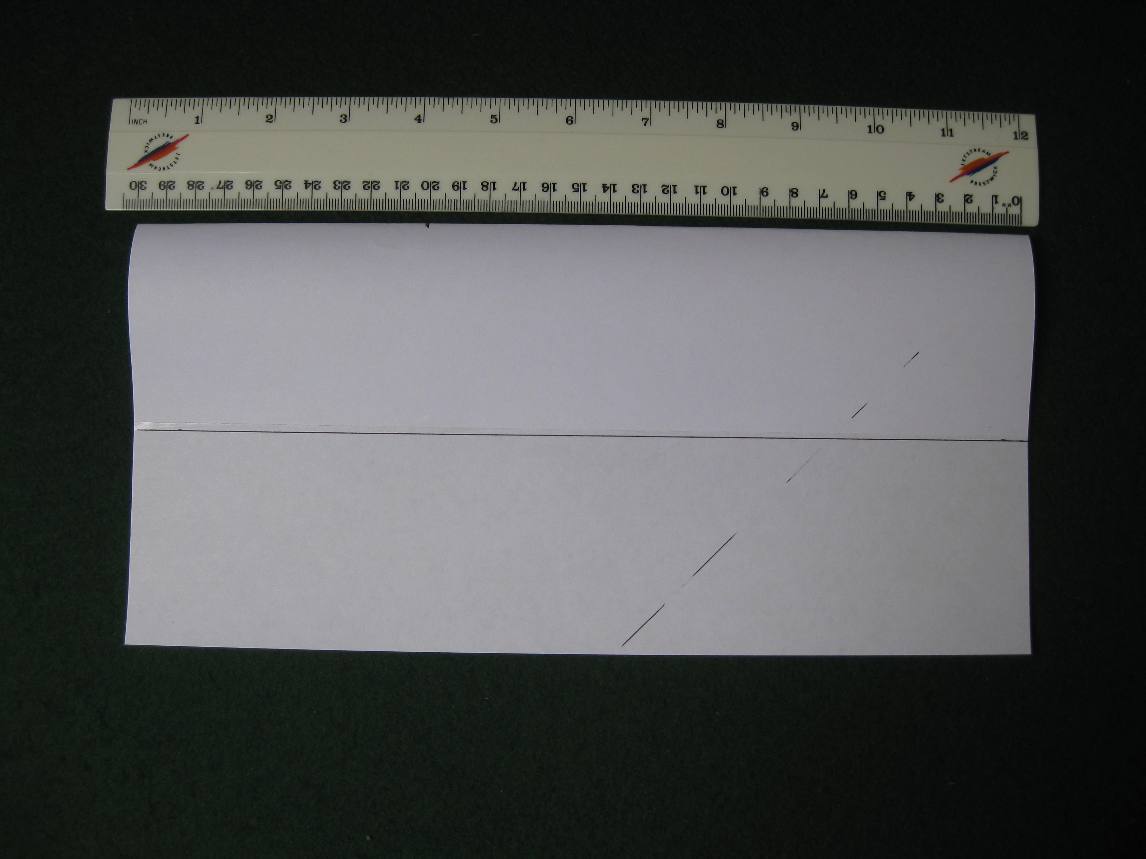
Measure 20cm along the section, make a mark and again lay the setsquare on the section to draw another line parallel to the first one

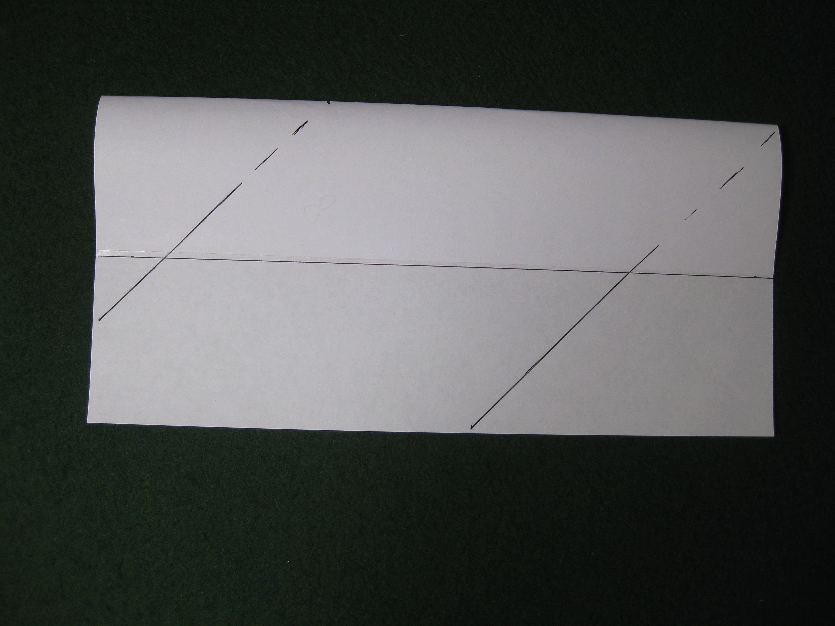
You should now have two lines across the section like this.
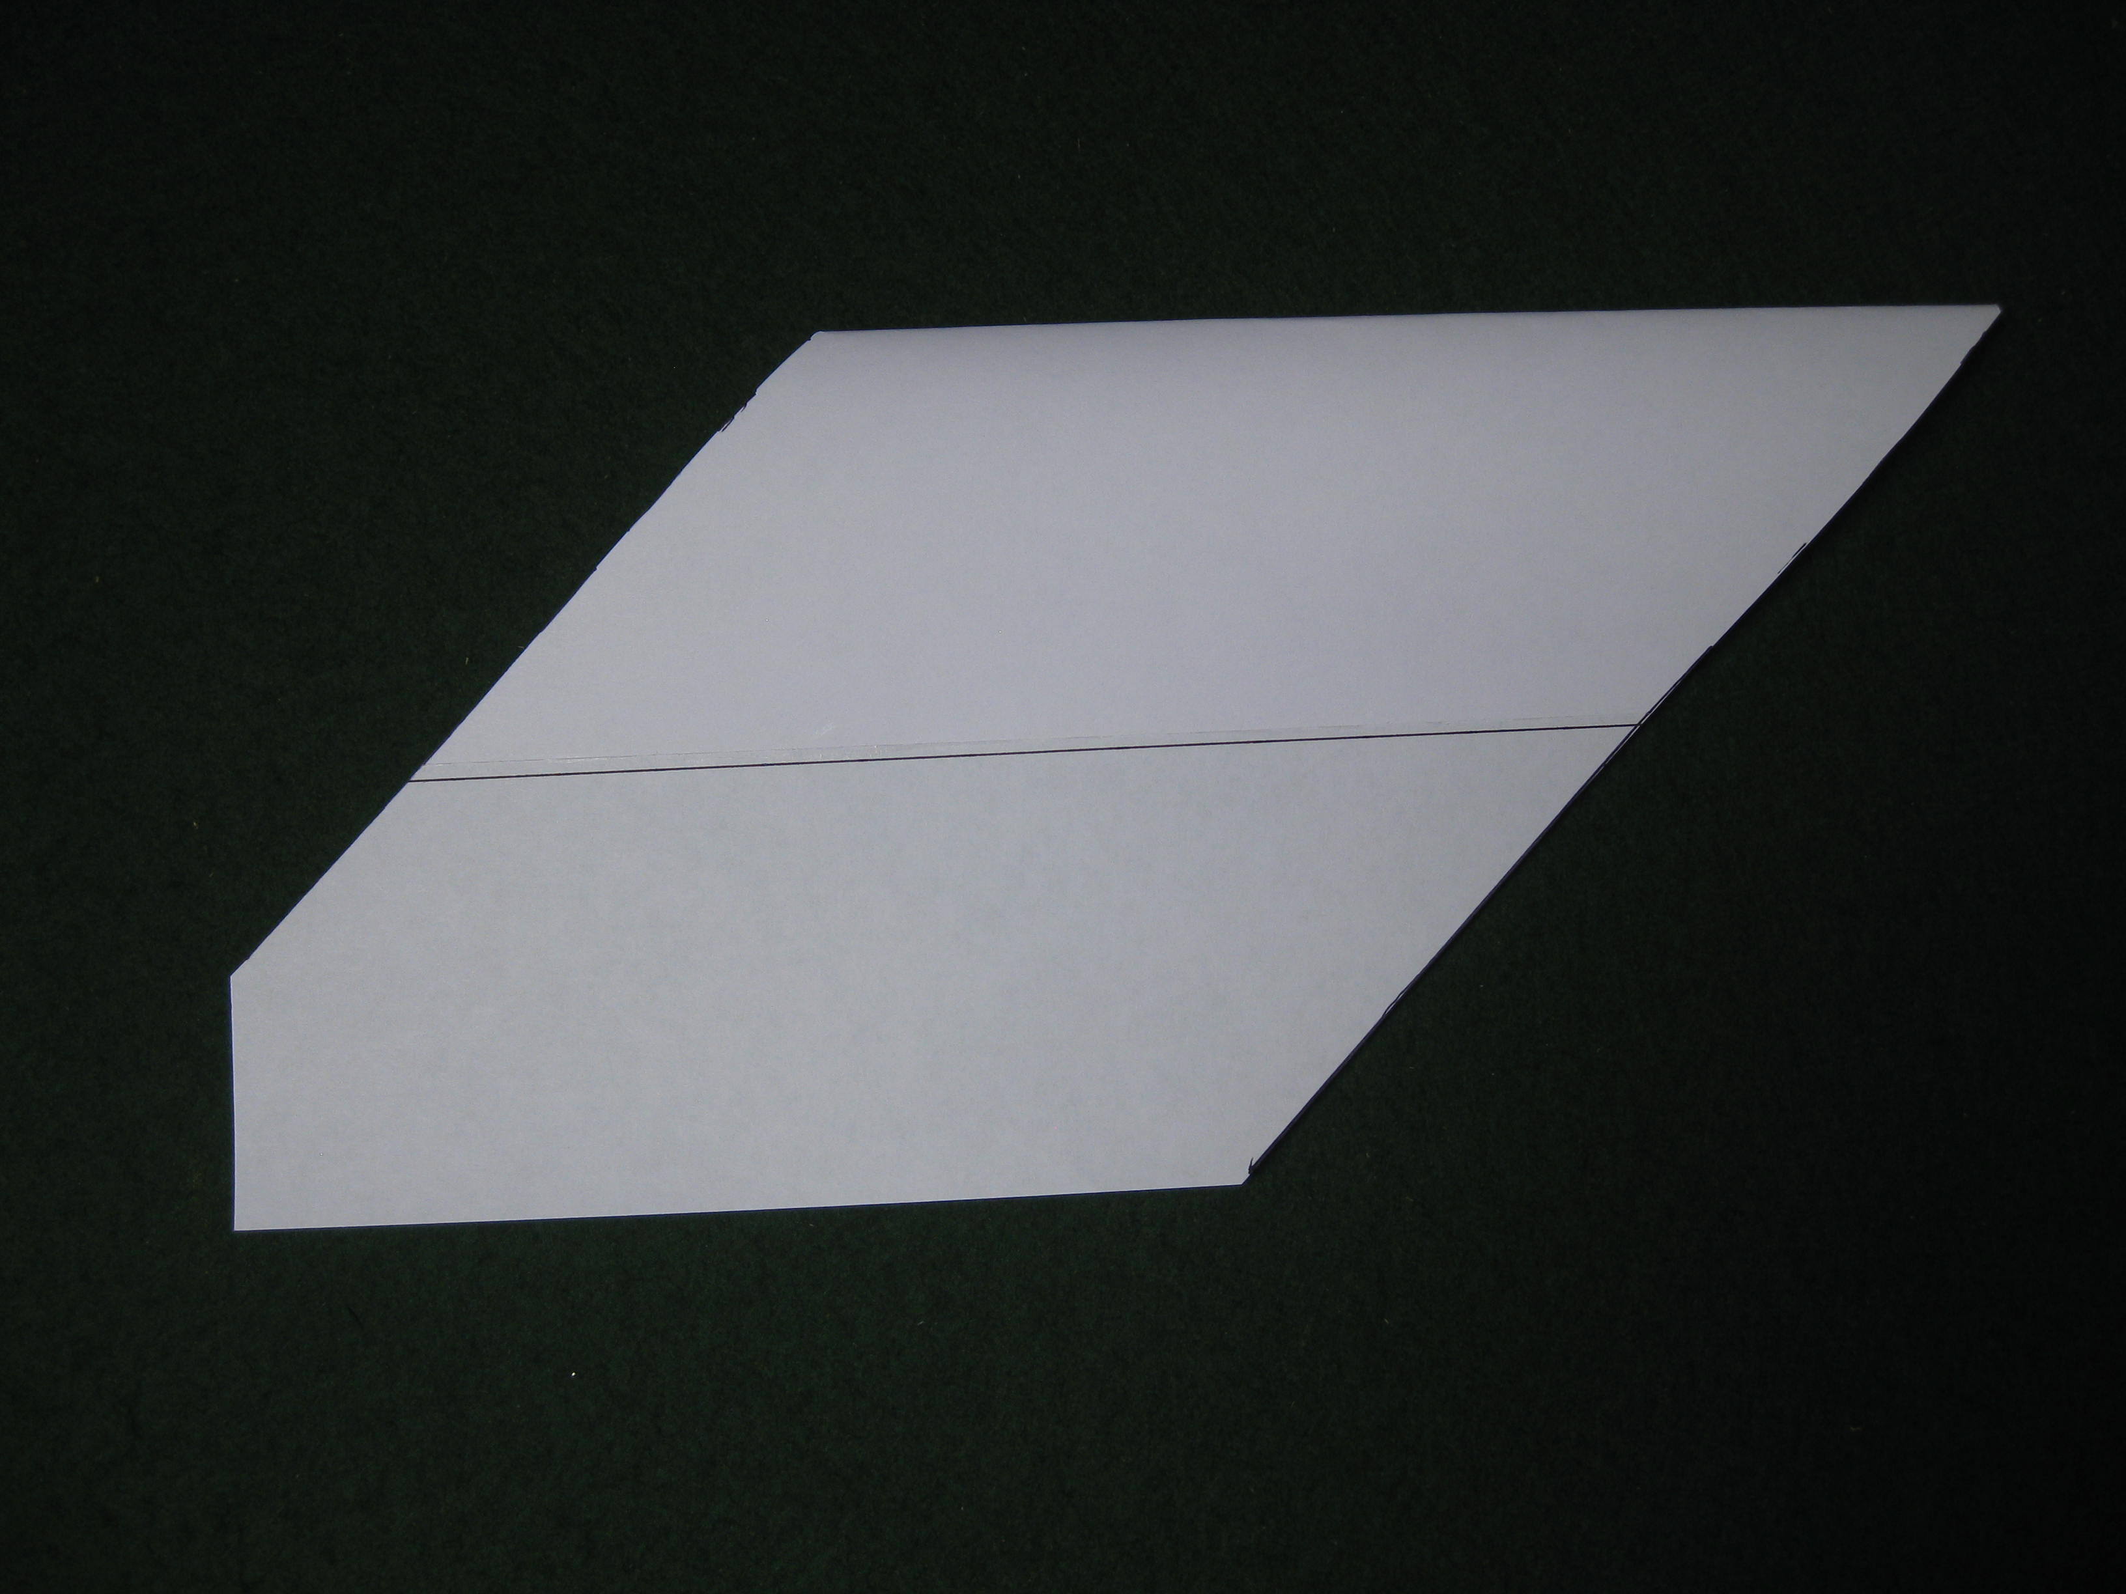
Using large scissors, cut along the lines to make a shape like this. Do not worry if the section crushes when you cut it, it will either bounce back to its shape or you can gently ease it back to its shape.

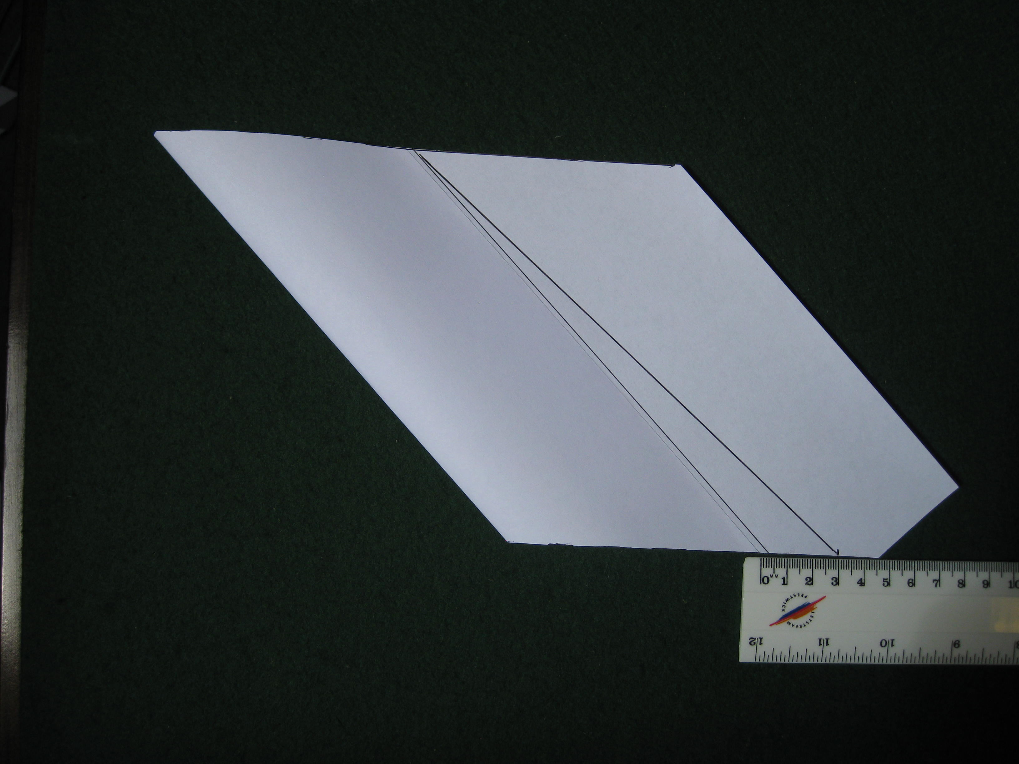
Now draw another line on the spare piece of paper at the back of the wing section. Measure 3cm along the edge shown and then draw a line that goes to the rear of the section at the other end.
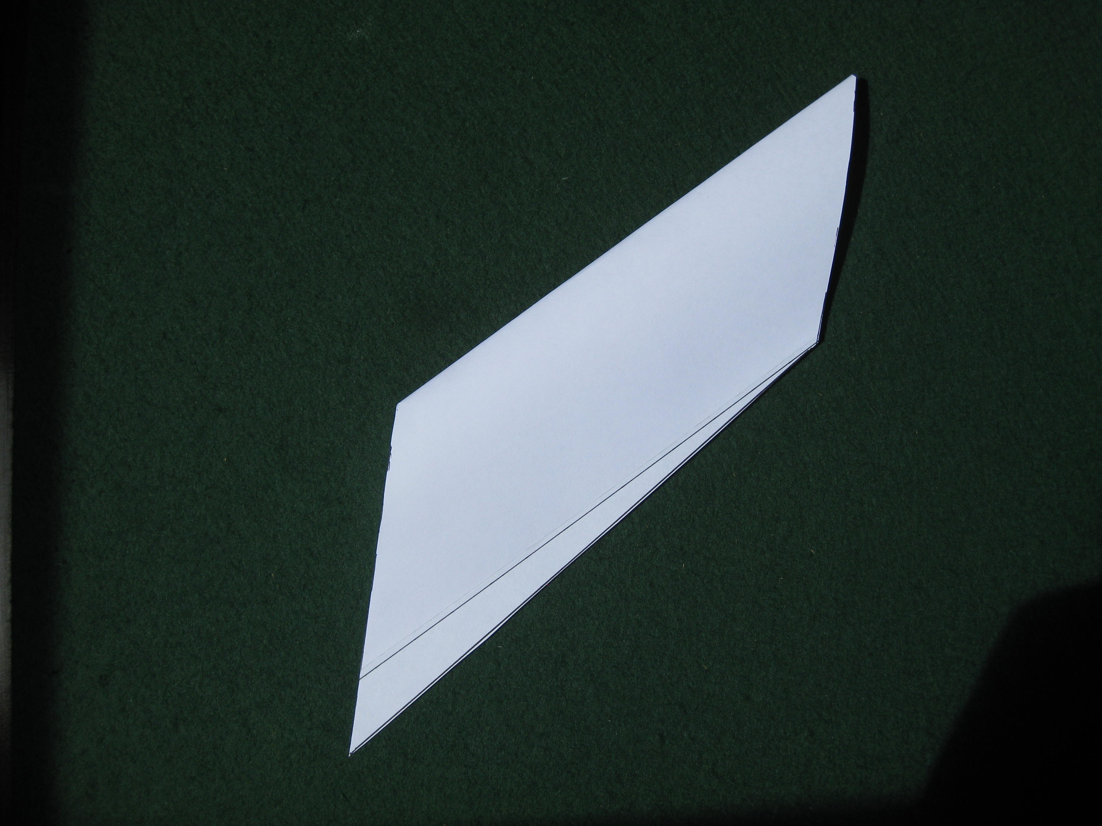
Cut off the spare piece of paper along this line.

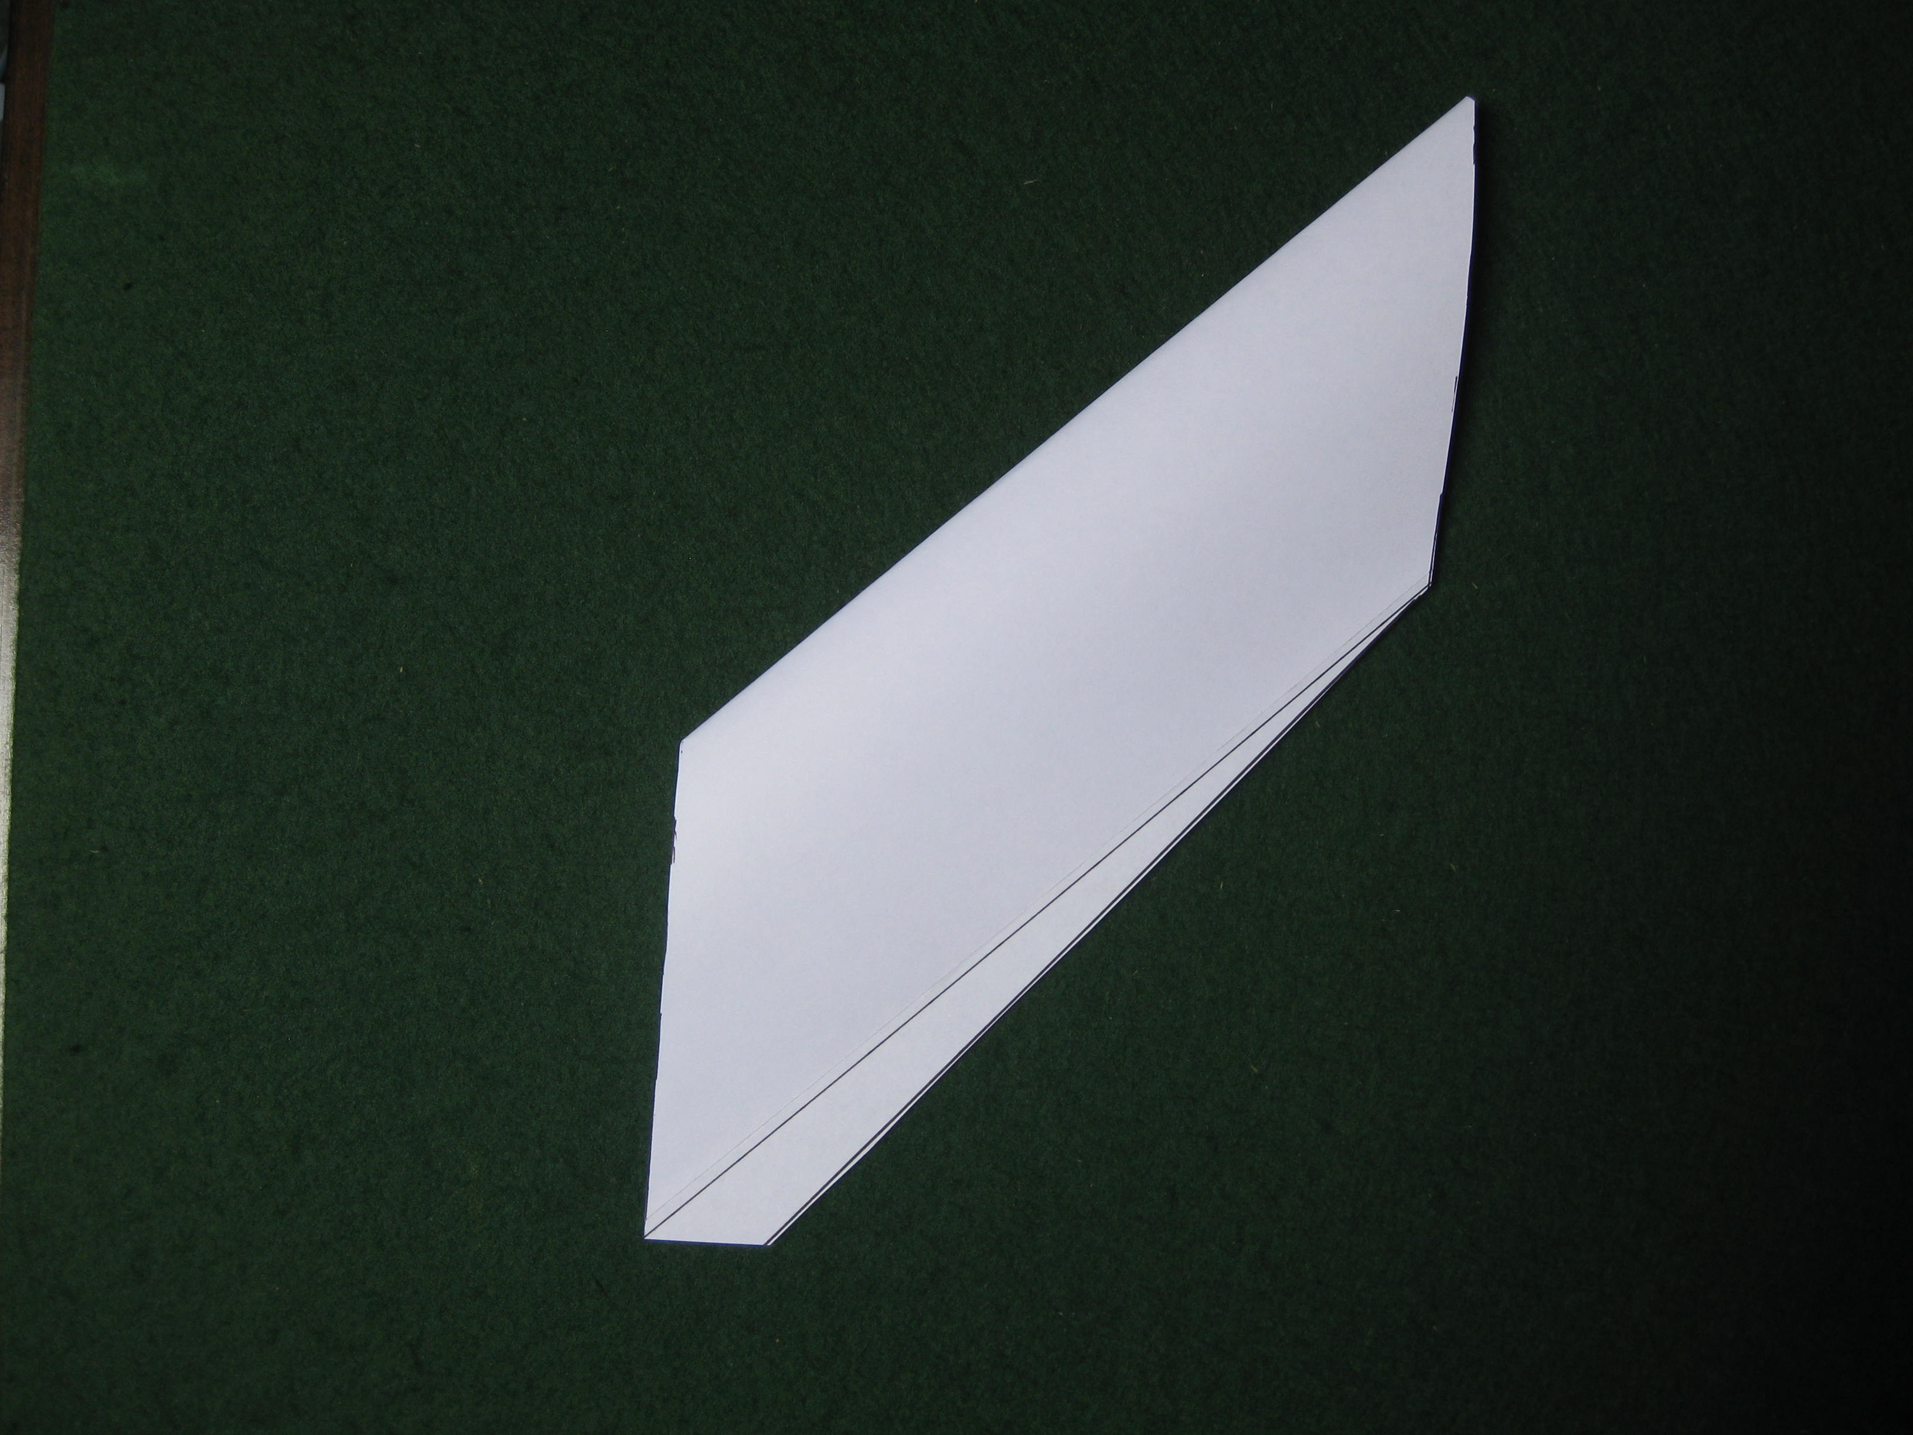
Snip off the point at the bottom as shown. You have now made the left wing. Make the right wing in the same way but this time all the lines will slope in the other direction.
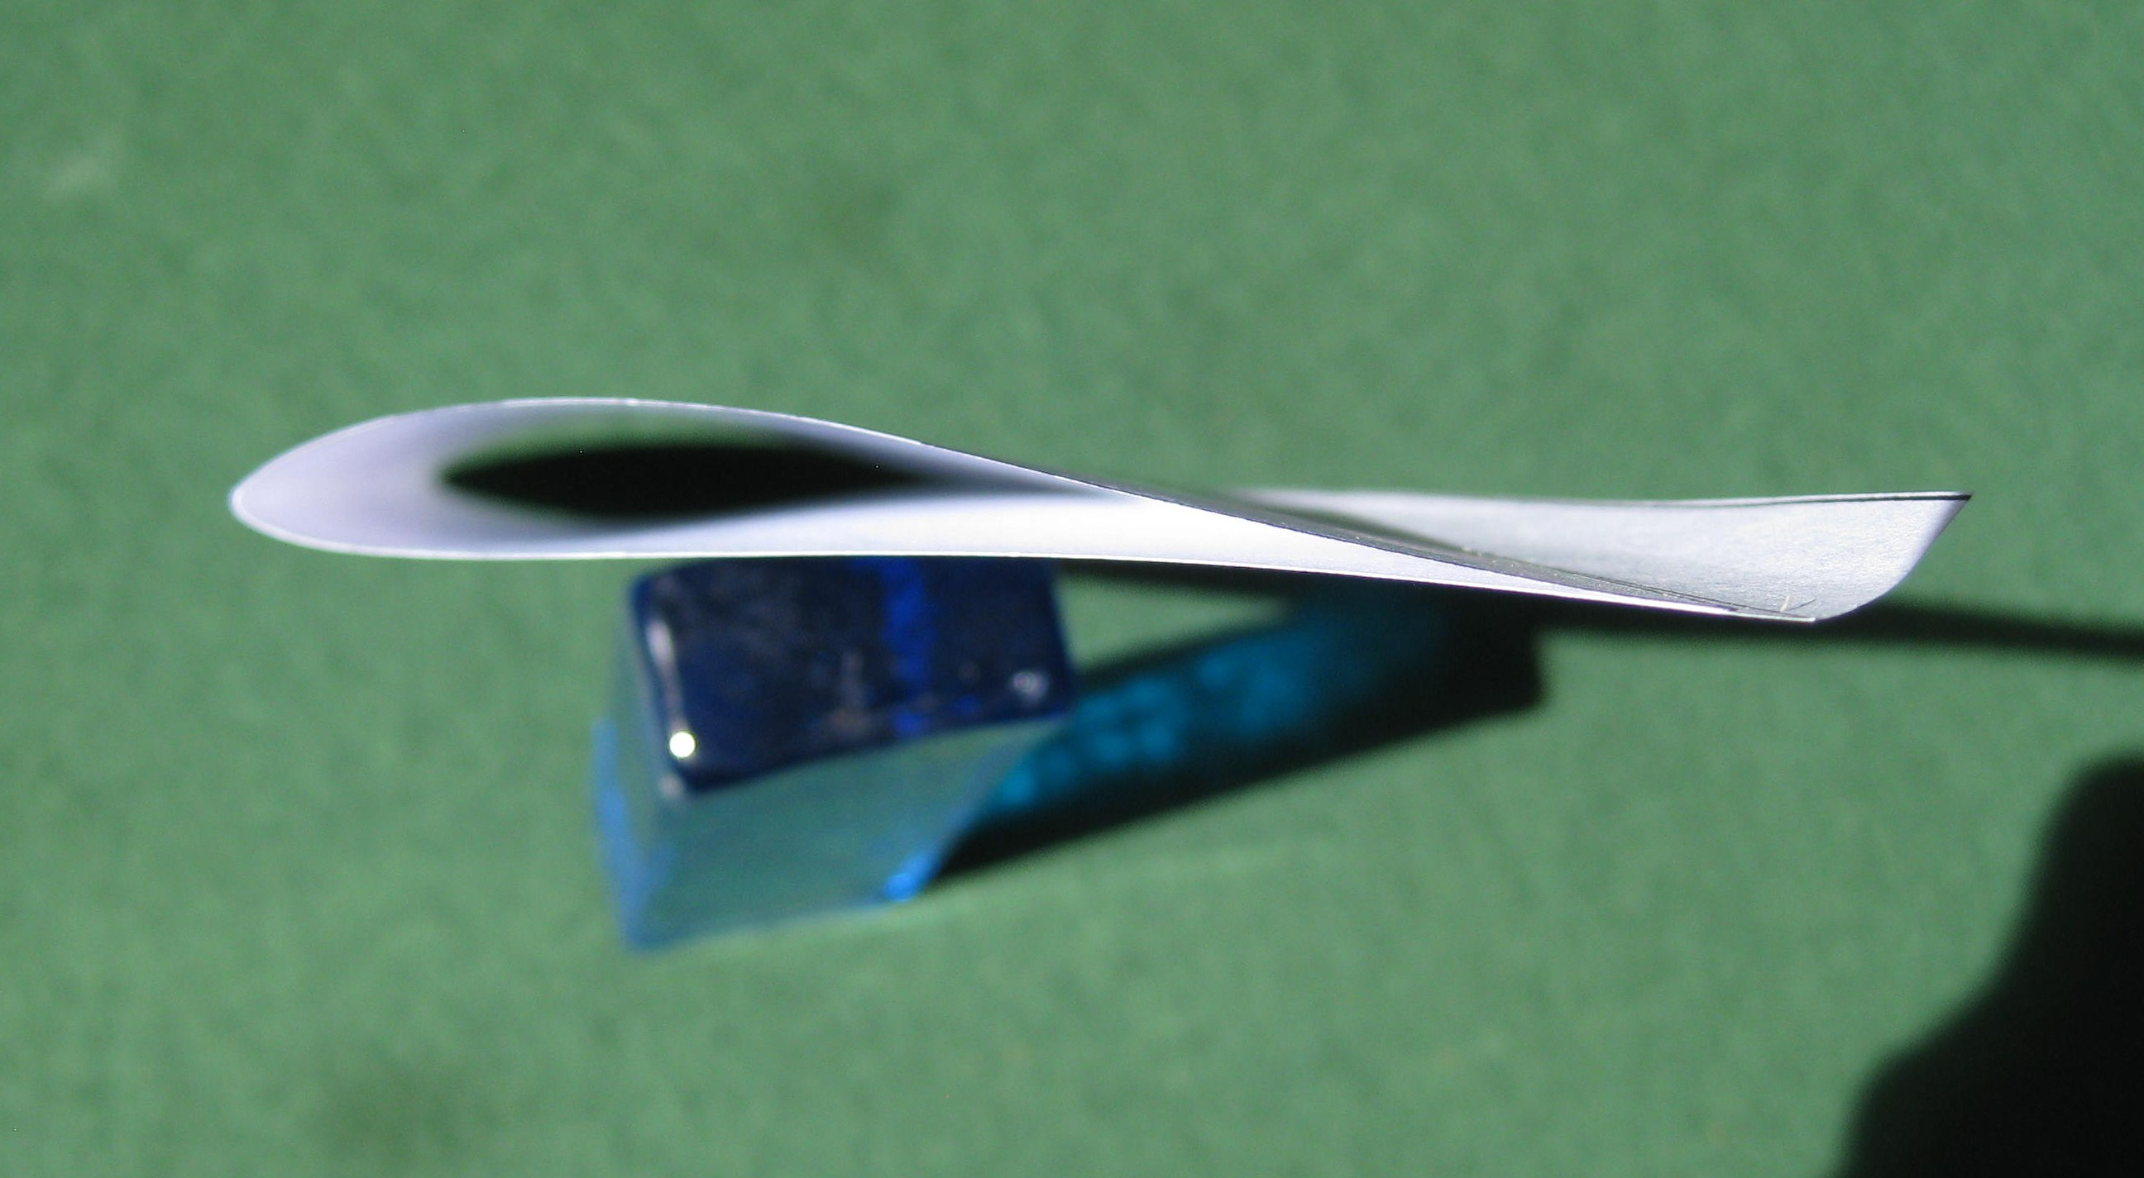
Curl up the flap at the rear of the wing so that you get a section that looks like this. This curled up section will act as the horizontal stabiliser for the wing.
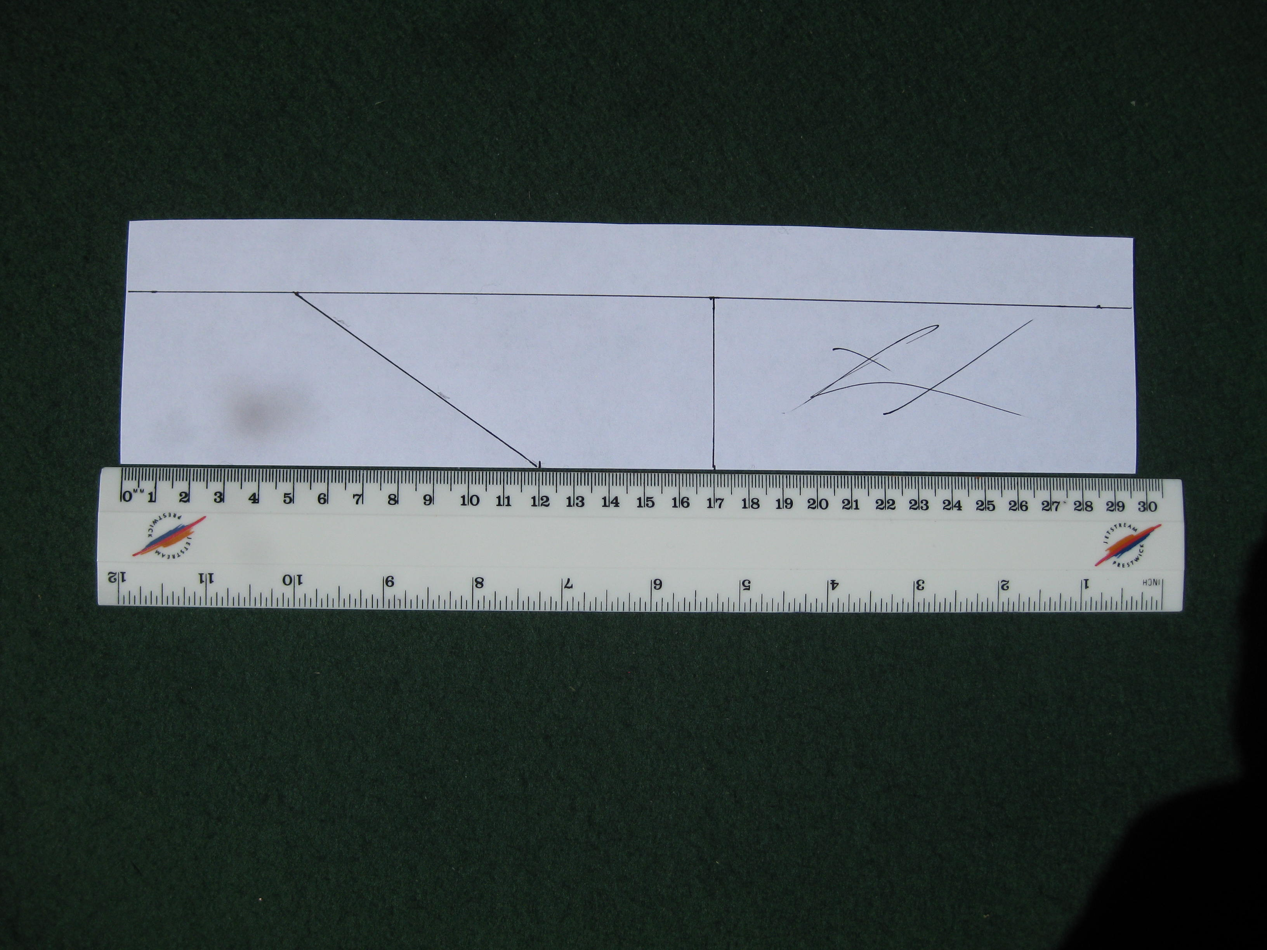
Mark out the shape of the vertical stabilisers, fins, on a scrap piece of paper. The fins are 5cm tall, 12cm long at the base and 5cm long at the top.

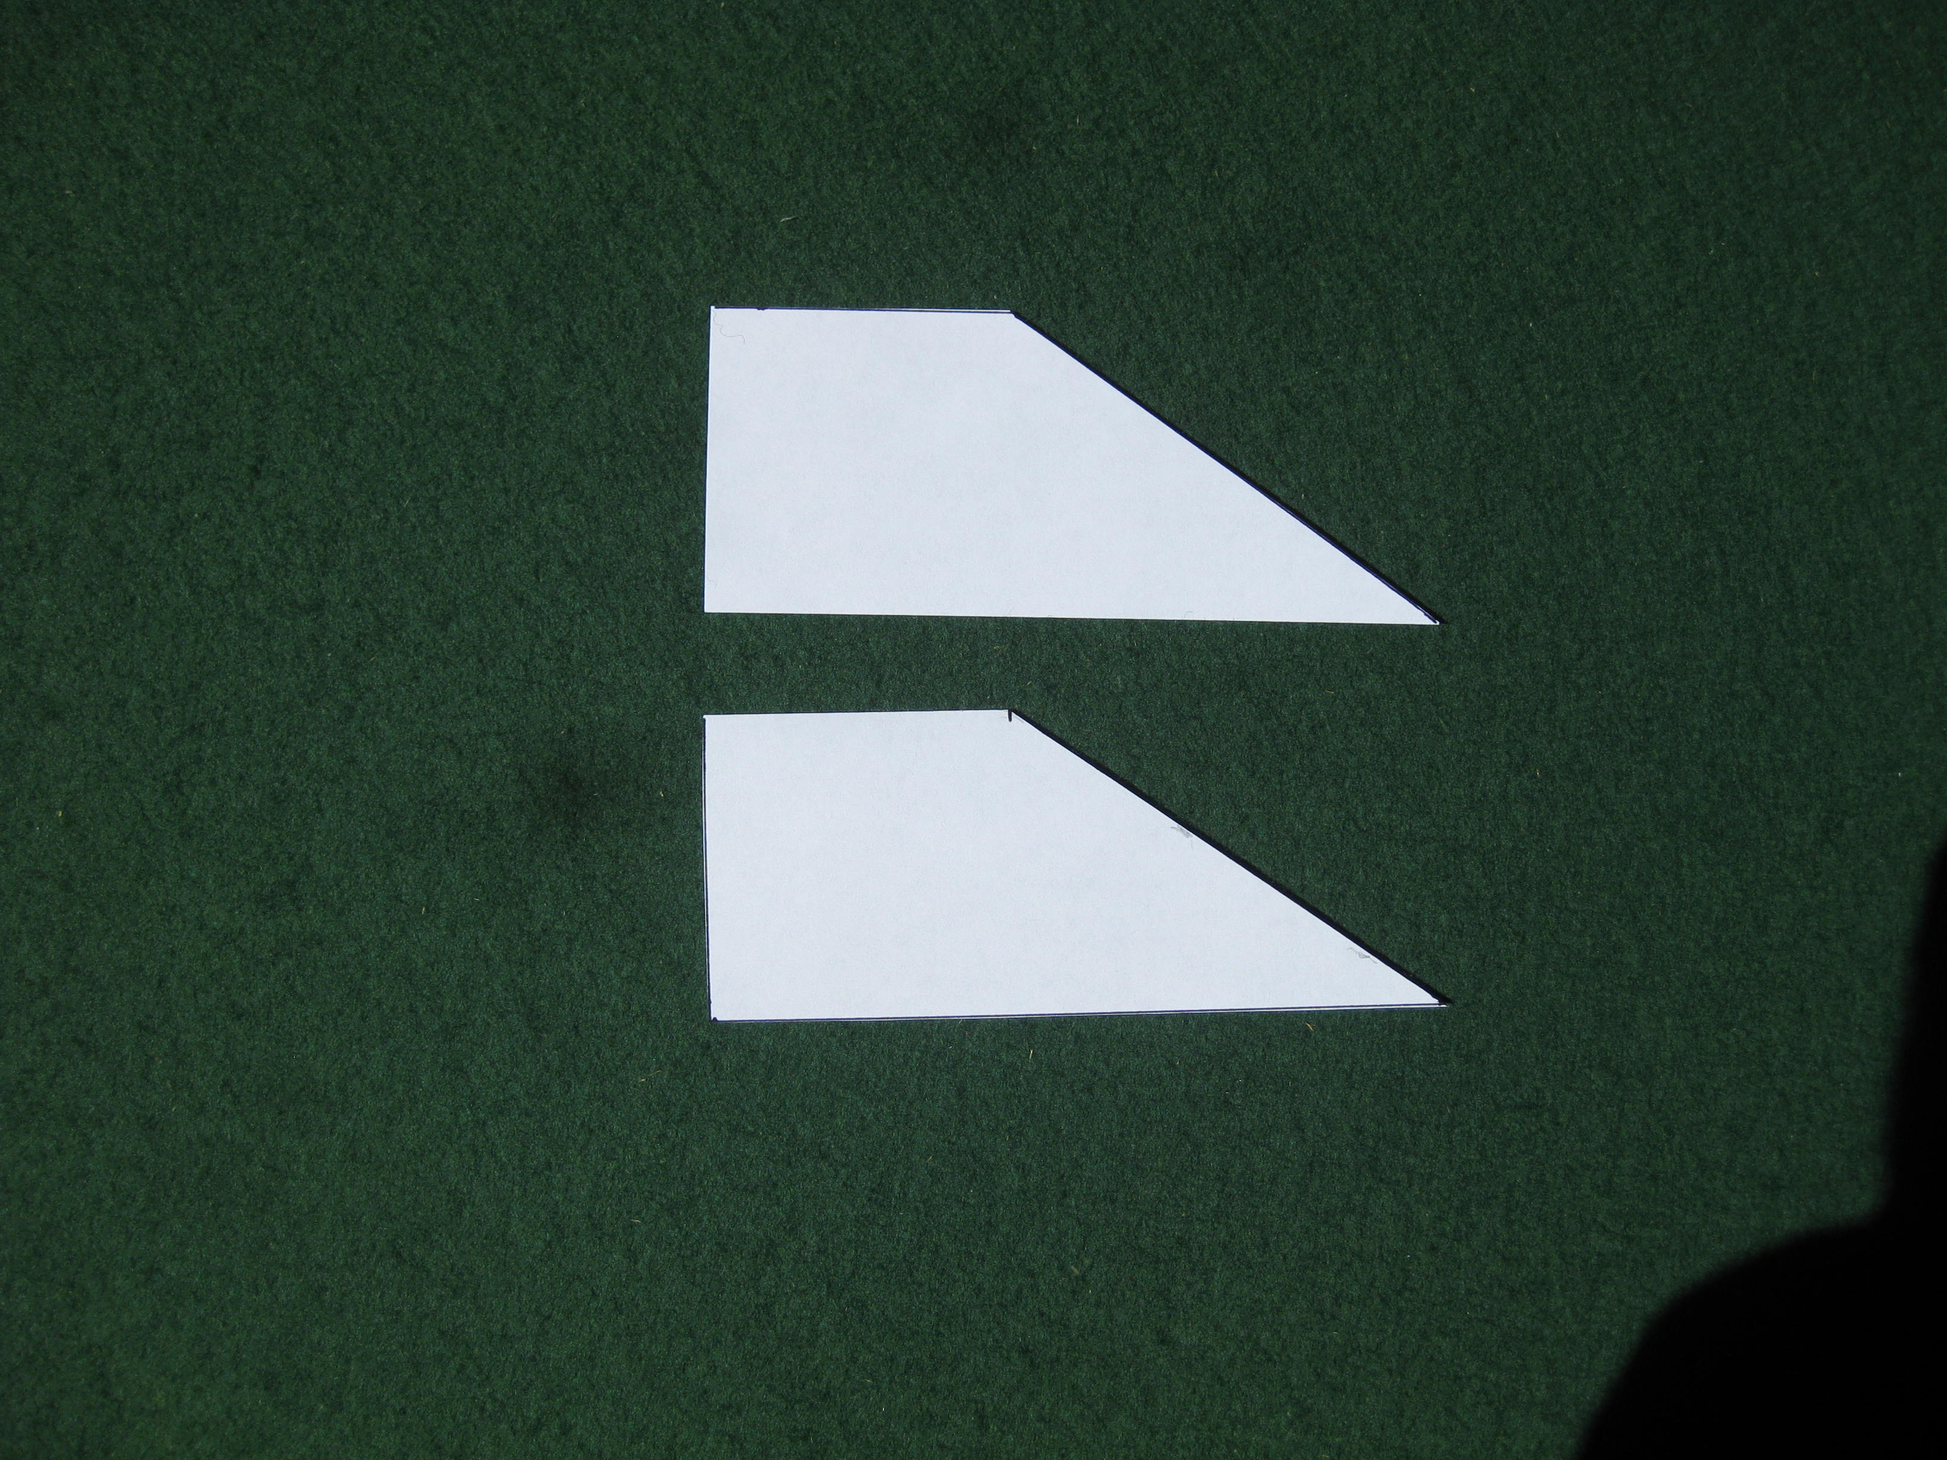
Cut out the fins and they should look like this.

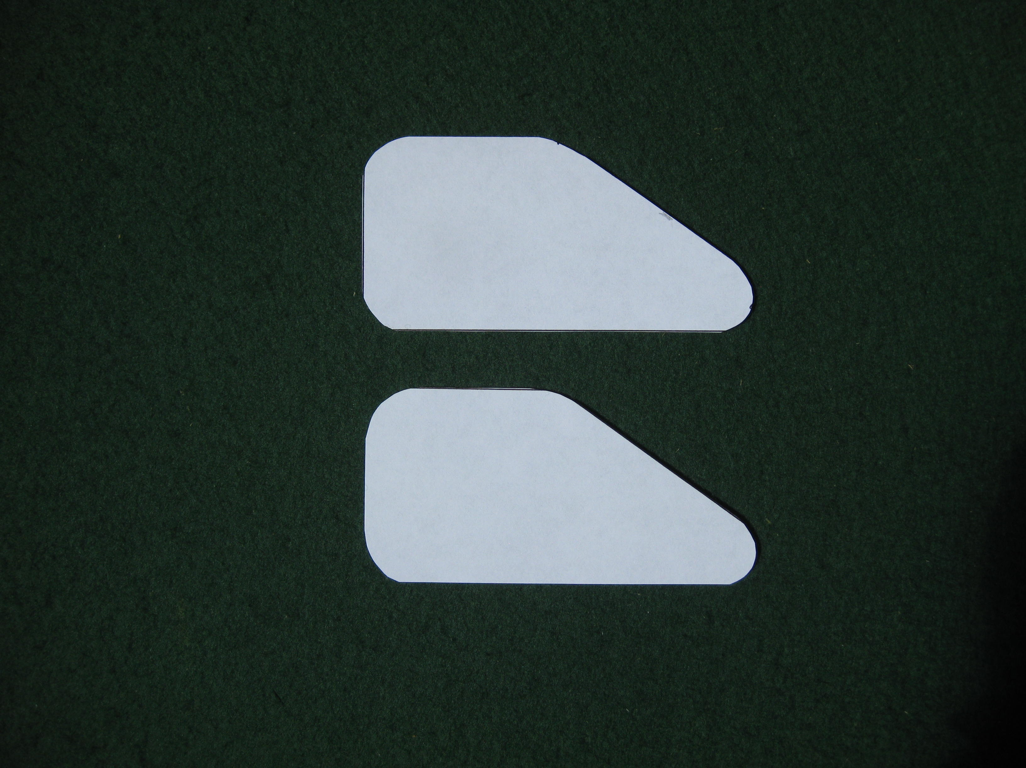
Round off all the corners until they look something like this.
Before we attach the fins, we have to join the two wings.
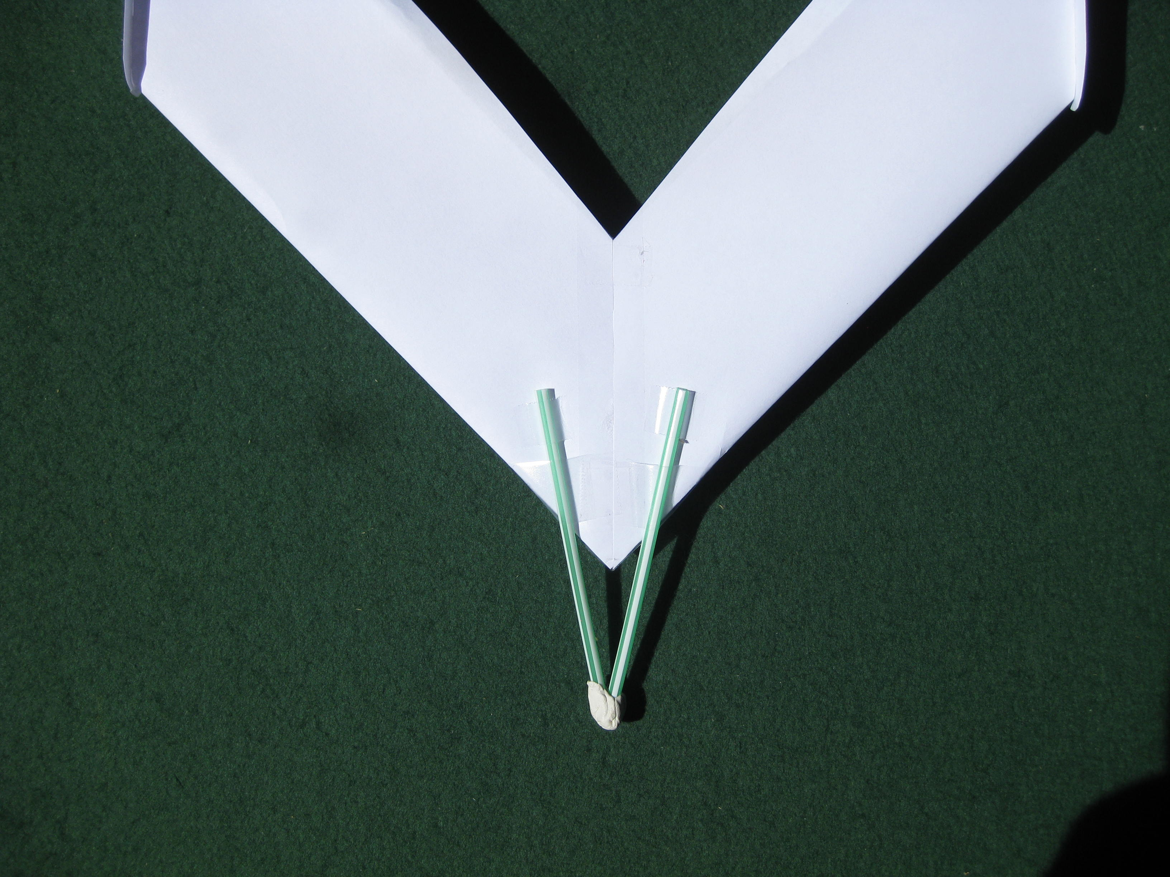
Place the two wings together and join them with adhesive tape. This can be a bit tricky. Try to not squash the wing section too much. It is a good idea to use very small pieces of tape to join the wings. Fold a straw in half and tape it to the underside of the wing as shown.
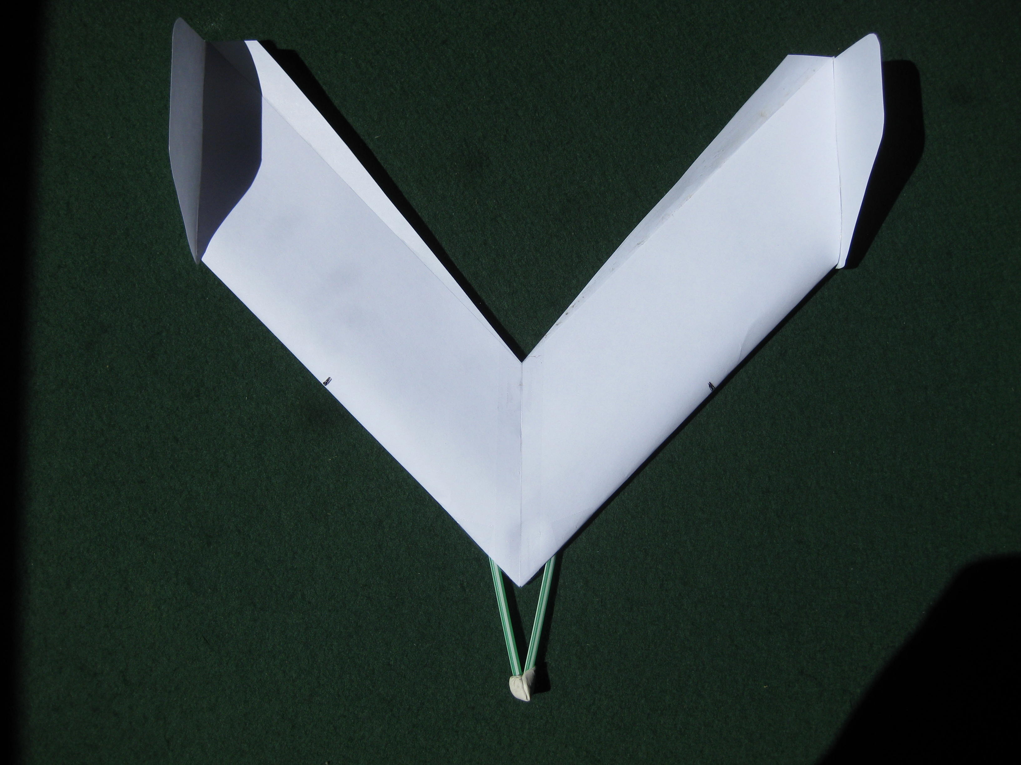
Stick the vertical stabilisers on to the wing tips in the same way as the other models.

The aircraft now needs to be balanced for flight. Measure 13cm from the nose of the wing along each leading edge and make a mark. Gently lift the aircraft at these marks and add small pieces of modelling clay or BluTack until the aircraft balances.
Instructions for trimming and flying the demonstration models.
These models are intended to demonstrate the various forms of achieving stability in flight. They are not robust enough to be used as toys and will have to be flown indoors in an uncluttered space to avoid damage.
Before attempting to fly the models, check that they have been balanced at the points shown in the build instructions i.e. the centre-of-gravity is in the right place. [see photos]
Remember that these models have fixed wing and stabiliser surfaces so they will only be in trim at one speed. If they are launched faster or slower than that speed then they will be out-of-trim and may not recover to their proper flight path.
Because of the method of construction, they will have to be handled carefully when launching into flight.
The above points will become apparent after the first few attempts to fly them.
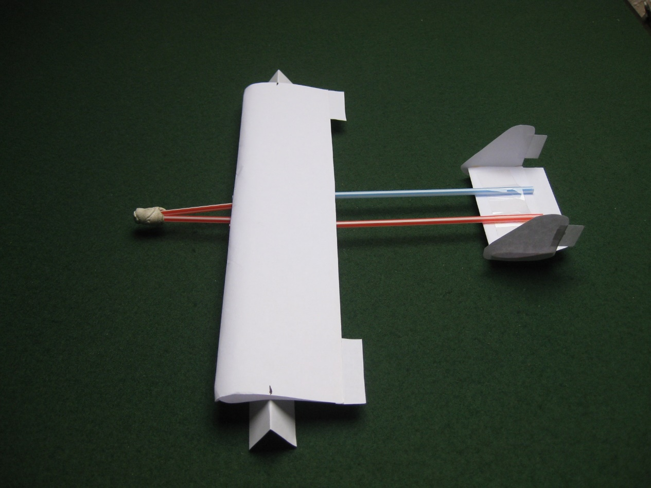
To make it easier to check the balance of the aircraft, fold two small pieces of paper to form a sharp edge to position the balance marks. To prevent the balance points from slipping, place them on a piece of cloth or tissue paper.
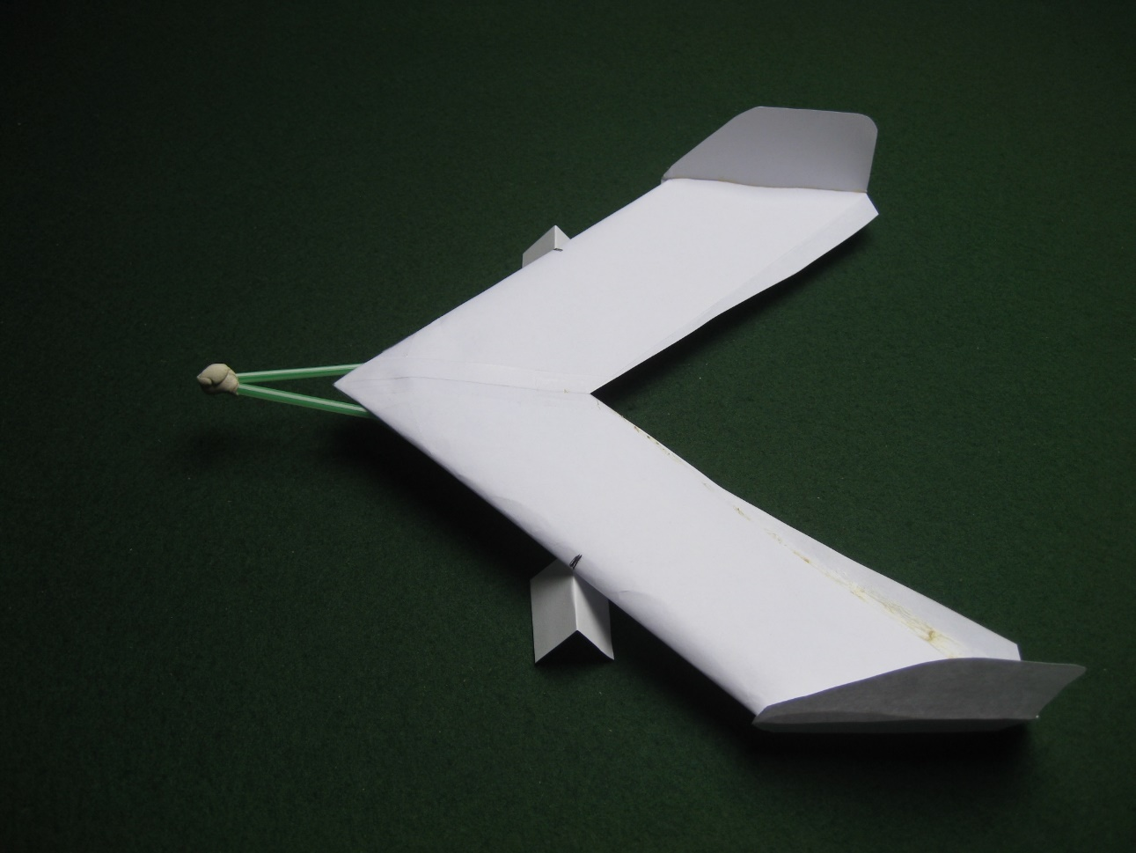
Balance the “tailless” aircraft and the “canard” aircraft using the same method.

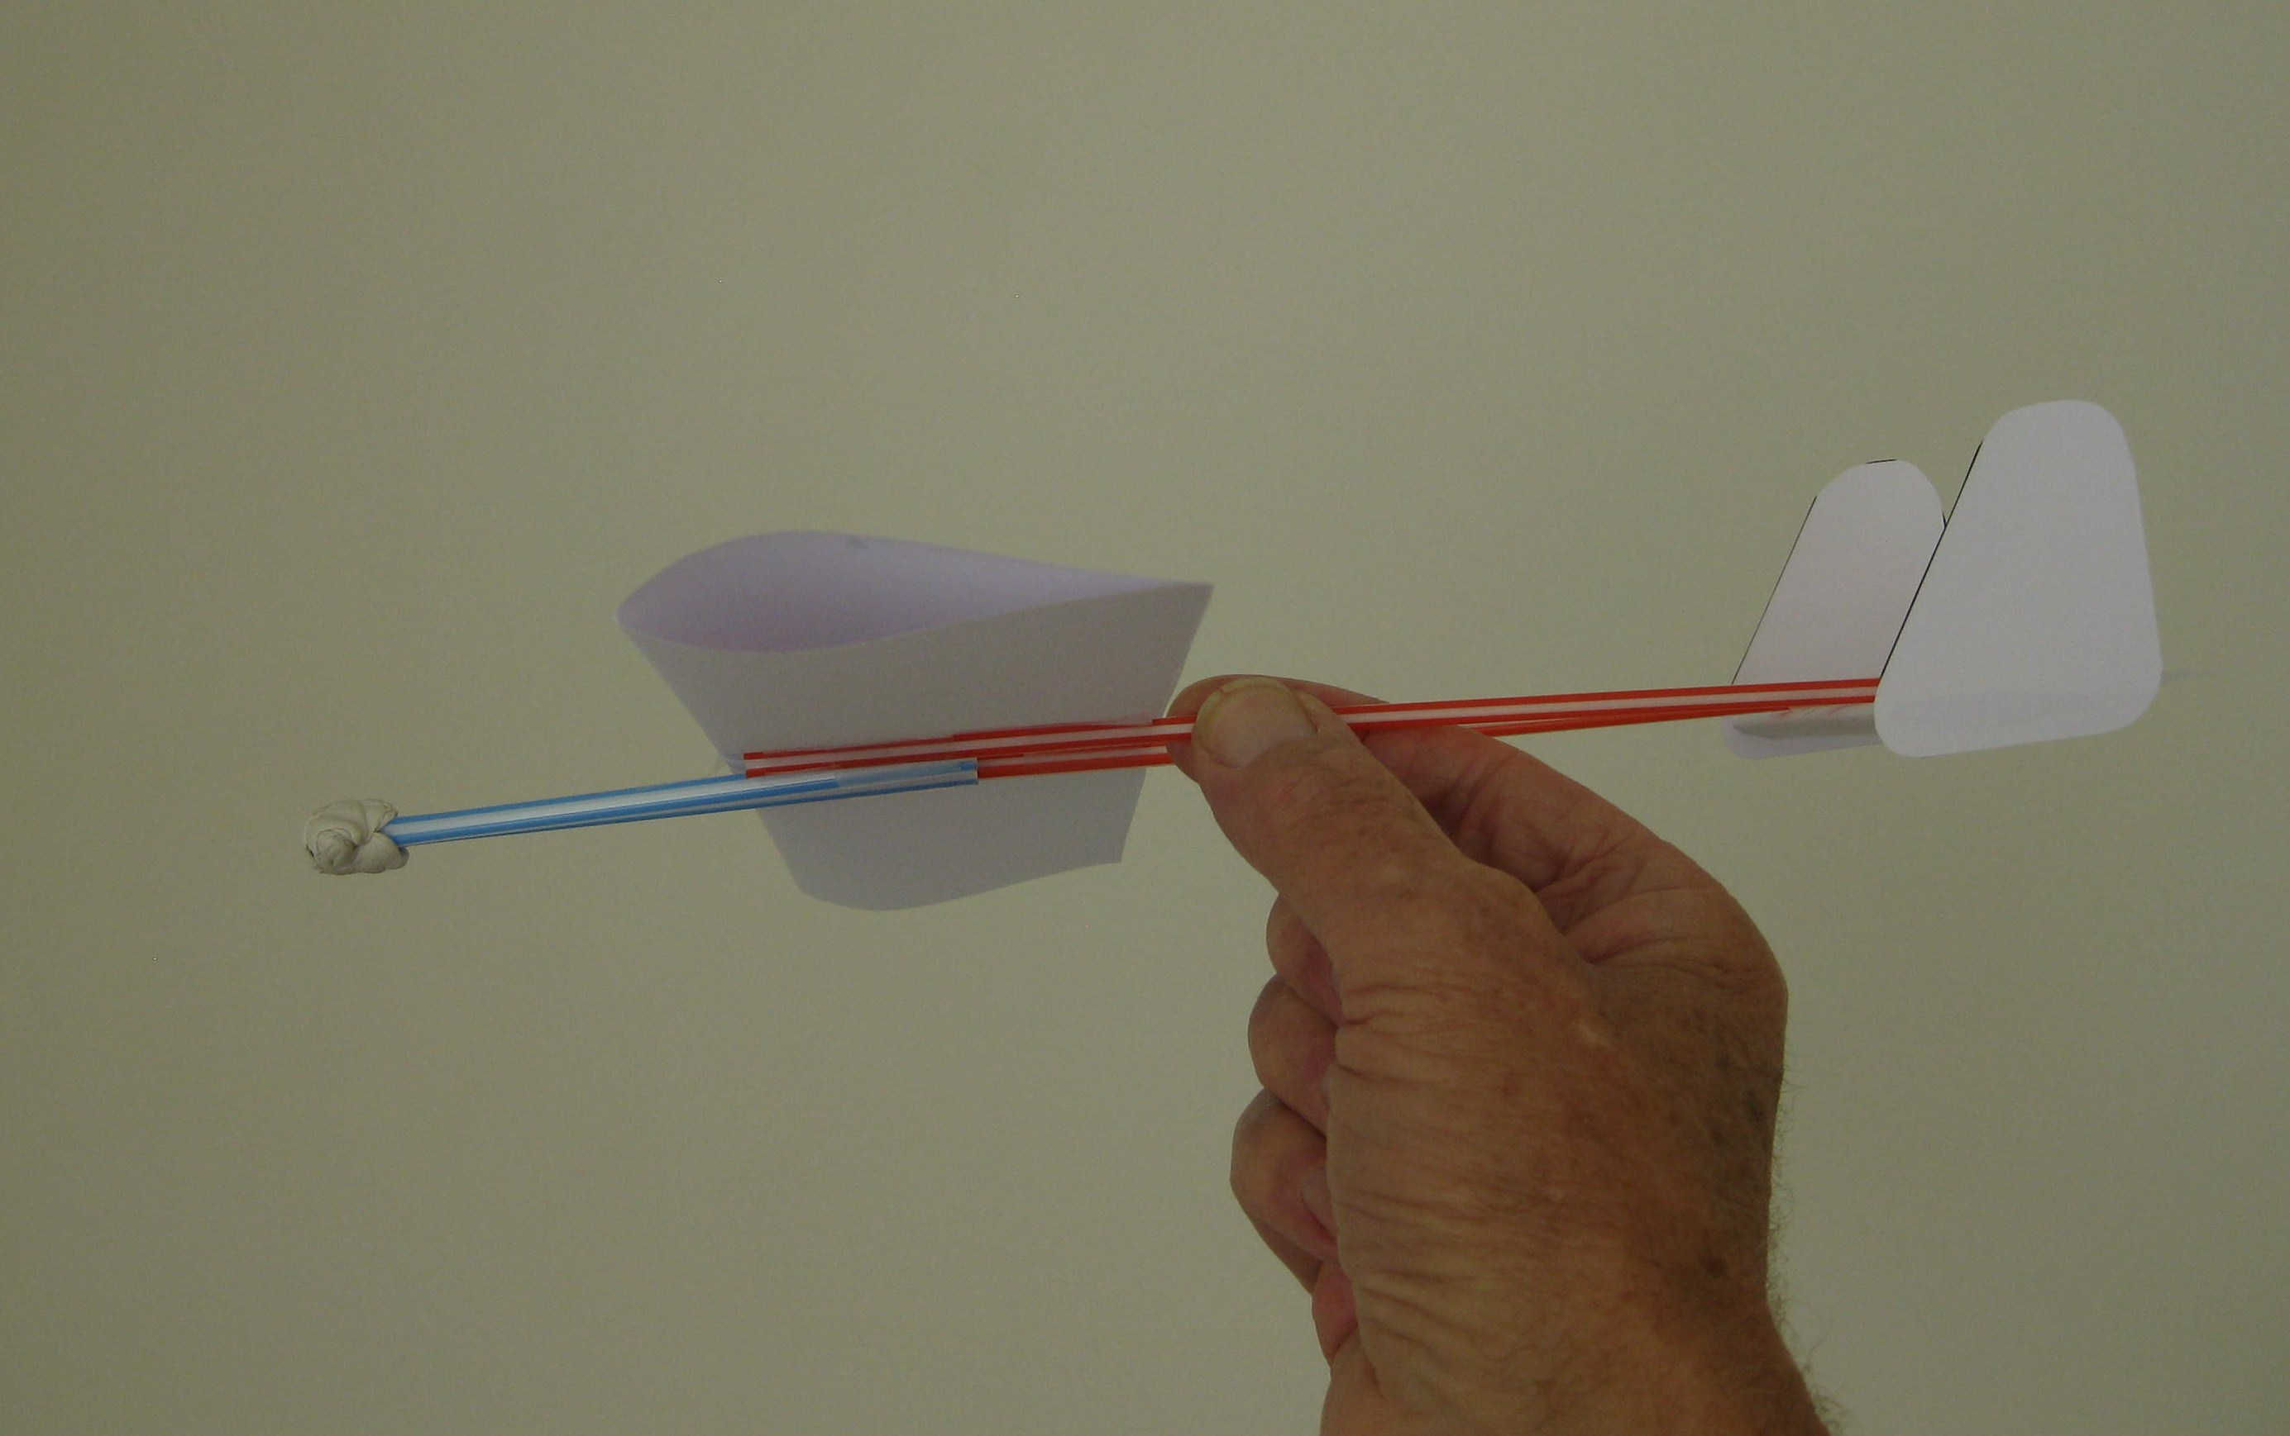
To launch the standard model, gently grip the straw nearest to you at a position just behind the wing.

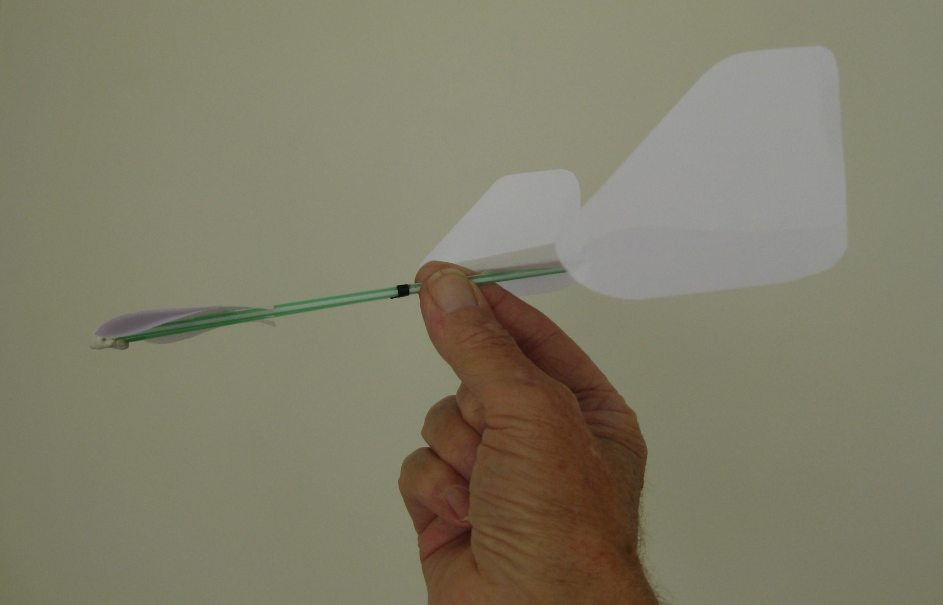
To launch the “canard” model gently grip the straw nearest to you just behind the marks at the balance point.
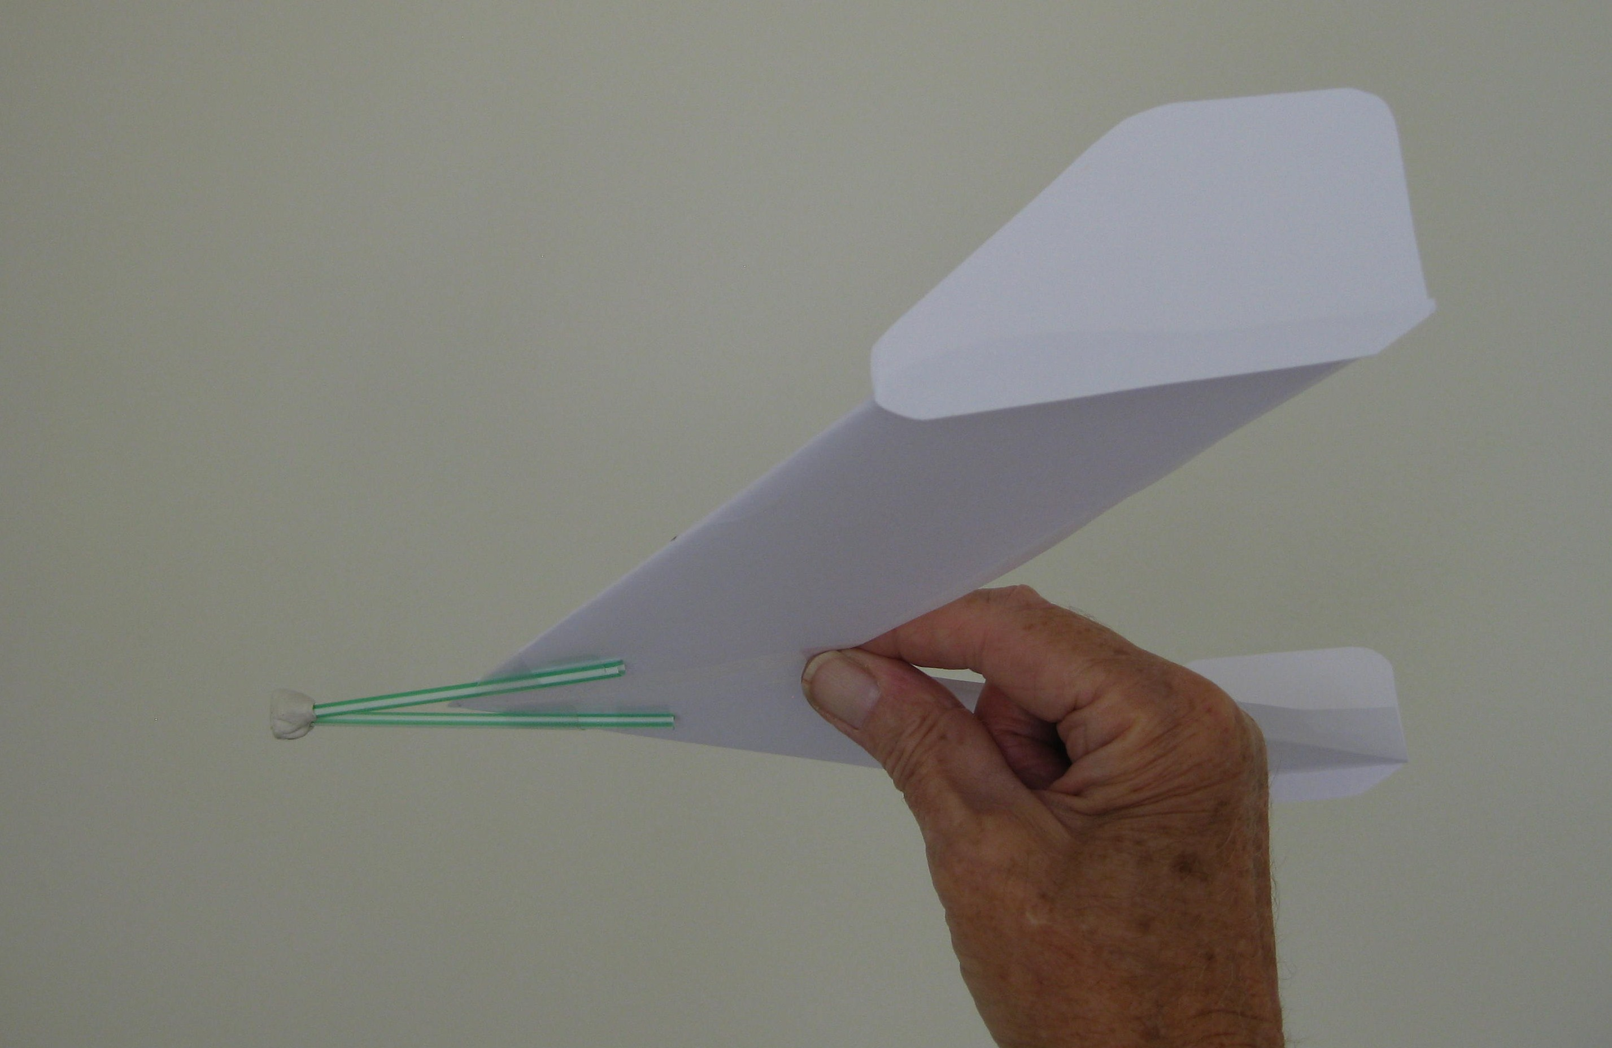
To launch the “tailless” model, gently grip the centre of the wing at the trailing edge.

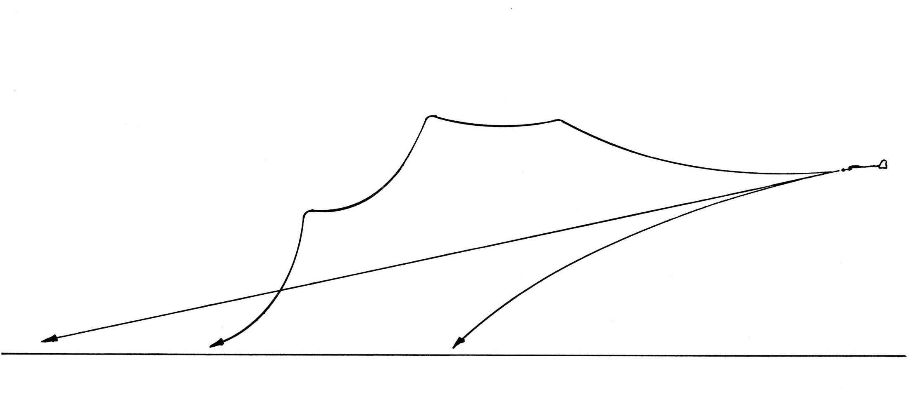
A
C
B
The above diagram shows three possible flight paths.

A Is the ideal steady shallow glide at constant speed.
B Is what happens if the aircraft is launched too slowly or does not have enough elevator angle.
C Is what happens if the aircraft is launched too quickly or has too much elevator angle. The wing is “stalling”.

To correct flight path problems, try the following.
On the standard model, bend the tab [elevator] at the rear of the horizontal stabiliser up till you get steady trimmed flight. Caution:- The elevator has quite a powerful effect so only small changes in angle should be required.
On the “canard” model the elevators are on the rear of the forward stabiliser and, in this case, you will find that they have to be bent down before starting to fly the model and then altered to suit. This model is quite difficult to trim and this demonstrates one of the inherent problems with this type of aircraft.
On the “tailless” model the up-curved rear of the wing not only acts as the stabiliser but also the elevator and again only small changes should be required to trim the aircraft. You will probably find that this aircraft flies slightly quicker than the other two.
Remember to always launch the aircraft slightly downwards along the flight path. Resist the temptation to throw the aircraft upwards, it does not work.
If you find that the aircraft turns to the left or the right you can try correcting this by slightly bending the vertical stabilisers away from the turn to see if this straightens the flight path.
Do not give up on trying to trim the aircraft, they will all fly well when trimmed correctly.
Real aircraft can also have problems in getting the trim right. Flight testing, carried out by a good test pilot, will often be required to provide information to fix the aircraft.

.

