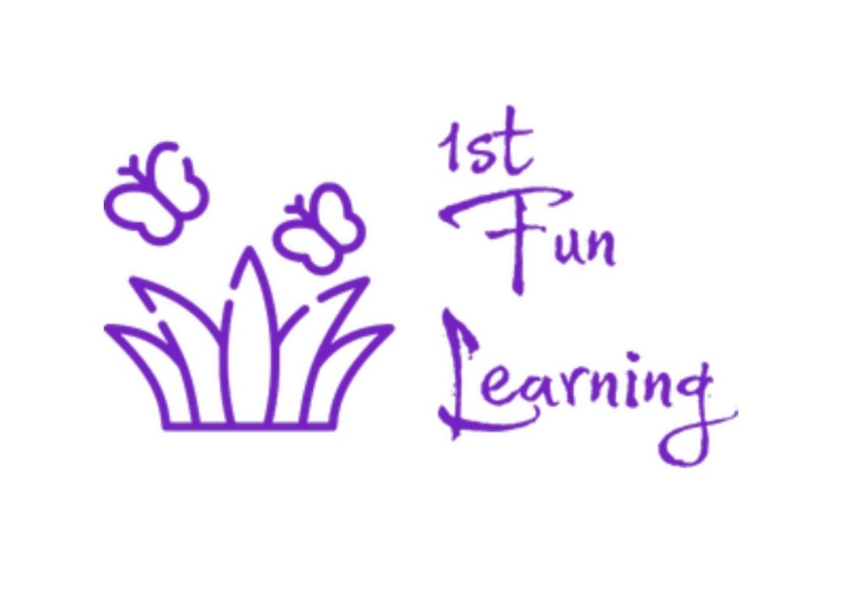

Partnership with Parent/Carers and Professionals Policy

Policy review
The responsibility of reviewing and maintaining this policy is Stacey Moxham and Jaime Solomon (Director’s). This policy will be reviewed annually.

Last review date of policy: June 2025
Date of next review: June 2026

Signed: Date: June 2025

Stacey Moxham Jaime Solomon
Director Director
1st Fun Learning 1st Fun Learning

Email: directors@1stfunlearning.education
Phone: 0117 4725300

Contents page

Purpose of this policy 3

Why we aim to build good relationships 3

Network partnerships 3

Good relationship role modelling 3

Purpose of this Policy
1st Fun Learning acknowledges the importance in working with Parents/Carers building a positive and professional relationship with them as this has a crucial impact on the children. We also understand the relevance and importance to build a good working relationship with the schools and professionals involved with and around the children. Working to create a professional umbrella that provides a supportive network to the family and the child’s development.

Why we aim to build good relationships
Our reasons to build a transparent relationship with Parent/Carers and professionals are:
- Supports the learning and development of the children.
- Helps with sharing information.
- Supports and demonstrates a positive attitude between Parent/Carers, Children, professionals and Staff, towards the setting and the working relationship.
- Supports the outcome of the children’s development and journey at 1st Fun Learning into their next steps of education.
- Enables staff and other professionals to help the families.

Network partnership
With a positive working relationship between Parent/Carers, Schools and 1st Fun Learning we can establish a unique development package for each child to ensure they gain a good knowledge of themselves, which helps them become happy and balanced individuals.
1st Fun Learning also promotes a good working relationship so, Parent/Carers and professionals always feel welcome and valued within the setting. This also helps Parent/Carers and professional to raise any concerns and feel involved in their child’s journey.
During the induction period new Parent/Carers and School will be given an information pack about the setting, activities and what to expect at 1st Fun Learning. Staff will complete daily and termly observations on each child to support their development, which will be accessible to Parent/Carers and Schools on their request along with any other information held on the individual child.

Good relationship role modelling
1st Fun Learning also ensures that the following points will be met to support and promote a good working relationship with Parent/Carers, Schools and other Professionals:
- Policies and procedures are kept up to date with the latest regulations and legislations and that they are available at any time.
- Regular input and meetings; regarding activities, planning and target setting.
- Ensure that regular opportunities for Parent/Carers to arrange to meet staff to discuss their child’s development and wellbeing.
- Ensure Parent/Carers receive a daily hand over about their child’s session.
- Ensure schools and or local authorities receive a weekly update on the child’s sessions.
- Work to deal with any concerns and or complaints appropriately and efficiently in accordance with the complaints policy.
- Provide regular and confidential questionnaires and or feedback sheet to comment on the daily running and or activities of 1st Fun Learning.

In addition, 1st Fun Learning asks Parent/Carers, School and other Professional to keep Staff up to date with any changes to circumstances, meetings and new information relevant to our practice.

