Dreaming in Gardens
Three poems - Published 2016

Dreaming in Gardens 20160418 B.pdf

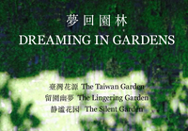
The Taiwan Garden
Peter Stickland and Wu-Han Chou
from a journey made together with Yun-Na Liu, Hiroyuki Iwashita and Shih-Yi Tsai

The Lingering Garden
Peter Stickland and Red Hu translated into Chinese by May Wang

The Silent Garden
Peter Stickland and Qiao Zhenglin

