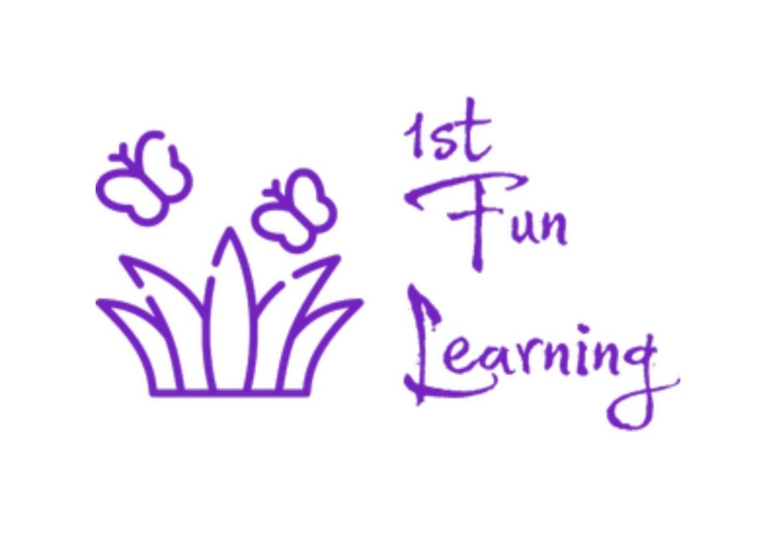

Communication, Partnership and Effective Involvement Policy

Policy review
The responsibility of reviewing and maintaining this policy is Stacey Moxham and Jaime Solomon (Director’s). This policy will be reviewed annually.

Last review date of policy: May 2025
Date of next review: May 2026

Signed: Date: May 2025

Stacey Moxham Jaime Solomon
Director Director
1st Fun Learning 1st Fun Learning

Email: directors@1stfunlearning.education
Phone: 0117 4725300

Purpose of the Policy:

Contents Page

Section | Page number
Purpose of this policy  Building positive relationships  Our communication  Importance of communication  Child engagement  Good relationship role modelling  Network partnership  How we do this | 3  3  3  4  4  5  5  6

Purpose of this policy
At 1st Fun Learning we acknowledge the importance of developing strong and open communication between our provision, the children, their families, the commissioning schools and outside professionals to create an umbrella of support for everyone involved. Communication and effective partnership plays an essential role in both the performance and success of our community. We encourage a positive and effective organisation culture which is inclusive of involving the child’s and their families voice in the delivery of their bespoke care package. We also understand the relevance and importance to build a good working relationship with the parent/carers, schools and professionals involved with and around the children to create a supportive network, so we strive to implement support and effective learning into all aspects of the child’s life.

Building positive relationships
We strive to build transparent and highly supportive relationships with parent/carers, schools and outside professionals as we feel this is highly important for effective success. We do this by;
- Support and develop the child’s learning in a way that suits them, and they feel heard and understood.
- Assist the child and their families to improve their social and home life, by accessing outside support.
- Support schools in their journey to support challenging situations.
- Support and demonstrate positive attitudes between parent/carers, children, school, professionals and staff.
- Support the outcome of the children’s development and journey at 1st Fun Learning into their next steps as a network.

Our communication
How you communicate with people, from colleagues, children, parents/carers, professionals and outside agencies not only reflect on you as an individual but also 1st Fun Learning as an organisation. With this in mind we value staff’s abilities to communicate well and encourage all staff to be respectful and considerate when communicating at all times especially inside of working hours.
The telephone is still a main form of contact for our clients and ourselves, so answering the phone in an appropriate manner is essential. Even on a busy day staff should try their upmost to answer every phone call and in a polite manner. Any messages taken should be passed on to the directors and or left in the communication book.
Any blogs or social networking sites such as Facebook or Twitter should only be used in your own time and must not be used to discuss any issues relating to 1st Fun Learning (see social networking policy).

Importance of communication
As an organisation we feel communication is extremely important for providing an outstanding provision. Below are a few of the reasons why we feel so strongly about promoting a strong organisation culture and good levels of communication;
- Helps build trusting relationships with the children providing them with good role models so they can learn to develop their communication skills.
- It helps the children develop and learn their desired outcomes as they are able to learn and understand what is expected in a calm and respectful manner.
- Helps to build respectful and trusting relationships with parent/carers, so we can help them engage with their child’s journey, with professionals and we can offer then support and advice.
- Helps build and maintain good relationships with professionals and commissioning schools. This encourages them to use our service in a positive manner.
- Encourages professionals and commissioning schools to return and use our service again. They are more inclined to promote our service and pass our information on to other prospective professionals and schools.
- It increases staff engagement and productivity and encourages their levels of success.
- Drives staff to have a strong company culture, want for the organisation to do well in helping ‘pushed out’ learners and deliver a high-level service everyday working towards our mission.
- Supports our aim to work and support children, families and schools in crisis to re-engage back into the educational system.
- Promotes organisational growth and achievement.

Child engagement
We encourage each child to have an active role in their learning, recognising the importance of their opinions, this will allow them to feel a sense of ownership over their style of learning and development. We also openly discuss with the children on how we can help to implement different approaches to their development and behaviour that they feel could help them individually. Giving each child a safe space, they feel heard and understood, along with a sense of control over their wellbeing and development.
1st Fun Learning recognises the significance of effective involving and consulting with all the staff, children, families and professionals to establish a welcoming, engaging and respectful community within our provision. This not only develops a good working relationship but a place that all staff, children, families and professionals can feel secure and confident to learn.

Good relationship role modelling
1st Fun Learning also ensures that the following points will be met to support and promote a good working relationship with Parent/Carers, Schools and other Professionals:
- Policies and procedures are kept up to date with the latest regulations and legislations and that they are available at any time.
- Encourage and promote effective communication without judgment or discrimination.
- Regular input and meetings; regarding activities, planning and target setting.
- Ensure that regular opportunities for Parent/Carers to arrange to meet staff to discuss their child’s development and wellbeing.
- Ensure Parent/Carers receive a daily hand over about their child’s session.
- Ensure schools and or local authorities receive a weekly update on the child’s sessions.
- Work to deal with any concerns and or complaints appropriately and efficiently in accordance with the complaints policy.
- Provide regular and confidential questionnaires and or feedback sheet to comment on the daily running and or activities of 1st Fun Learning.
- In addition, 1st Fun Learning asks Parent/Carers, School and other Professional to keep Staff up to date with any changes to circumstances, meetings and new information relevant to our practice.

Network partnership
With a positive working relationship between Parent/Carers, Schools and 1st Fun Learning we can establish a unique development package for each child to ensure they gain a good knowledge of themselves, which helps them become happy and balanced individuals.
1st Fun Learning also promotes a good working relationship so, Parent/Carers and professional always feel welcome and valued within the setting. This also helps Parent/Carers and professional to raise any concerns and feel involved in their child’s journey.
During the induction period new Parent/Carers and School will be given an information pack about the setting, activities and what to expect at 1st Fun Learning. Staff will complete daily and termly observations on each child to support their development, which will be accessible to Parent/Carers and Schools on their request along with any other information held on the individual child.

How we do this
We encourage the children and their family’s involvement with planning activity ideas, development and evaluation of our service. It is the director’s responsibility to ensure the children and their family’s involvement is in guidance with every child matter, united nations conventions on the rights of children and the local government guidelines.
We will do this by:
- Regular letters and newsletters home
- Questionnaire and comment forms
- Regular chats with children and families
- Feedback activities
- Ideas board on different topics
- All staff will invite any suggestions during daily conversations
- Individual child observations and interests
- End of programme evaluation forms that parent/carers and commissioning schools receive
- Consistent communication with parent/carers, schools and outside professionals
- Regular review meetings held with school and parent/carers where we encourage everyone to have a voice even the children

