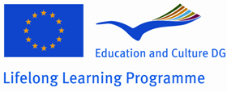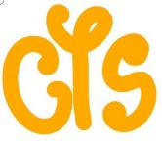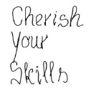

Cherish Your Skills

Every person should have an opportunity to develop his/her potentials and get all the skills he/she needs due to satisfy living, working, lifelong learning and participating in society due to his/her own potentials.
Cherish your skills - use a passport and other materials, developed in the project. They are useful tools to prove yourself, to find a job, to participate in projects or to get new skills and knowledge.
Skills Passport

The Skills Passport is a document which has been developed to help you recognize the skills you have achieved at school, at work and through life experiences. These skills are called the Key Competencies.
Key Competencies can be demonstrated through employment, voluntary work, during student life and in day-to-day life. The key competencies are divided in five areas:
- Language and Communication;
- Mathematics for Life;
- Citizenship and Employability;
- Information and Communication Technologies;
- Soft Skills.

What is the Skills Passport Process?
The Skills Passport process identifies your achievement of the Key Competencies and gives you recognition for work and life skills as well as providing you with feedback on your further training needs.
Digital version: www.skills.gekopwerk.nl
https://www.facebook.com/pages/Grundtvig-Cherish-Your-skills/1409484079313735
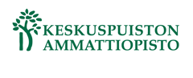
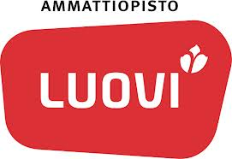
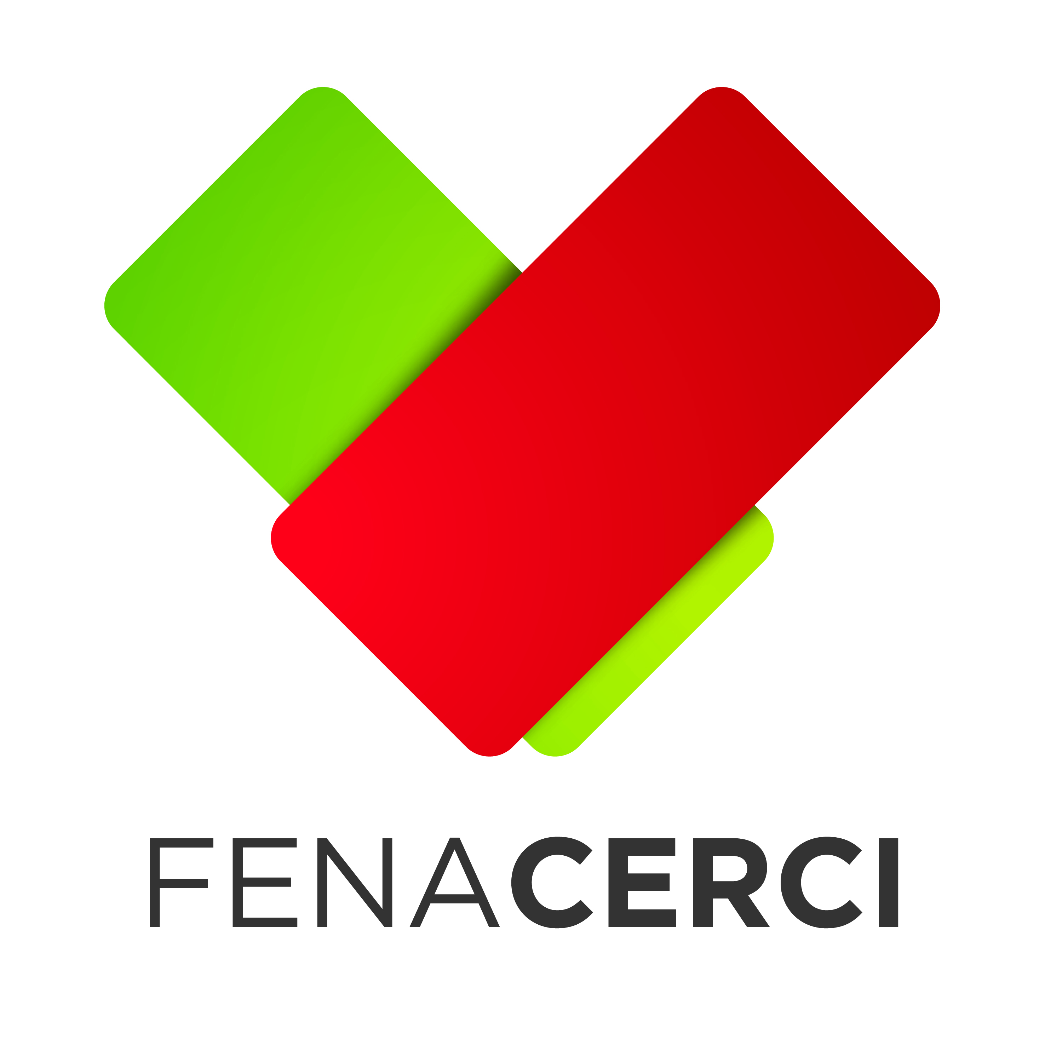
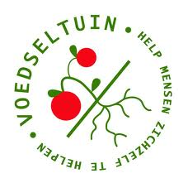
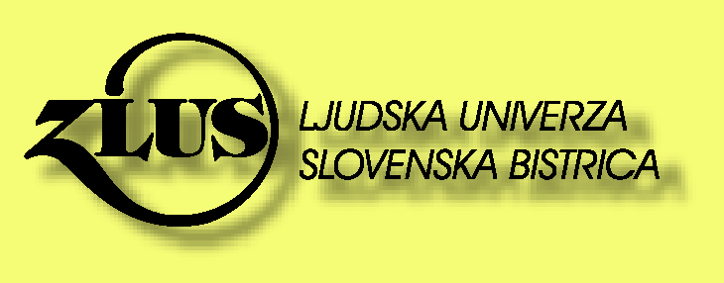
Partners:

