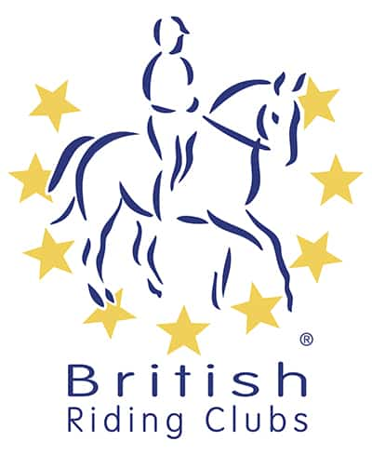

BRC
AREA 21
Horse Trials - One Day Event
Area Qualifier for BRC Horse Trials Championships*
organised by
Gower Riding Club
Sunday 5th July 2026
at
Gower Riding Club
SA3 2EE
what3words /// thousands.sues.send

Official Steward:
To be confirmed **
Course Builder:
Helen Evans
Paramedic:
John Cutter
Photographer:
In attendance
Vet on Call:
Ifan Lloyd
ORGANISER and ENTRIES SECRETARY:
Helen Groom
Mobile: 07966884770
heleng350@btinternet.com

AREA entries to Helen Groom close on
Friday 19th June 2026
Open entries (if numbers of entries allow) close on
Friday 26th June 2026

Course walk, warm up and start times will be clearly stated when the rider times are published.
There will be plenty of time allocated to walk the cross country course on the day.
Provisional Times

Dressage | 09:00 – 12:30
Show Jumping | 11:30 – 13:30
Cross Country | 14:00 – 16:00
Results / Prize Giving | 17:00

Passport of all horses in all classes must be up to date. Flu vaccination record must comply with the 2026 updated policy currently only needing annual vaccinations.

PLEASE REMOVE AND TAKE HOME ANY LITTER AND ALL DROPPINGS/HAY LEFT BY YOUR HORSE AROUND YOUR VEHICLE

Schedule
Class 1 – 70 cm
Section a = Qualifying Class - Senior or Junior competitors individuals. Teams (may be mixed senior or junior)
Section b = Non-qualifying Open (Individual only)

Entry Fees – Payable to Gower Riding Club
Class | Team Price | Individual Price
Senior /Junior | £300 | £75
Open | NA | £75

TESTS
BE90 Dressage 91 (2009)

TACK CHECK
It is the responsibility of the rider to ensure their tack and equipment conform to the rules. Full details are in the current BRC Handbook.

COMPETITOR NUMBERS
Competitors must provide their own number bib with number clearly displayed on front and back of rider.

HELPERS
Each participating Club entering a team /individual will be required to provide names and contact details of 1 helper (full day) or two helpers (half day). It is the responsibility of the club to ensure helpers are made available and suitable for the allocated roles.

AREA entries to Helen Groom close on
Friday 19th June 2026

Open entries close
Friday 26th June 2026

sent to HELEN GROOM via email to
heleng350@btinternet.com
Payment should be made via BACS to
GOWER RIDING CLUB,
Sort code: 30-95-46 Acc no: 00051535 reference: AREA 21 ODE (insert club name).

Clubs - Times will be emailed to Team Managers and will be available on the Area 21 website and Facebook pages - By MONDAY 29th June 2026

Parking: Please follow directions of the parking attendants

Catering: will be available on site during competition hours

RULES

Dogs must be kept under control at all times, on short leads and cleared up after. Do not leave dogs in cars or lorries if it is too hot to do so!

This competition will be run in accordance with the official rules for all British Riding Club Competitions 2025. Area 21, Gower Riding Club, and persons acting on their behalf, do not accept any liability for any loss, accident or damage to any person, animal, vehicle or goods occurring in connection with this event. It is a condition of entry that each competitor indemnifies the organiser against any claim.

To qualify for the relevant British Riding Club Championships, entries must be made through clubs on the official forms.
Competitors only are allowed to ride their horse on the showground. Everyone mounted must wear a hard hat with the harness adjusted and fastened.
Under BRC rules, any rider who has a fall from their horse anywhere on the showground must see the paramedic before remounting and follow their instructions. The paramedics decision is final. Any breach of this rule will be reported to the Official Steward. Team managers are responsible for making sure all riders understand and accept this rule.
The Passport/Vaccination Certificate must, under penalty of elimination, accompany the horse to all official competitions. The competitor is responsible for producing it on demand.

The Organisers of this competition have taken reasonable precautions to ensure the health and safety of everyone present. For these measures to be effective everyone must obey the instructions of the Organisers, Officials and Stewards and take all reasonable precautions to avoid and prevent accidents occurring. A Paramedic will be available, and the event will be run in line with BRC First Aid Rules.
It is a condition of entry that neither the Organisers nor Landowners nor their agents shall be held responsible for any loss, injury, damage to competitors, onlookers, their property, horses or ponies, howsoever caused.
The Organisers reserve the right to cancel the event, alter classes, judges, times or any other published information. In the event of cancellation, a proportion of entry fees will be retained for administration purposes.
Protective headwear for all classes must comply with BRC rules 2024. All competitors in the qualifying classes must ensure their hat has been tagged by the Official Steward and carries the PINK tag. Accepted hat standards:

Hats
Hats which meet the standards below must be worn with harness properly adjusted and fastened. Skull caps mush be worn with a silk. All Hats must be tagged with an aqua tag from BRC, PC or BE. Fixed peaks are not permitted in any competition where cross-country is involved but are permitted for dressage and showjumping
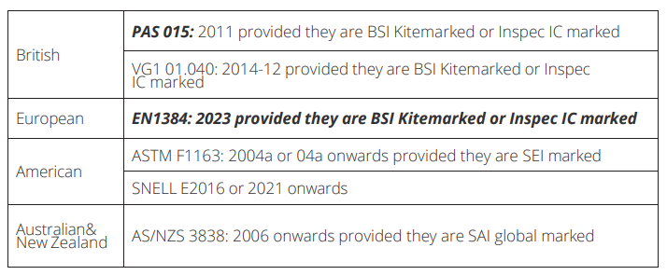
For full hat guidelines see G22.2 Please see the current BRC Handbook and also BRC rule amendments and changes document which can be found via the link below.
IMPORTANT : Hats and Body protectors must be presented and checked upon arrival and before mounting
BRC Handbook | The British Horse Society (bhs.org.uk)
*CHAMPIONSHIP
BRC Horse Trials Championships will be held over 2 days 1 - 2 August 2026. Location: Swalcliffe Park, Grange Farm, Swalcliffe, Banbury, OX15 5EX.

Good Luck and Enjoy

