Main Title

Main title subhead
First name LAST NAME¹, First name LAST NAME²
1. Academic or other professional affiliation, complete mailing information and e-mail address of the author.
2. Example: CY Cergy Paris University – MRTE Research Group, France, damien.masson@cyu.fr
Abstract. Every paper should start with an abstract, about 800 characters long (spaces included) and written in a single paragraph. Please, make sure it outlines the aims, scope and outcomes of the paper.
Keywords: 1 line of keywords, separated by commas

Title 1- Please make sure to use ‘Amb2020 – Main section’ style here
Here should be written the main body of the text. It can be filled with tables and figures. You will find all the explications needed in the author’s guideline file (Ambiances2020_Authors-guidelines.pdf).

The article must be written following this style sheet. Please make sure to write your main texte using ‘Text’ (or ‘Normal’) style, and to use 'Title 1' style for the main titles, and 'Title 2' for the subtitles. Please do not number sections and subsections.

Quotations and references in the text must be followed by a reference in the following format (Author, Date, page – if applicable).

The article in MS-Word .docx format shall be written following this template. Please indicate in the filename the digit code corresponding to your proposal (ID, as received when you deposited your file using the conference console), your Last Name, and the version. (e.g. 103_NAME_V1.docx).

Title 2- Please make sure to use ‘Amb2020 – subsection’ style here
It is required that manuscripts submitted meet international English language standards (American or British usage is accepted, but not a mixture of these) to be considered for final publication. Please note that submitting proofread material is mandatory.

The papers should not exceed 18’000 characters spaces included, the number of pages of the final print version of the book depends on this. These 18’000 characters include abstract, keywords and bibliography. Chapters that exceed this number of characters will automatically be returned to their authors for reduction in size.

It is possible to include images in the body of the text. Please use the 'Caption' style for illustration captions. Please also provide your images as a separate file, titled in the following format: ID_Name_ImageXX.jpg (or png). Images should be 300 dpi resolution. Each illustration implies a reduction in the number of characters, corresponding to its size (please consult the authors-guidelines file on this subject).

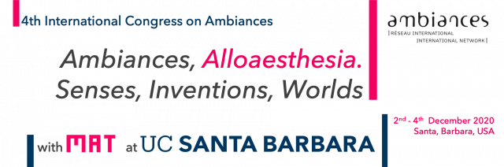
Figure 1. Title, Author, Date (Please, use the ‘Caption’ style here)

References - Please make sure to use ‘Title 1’ (from the Style tab) style here

Only references cited in the text, must appear in the reference list. References are unnumbered and presented in alphabetical order

Citation in text
Please ensure that every reference cited in the text is also present in the reference list (and vice versa). For any works, include the author(s) surname(s), followed by the year. Any references cited in the abstract must be given in full.

Reference style
References should follow the referencing style used by the Chicago Manual of Style 17th edition, which is available in most citation managers (e.g. Zotero freeware).

Book
Chion, Michel. Film, a Sound Art. Film and Culture. New York ; Chichester: Columbia University Press, 2009.

Chapter in a book
Hui, Allison. “Enthusiasm.” In The Routledge Handbook of Mobilities, edited by Peter Adey, David Bissell, Kevin Hannam, Peter Merriman, and Mimi Sheller, 172–81. Routledge Handbooks. London: Routledge, 2014.

Article in a Journal (print or online)
Ebbensgaard, Casper Laing. “Making Sense of Diodes and Sodium: Vision, Visuality and the Everyday Experience of Infrastructural Change.” Geoforum 103 (July 1, 2019): 95–104. https://doi.org/10.1016/j.geoforum.2019.04.009.

Research reports, Theses and Dissertations
RATP. Écologie Des Transports Urbains. Actes Du Séminaire. 1ère Partie. Rapport de Recherche N°85, RATP- Département Développement Prospective. Paris: RATP, 1993.
Website
“Research | TransLAB - Media Arts and Technology.” Accessed May 6, 2020. http://translab.mat.ucsb.edu/.

Please use footnotes and not end notes. Footnotes should be written in 'Footnotes' style. Footnotes should be short and relatively limited in number. Please do not place bibliographical references here, except for URLs.

