Unit 2: Understanding the core
Vaja slušnega razumevanja:
Tapescript 4 (vaja se nanaša na razdelke Unit 2 od A do D)

A: ženski glas, B: moški glas
A: We just moved into a new house and I can’t tell you how good I feel leaving the old apartment behind. Of course this one is bigger and has more rooms but I am the happiest to finally have my own room. The new room has three big windows so it is very bright. It also has a big bed and a desk.
B: Does it have a new computer as well?
A: Not yet, but my mum promised the computer is next on the list. I hope to get it for Christmas.
B: Great, then we can play games together. But tell me more about the room! Do you have anything on the walls already?
A: Yes, I have a big poster of Ronaldo above my desk. And on the wall, to the right of the bed I have my old red Ferrari towel. It is the only old thing in my room at the moment, but I love it so I took it with me. Next to the towel I have a big map of the world. On the map I plan to colour all the countries I go to. But the coolest thing is, my room is just under the roof. My sister, the one I shared a room with until now, her new room is just under my room. Only my brother and I have rooms on the top floor.
B: That is so cool.

Naloga:
Circle True or False.

- The new home is a house. T F
- The new room gets a lot of sunlight. T F
- They have a new computer. T F
- The room is full of things from the old room. T F
- The poster of Ronaldo is above the bed. T F
- She loves the Ferrari towel. T F
- Next to the towel is a big ball. T F
- The room is under the room of her sister. T F
- Her brother has a room on the same floor. T F

Rešitve:
1. T, 2. T, 3. F, 4. F, 5. F, 6. T, 7. F, 8. F, 9. T

Vaja za bralno razumevanje:
Read the text and answer the questions.

My name is Tom. I go to secondary school now. I am in my first year. I start school at 7:45 am. but I have to get up at 6:30 already because I have to catch a bus at 7:15. I don’t like getting up early in the morning but I have to. I want to be a car mechanic after I finish school. After school, I go back home and have lunch. Sometimes I do my homework, but when I am tired, I just lie down and watch a film or something. I often talk to my friends on the phone. When my mum comes home from work we have lunch. Usually she brings it from work. My mum works as a cook in a restaurant. She is a very good cook and I like to eat her food but she often works in the evenings and I don’t like that. My father is a shop assistant. He likes his job very much. When he is not at work he drives his motorbike or plays football. My brother plays football, too. He never does his homework and is not very good at school but he is a very good football player. My grandmother lives next to our house. I often eat dinner at her place. She always cooks things I like and she often gives me money for drinks with friends. I don’t go out often, only at the weekends, and in the summer I use the money to go to swimming pool.

Naloga:
1. How old is Tom? ________________________________________________________________
2. What time does the first lesson start? _______________________________________________
3. What job would Tom like to get after school? _________________________________________
4. Does he always do his homework? __________________________________________________
5. Where does his mother work? _____________________________________________________
6. What is the bad side of her job? ____________________________________________________
7. What job does his father have? ____________________________________________________
8. What is his brother’s hobby? ______________________________________________________
9. Does his grandmother live with them? ______________________________________________
10. Where does Tom go in the summer? ________________________________________________

Rešitve:
1. 15 (the same age as the students)
2. 7:45
3. Car mechanic
4. No
5. Restaurant/Kitchen
6. Work in the evenings
7. Shop assistant
8. Football
9. No
10. Swimming pool

Še nekaj predlogov za sestavo preverjanja, ki se nanašajo na Unit 2.
Put in am, is or are.

1. We ______________ in class 1F.
2. Tina ______________beautiful today.
3. I ______________sitting next to Tom.
4. They ______________busy today.
5. ______________you in school today?
6. There ______________a problem with your computer.
7. There ______________350 students in my school.
8. Paul ______________from Maribor.
9. ______________she your friend?

Make affirmative, negative and question forms.

- Nika / at home
______________________________________________________________________________________________________________________________________________________________________________________________________________________________________________________
- We / all in class 1B
______________________________________________________________________________________________________________________________________________________________________________________________________________________________________________________

- I / a student
______________________________________________________________________________________________________________________________________________________________________________________________________________________________________________________

Insert the correct form of the verb in brackets.

1. I ____________________ (have) a new computer.
2. They ____________________ (have) a cat but they ____________________ (not have) a dog.
3. My mother ____________________ (work) in the kitchen.
4. I ____________________ (play) computer games every day.
5. He ____________________ (like) pop music, but he ____________________ (not like) hip hop.
6. Simon ____________________ (get up) at 6 am every day.
7. You ____________________ (get up) at 6 am too.
8. We ____________________ (need) a new computer.
9. Your sister ____________________ (need) glasses.

Where are the books, the guitar, the chair and the bed?

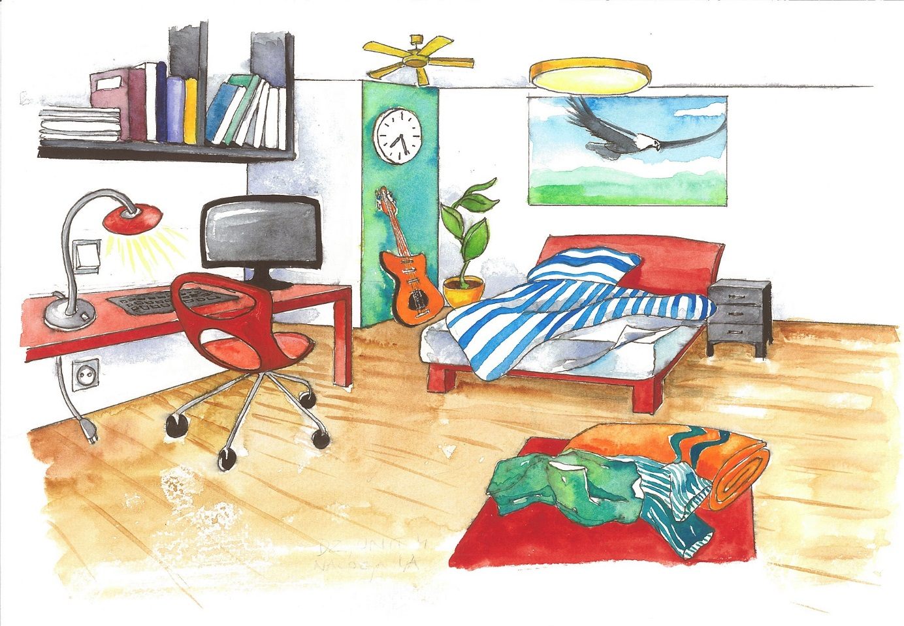

________________________________________________________________________________________________________________________________________________________________________________________________________________________________________________________________________________________________________
Put the words in brackets in the right place in the sentence.

1. I play games on my phone. (always, every day)
__________________________________________________________________________________

2. We have to cook. (sometimes, every day)
__________________________________________________________________________________

3. They wear uniforms. (never, at night)
__________________________________________________________________________

What is your typical day like? Write 6 sentences.
Vaja se nanaša na razdelke Unit 2 G, I, J.

____________________________________________________________________________________________________________________________________________________________________________________________________________________________________________________________________________________________________________________________________________________________________________________________________________________________________________________________________________________________________________

Complete the sentences with missing words.

Last month I was not at school because I was at a job placement. We were learning how to work as _________________________________________. Every day, before we started working we had to _________________________________________and ___________________________________In this line of work we have to always be careful so that we avoid accidents, such as _________________________________________or ______________________________________.
We also learned about first aid and what to do in an emergency. I learned that when I call 113, I always have to first _________________________________________and then _________________________________________.
I also have to describe _________________________________________.

