SURVIVE
Sandra Vida
TESTI

UČBENIK ZA ANGLEŠKI JEZIK ZA POKLICNO IZOBRAŽEVANJE

TESTI K UČNEMU KOMPLETU SURVIVE
ZA ANGLEŠKI JEZIK ZA POKLICNO IZOBRAŽEVANJE

Avtorice: Sandra Vida
Lektor za angleški jezik: Anita Medved
Lektor za slovenski jezik: Anita Medved
Urednik: Saša Fister
Oblikovanje: Nisa Perišić
1. izdaja, 1 natis: 2019
Naklada: 150

Za založbo: Andrej Rutar
Založnik: Založba Tangram d. o. o., Dolenjska cesta 242b, 1000 Ljubljana
©Založba Tangram d. o. o., 2019. Vse pravice pridržane.

Založba Tangram d. o. o.
Dolenjska cesta 242b

1000 Ljubljana
tel: 01 427 29 39
faks: 01 427 29 40
e-pošta: ztangram@gmail.com
spletna stran: www.survive.si

Unit 1: Remembering the basics
Vaje slušnega razumevanja:
Tapescript 1 (vaja se nanaša na razdelke Unit 1 od A do H)

A: Hi there, can I make a reservation please? A table for four people for tonight at 7 pm.
B: Yes, sure. On what name?
A: Harlow. James Harlow.
B: Is that H A R L O V?
A: No, there is a double-U at the end. So H A R L O W.
B: HARLOW. Thank you. 7 o’clock then.

Naloga:
Listen to the dialogue and answer the questions.

- The reservation is on the name: _________________________________________________
- How many people: ____________________________________________________________
- The reservation is at: __________________________________________________________

Rešitve:
1. Harlow, 2. 4, 3. 7 o'clock

Tapescript 2 (vaja se nanaša na razdelke Unit 1 od A do I)

A: Hi, Tina! I am just calling to check if you know Simon’s birthday is on the 14th and we are planning a party.
B: Oh, really? When is that? Friday, the 13th?
A: No, on Saturday, the 14th.
B: Ok. Sure, I will be there. What about the present? We should bring a present.
A: Yes, Barbi is collecting money from everybody to buy something. You can call her at 031 859 426.
B: 031 859 426. OK, I will call Barbi and see you on the 14th then. Is there anything else I can help with?
A: No, we are fine, thanks.

Naloga:
Listen to the dialogue and answer the questions.

- When is Simon’s birthday? ______________________________________________________
- Barbi’s phone number is: _______________________________________________________

Rešitve:
1. (on Saturday) 14th, 2. 031 869 426

Tapescript 3 (vaja se nanaša na razdelke Unit 1 od A do K)

A: Hi Peter! Good to see you after such a long time! How are you?
B: Fine, thanks. Yes. Last time we saw each other was I think… Easter? I was at the seaside for 5 weeks for the summer holidays. I worked for my uncle. In September and October, I had my work placement in a local firm, so I did not go to school.
A: Oh, how was that?
B: Good, much better than school. Easier. When is your work placement this year?
A: January and February. I can hardly wait. What are you doing for Christmas holidays?
B: Not much. Relaxing, taking it easy, watching TV, going out with friends, like every year.
A: Yeah, me too. Let’s get together at the weekend then. You can tell me all about the 2 months of your work placement.
B: Sure.

Naloga:
Listen to the dialogue and answer the questions.

- When did they see each other last? _______________________________________________
- How long does the work placement last? __________________________________________
- What is he doing at Christmas? __________________________________________________
- How long was he at the seaside? _________________________________________________

Rešitve:
1. Easter, 2. 2 months, 3. nothing/relaxing, 4. 5 weeks

Vaja za bralno razumevanje:
Read the text and answer the questions. Choose a or b.
Hi Lisa,

How are you? Thanks for your messages. I didn’t forget you, I was just very busy with everything. My new school is great and my new classmates seem nice, too. I already have a new friend. Her name is Maja. She’s Croatian. She’s from Pula. She is also new at the school. She’s very good at English so she helps me when I need help. She also plays volleyball very well and wants to get into the school volleyball team.
I also have a great new Geography teacher, Mrs. Kos. As you know, Geography isn’t my favourite subject, but she’s a great teacher so I like it better now. My favourite subject is Art. That’s right! I love it. The Art teacher always lets us listen to music when we work. That is so cool.

I have to go now. I will write more soon, don’t worry.

Love,
Nina

1. Who is Maja?
a. Nina’s friend. b. Nina’s teacher.

2. Is Maja good at volleyball?
a. Yes, she is. b. No, she isn’t.

3. Who is from Croatia?
a. Mrs. Kos. b. Maja.

4. What’s Nina’s favourite subject?
a. Geography. b. Art.

5. Who lets them listen to music during classes?
a. Mrs. Kos. b. Art teacher.

Rešitve: 1. a, 2. b, 3. b, 4. b, 5. b

Še nekaj predlogov za sestavo preverjanja, ki se nanašajo na unit 1.
Write the numbers with words.

824 _______________________________________________________________________________

15 ________________________________________________________________________________

6043 ______________________________________________________________________________

Look at the clocks and write the time.

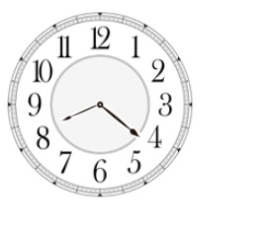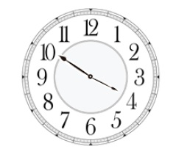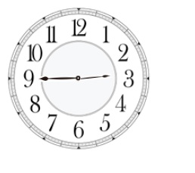
____________________ ____________________ ____________________
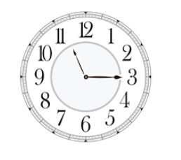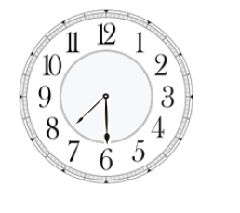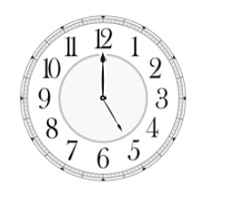
____________________ ____________________ ____________________
Insert much or many.

There are __________________________ people in our school.
How __________________________ homework did you get yesterday?
I was at a party yesterday and met __________________________ new friends.
I don’t know how __________________________ apples we need for this recipe.
How __________________________ money have you got?

Fill in the gaps with this, that, these or those.

Who is __________________________ boy over there?
__________________________ are my new glasses. Do you like them?
__________________________ is my new boyfriend. His name is Paul.
Could you pass me __________________________ pens over there? Thanks.

Insert in, on or at.

I was born ______________Sunday ______________ June. I think it was _________ 8 o’clock ___________ the evening.

Form plurals.

Man _________________
Person _________________
Knife _________________
Box _________________
Baby _________________
Star _________________
Fish _________________

Complete with a or an.

____ box
____ elephant
____ hour
____ university

Name the currencies.

$ _________________________
£ _________________________
€ _________________________

